Unit 2 Lesson 3: Scaled Relationships

1 Three Quadrilaterals (Part 1) (Warm up)

Student Task Statement
Each of these polygons is a scaled copy of the others.
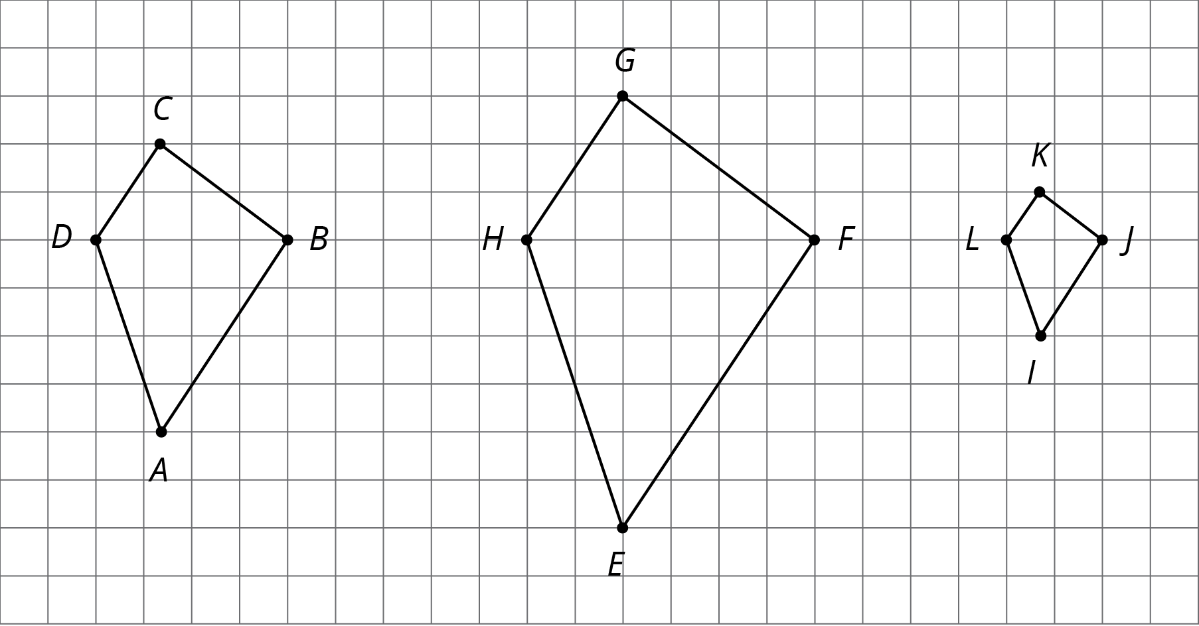
- Name two pairs of corresponding angles. What can you say about the sizes of these angles?
- Check your prediction by measuring at least one pair of corresponding angles using a protractor. Record your measurements to the nearest $5^{∘}$.

2 Three Quadrilaterals (Part 2)

Student Task Statement
Each of these polygons is a scaled copy of the others. You already checked their corresponding angles.
- The side lengths of the polygons are hard to tell from the grid, but there are other corresponding distances that are easier to compare. Identify the distances in the other two polygons that correspond to $DB$ and $AC$, and record them in the table.
- quadrilateral | - distance that  corresponds to $DB$ | - distance that  corresponds to $AC$
- $ABCD$ | - $DB=4$ | - $AC=6$
- $EFGH$
- $IJKL$
- Look at the values in the table. What do you notice?
- Pause here so your teacher can review your work.
- The larger figure is a scaled copy of the smaller figure.
- 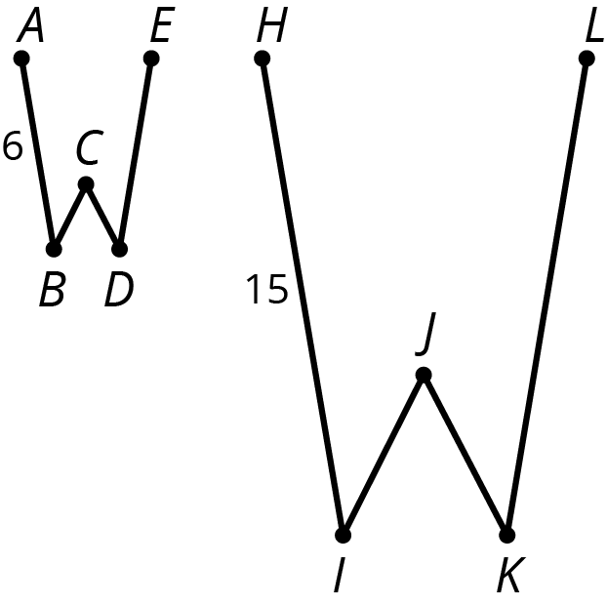
  - If $AE=4$, how long is the corresponding distance in the second figure? Explain or show your reasoning.
  - If $IK=5$, how long is the corresponding distance in the first figure? Explain or show your reasoning.

3 Card Sort: Scaled Copies

Student Task Statement
Your teacher will give you a set of cards. On each card, Figure A is the original and Figure B is a scaled copy.
- Sort the cards based on their scale factors. Be prepared to explain your reasoning.
- Examine cards 10 and 13 more closely. What do you notice about the shapes and sizes of the figures? What do you notice about the scale factors?
- Examine cards 8 and 12 more closely. What do you notice about the figures? What do you notice about the scale factors?

4 Scaling A Puzzle (Optional)

Student Task Statement
Your teacher will give you 2 pieces of a 6-piece puzzle.
- If you drew scaled copies of your puzzle pieces using a scale factor of $\frac{1}{2}$, would they be larger or smaller than the original pieces? How do you know?
- Create a scaled copy of each puzzle piece on a blank square, with a scale factor of $\frac{1}{2}$.
- When everyone in your group is finished, put all 6 of the original puzzle pieces together like this:
- 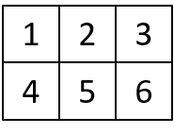
- Next, put all 6 of your scaled copies together. Compare your scaled puzzle with the original puzzle. Which parts seem to be scaled correctly and which seem off? What might have caused those parts to be off?
- Revise any of the scaled copies that may have been drawn incorrectly.
- If you were to lose one of the pieces of the original puzzle, but still had the scaled copy, how could you recreate the lost piece?
© CC BY Open Up Resources. Adaptations CC BY IM.

