Lesson 16 Practice Problems
- Automobiles start losing value, or depreciating, as soon as they leave the car dealership. Five years ago, a family purchased a new car that cost $16,490.
- If the car lost 13% of its value each year, what is the value of the car now?
- The number of trees in a rainforest decreases each month by 0.5%. The forest currently has 2.5 billion trees.
- Write an expression to represent how many trees will be left in 10 years. Then, evaluate the expression.
- From 2005 to 2015, a population of $P$ lions is modeled by the equation $P=1,​500⋅{\left(0.98\right)}^{t}$, where $t$ is the number of years since 2005.
  - About how many lions were there in 2005?
  - Describe what is happening to the population of lions over this decade.
  - About how many lions are there in 2015? Show your reasoning.
- A bank account pays 0.5% monthly interest.
  - If $500 is put in the account, what will the balance be at the end of one year, assuming no additional deposits or withdrawals are made?
  - What is the effective annual interest rate?
  - Is the effective annual interest rate more or less than 6% (the nominal interest rate)?
- Here are the graphs of three equations: ​​$y=50⋅{\left(1.5\right)}^{x}$, $y=50⋅2^{x}$, and $y=50⋅{\left(2.5\right)}^{x}$.
- Which equation matches each graph? Explain how you know.
- 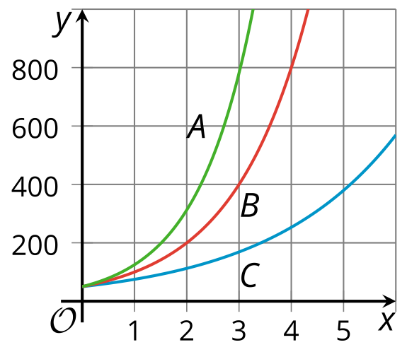
- (From Unit 5, Lesson 12.)
- A major retailer has a staff of 6,400 employees for the holidays. After the holidays, they will decrease their staff by 30%.
- How many employees will they have after the holidays?
- (From Unit 5, Lesson 14.)
- Ten students guessed the number of cubes in a jar that contains 202 cubes. Their names and guesses are listed in the table.
- Create a scatter plot with the guesses as the horizontal values and the absolute guessing errors as the vertical values.
- 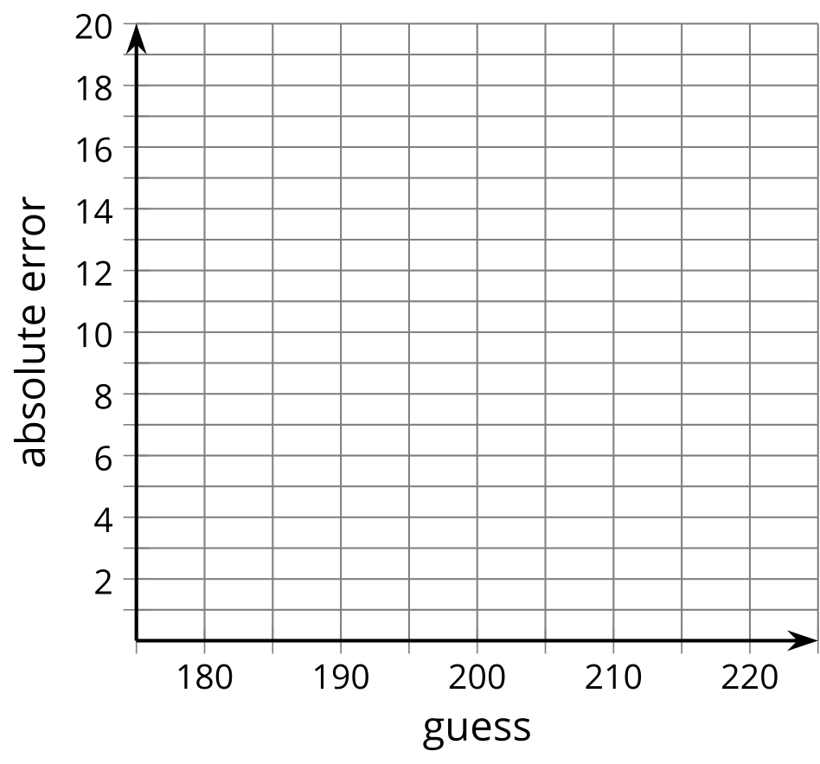
- Andre | - 205
- Clare | - 190
- Diego | - 197
- Elena | - 200
- Han | - 220
- Jada | - 210
- Kiran | - 202
- Lin | - 203
- Mai | - 199
- Noah | - 185
- (From Unit 4, Lesson 13.)
© CC BY 2019 by Illustrative Mathematics®

