Unit 1 Lesson 1: What Is Volume?

WU Which One Doesn’t Belong: Objects Made of Cubes (Warm up)

Student Task Statement
Which one doesn’t belong?
A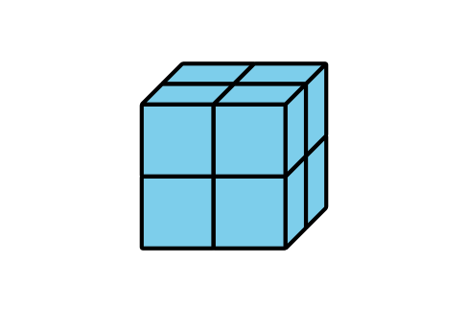
B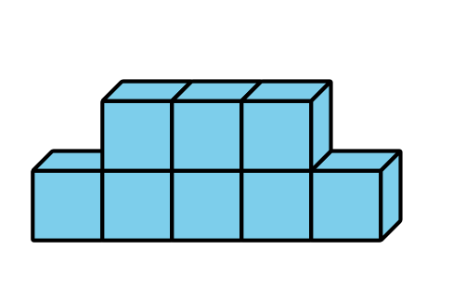
C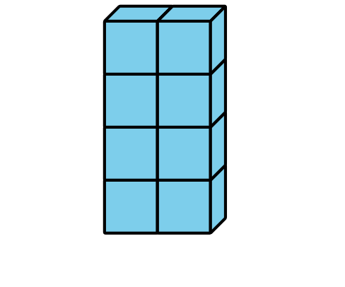
D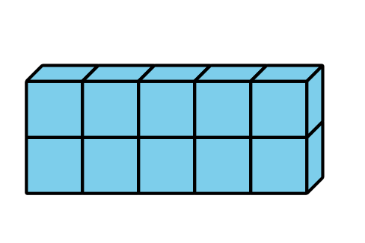

1 Build Objects with Cubes

Student Task Statement
- Which is bigger? Explain or show your reasoning.
- A
- B
- Which is bigger? Explain or show your reasoning.
- A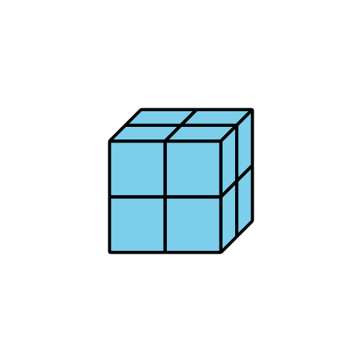
- B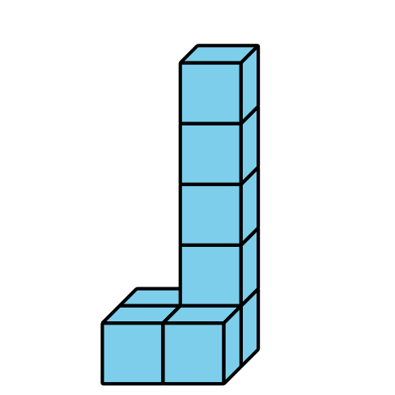
- What does it mean for an object to be “bigger”?

2 Build and Order

Student Task Statement
- Each group member:
  - Take a handful of connecting cubes.
  - Build an object.
- Order the objects by volume.
- Repeat.
- Each group member:
  - Take 9 connecting cubes.
  - Build an object.
- Order the objects by volume
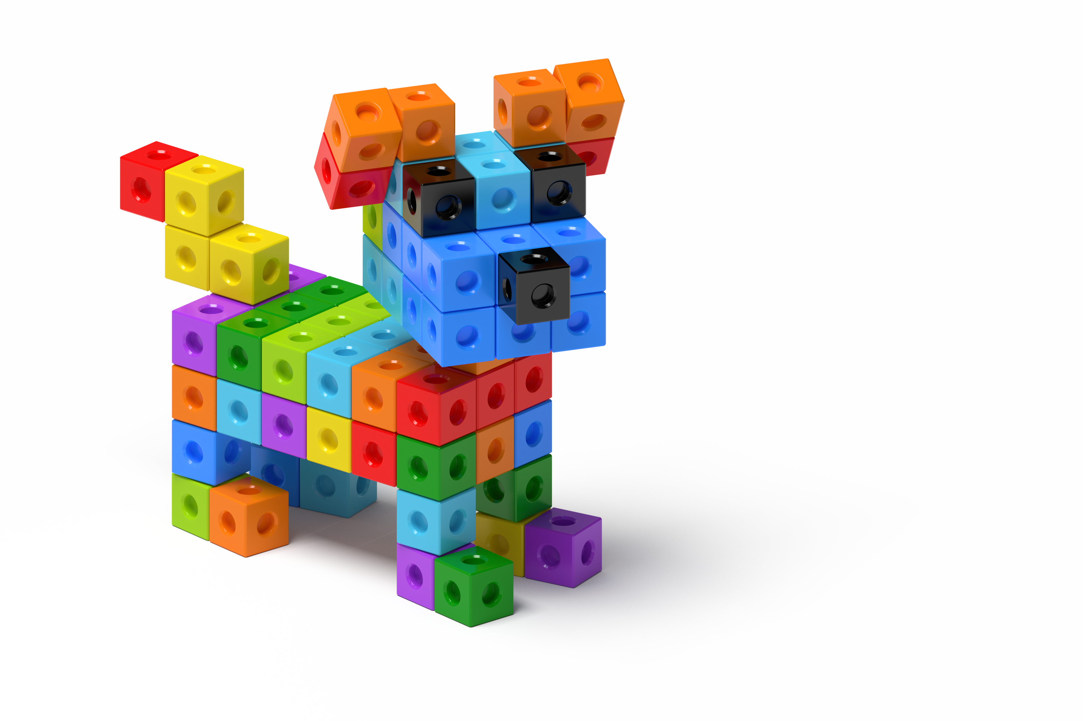

Images for Activity Synthesis
A
B
© CC BY 2021 Illustrative Mathematics®

