Lesson 10: Tens and Tens, Ones and Ones
- Let’s add two-digit numbers.

Warm-up: How Many Do You See: Tens and Ones
How many do you see?
How do you see them?
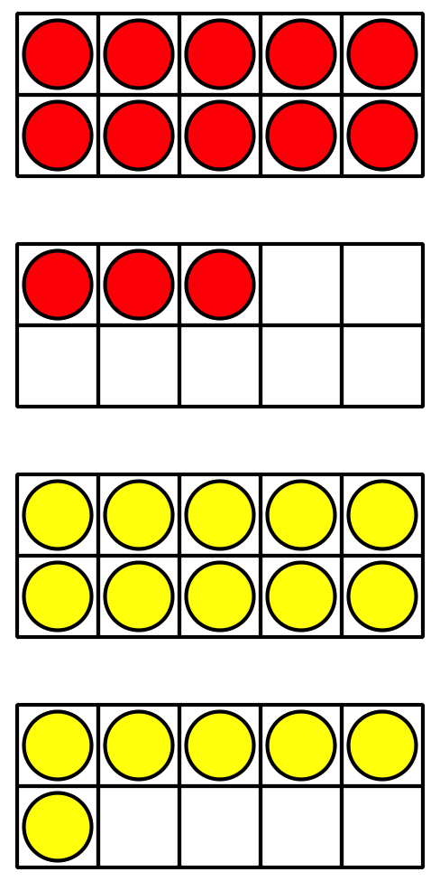
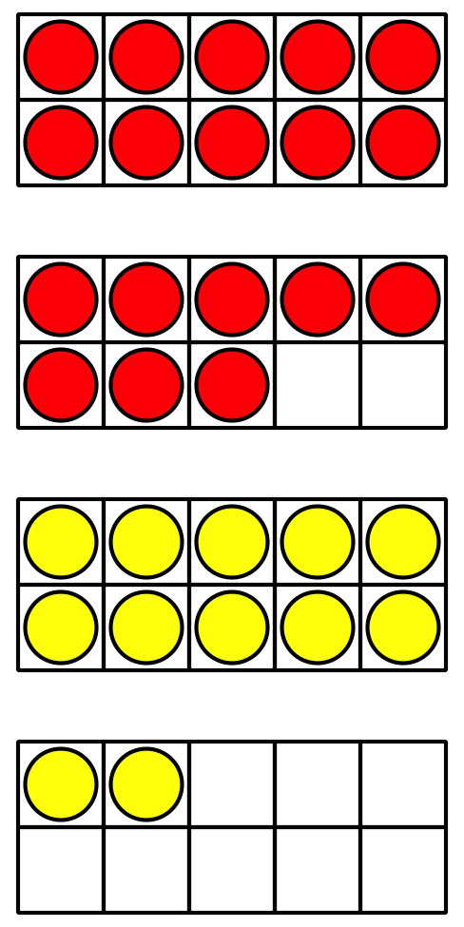
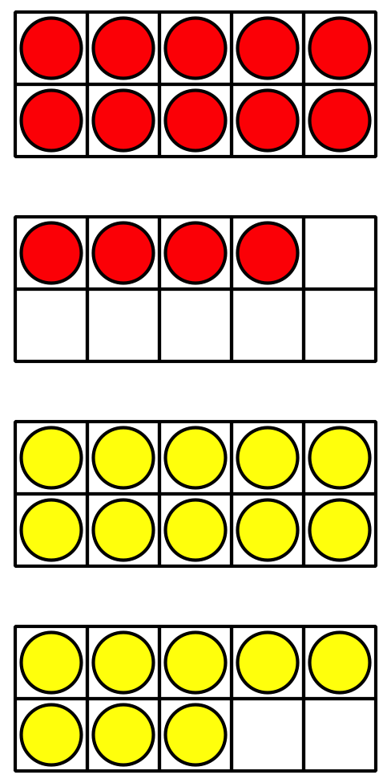

10.1: Priya‘s Work
Find the value of $37+26$.
Priya's work
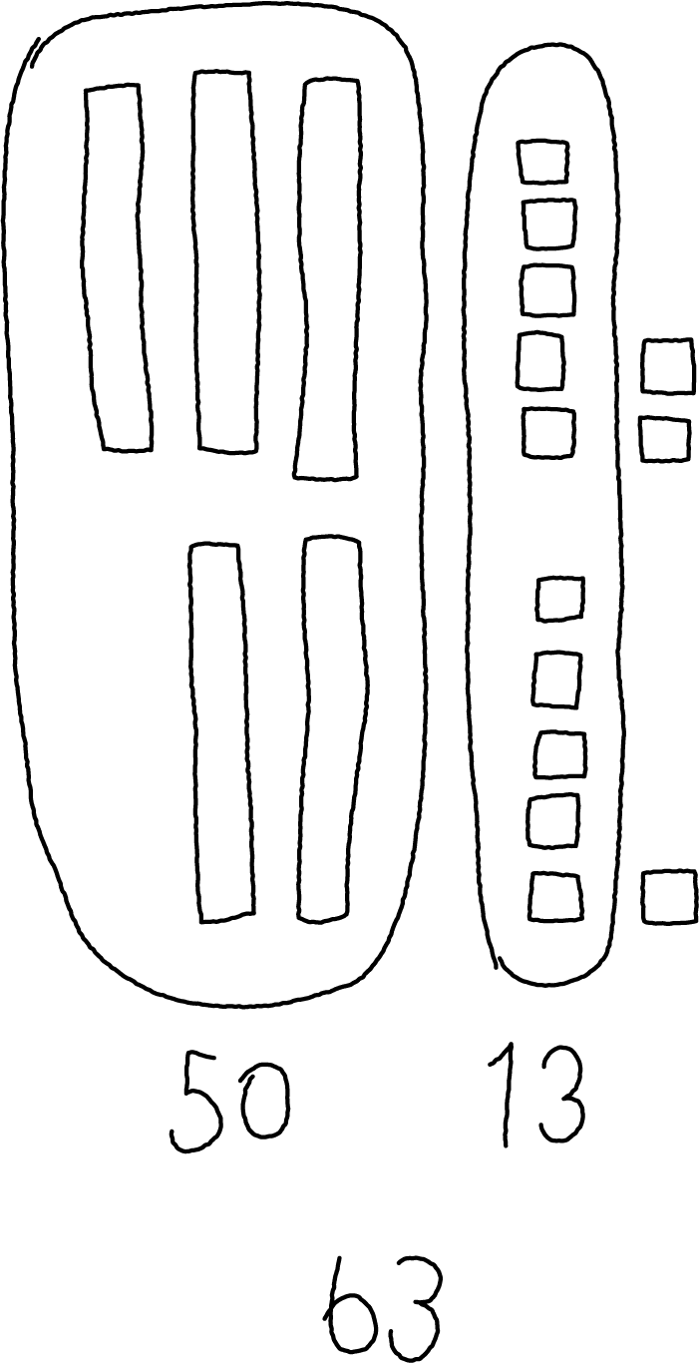
How did Priya find the value?

10.2: Finish the Work
- Each expression shows a first step to find the number that makes each equation true.
Finish the work to find the number that makes each equation true.
Show your thinking using drawings, numbers, or words.
  - 28+56=aaaiaaai
  - First step: $20+50$
  - 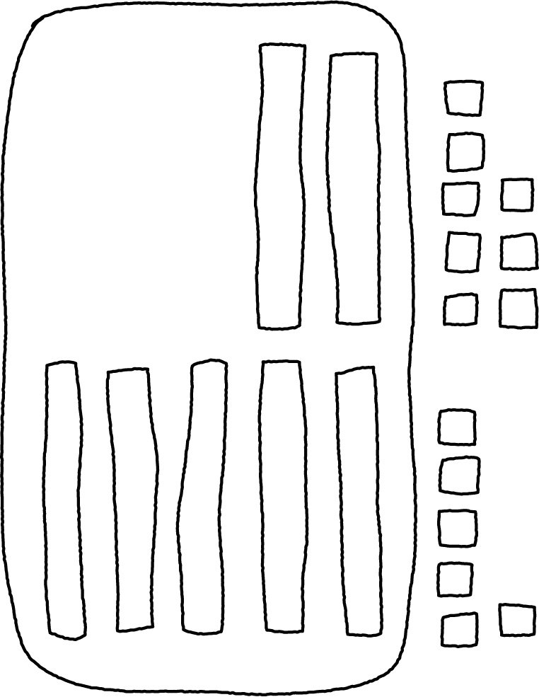
  - 27+44=aaaiaaai
  - First step: $7+4$
  - 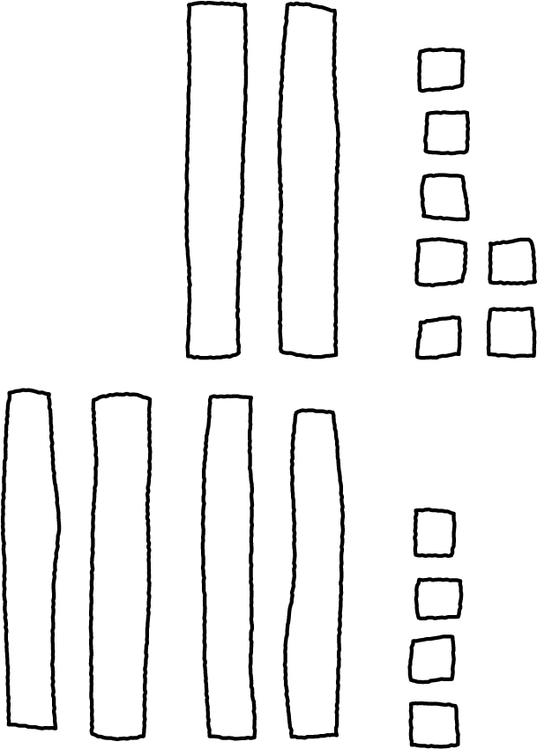
- Find the value of each sum.
Show your thinking using drawings, numbers, or words.
  - $34+57$
  - $18+55$
© CC BY 2021 Illustrative Mathematics®

