Unit 3 Lesson 18: Diagrams and Equations for Word Problems

WU Notice and Wonder: Diagrams (Warm up)

Student Task Statement
What do you notice? What do you wonder?
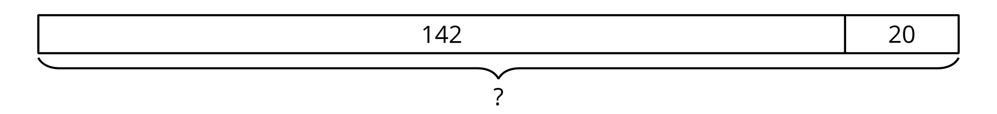
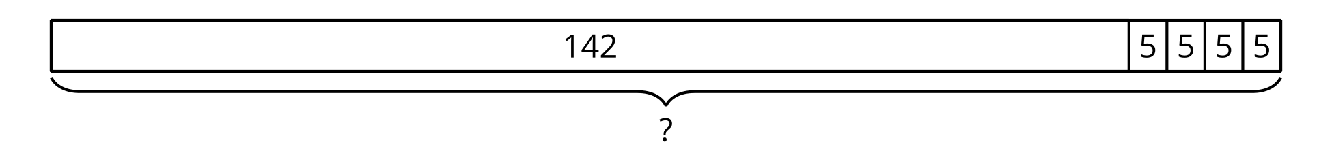

1 Card Sort: Situations, Equations, and Diagrams

Student Task Statement
Your teacher will give you a set of cards showing situations, equations, and diagrams.
Sort the cards into groups so that the cards in each group represent the same situation. Be ready to explain your reasoning.
A | Clare had 225 beads. A friend gave her a pack of 48 beads. Then she used 70 beads to make a necklace. How many beads does Clare have now?
B | 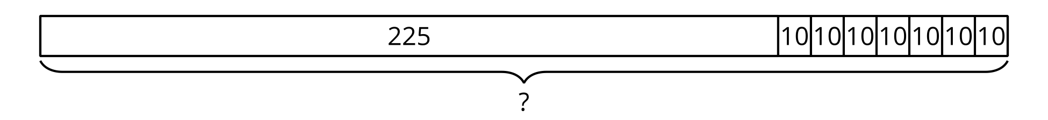
C | $225−\left(6×10\right)=?$
D | Elena has 7 notebooks. Each notebook has 10 paper clips in it. Elena also has a box of 225 paper clips. How many paper clips does Elena have?
E | $225+\left(6×10\right)=?$
F | $?=225+48−70$
G | Andre has 225 crayons. He buys 6 more packs and each pack has 10 crayons. How many crayons does Andre have now?
H | 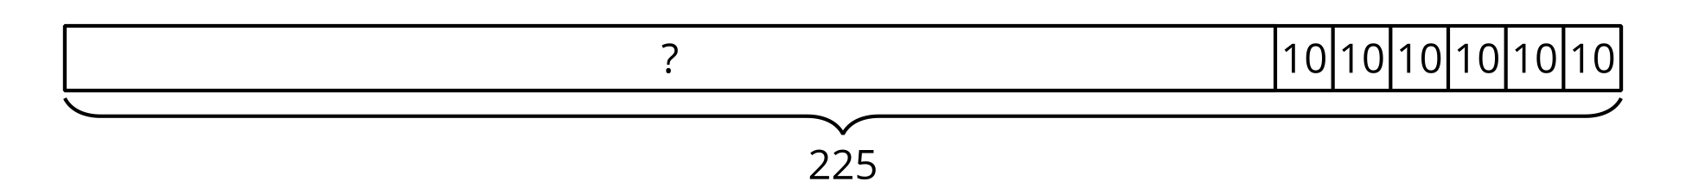
I | Diego has a collection of 225 baseball cards. He gets 35 more cards from a friend, then buys 72 cards. How many cards does Diego have now?
J | Han has 225 beads. Then he makes 6 bracelets for his friends. Each bracelet has 10 beads. How many beads does Han have now?
K | 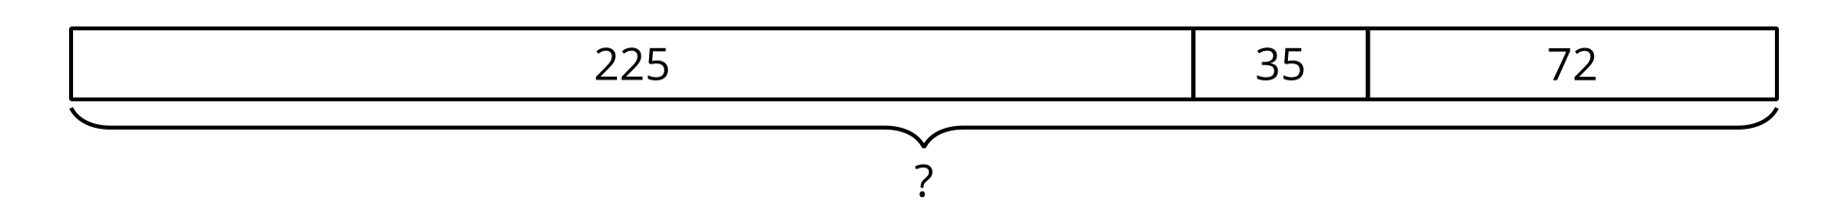
L | $?=\left(7×10\right)+225$

2 Makes Sense to Me: A Gallery Walk

Student Task Statement
- Your teacher will assign a problem to your group. Work together to solve your assigned problem.
- Create a poster of your group’s solution. Organize your work so that it can be followed by others.
- As you visit other groups' posters, consider how each answer makes sense.
- Choose one poster and make a comment on the solution. Write on your sticky note how you know the answer makes sense.

Images for Activity Synthesis
© CC BY 2021 Illustrative Mathematics®

