Lesson 17: Make 10 to Add
- Let’s look for patterns and think about making 10 as we add.

Warm-up: How Many Do You See: Double 10-frames
How many do you see?
How do you see them?
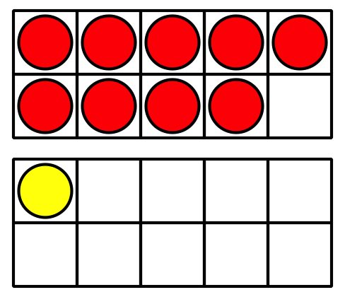
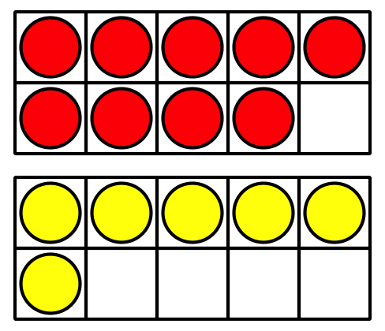
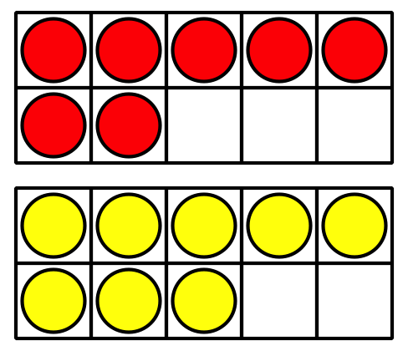

17.1: The 9 Plus Game
- Put out 9 counters.
- Pick a number card and add that many counters.
- Write an equation to represent the counters.
Can you write more than one?
Equations:
Round 1: ________________________________
Round 2: ________________________________
Round 3: ________________________________
Round 4: ________________________________
Round 5: ________________________________

17.2: Clare’s Birds
- Clare draws some birds.
She draws 3 birds in a nest and 9 birds flying.
How many birds did she draw?
Show your thinking using drawings, numbers, or words.
- Equation: ________________________________
- Clare draws birds that like warm weather.
She draws 6 toucans and 8 parrots.
How many birds did she draw?
Show your thinking using drawings, numbers, or words.
- Equation: ________________________________
- Clare draws birds that like cold weather.
She draws 7 penguins and 5 owls.
How many birds did she draw?
Show your thinking using drawings, numbers, or words.
- Equation: ________________________________
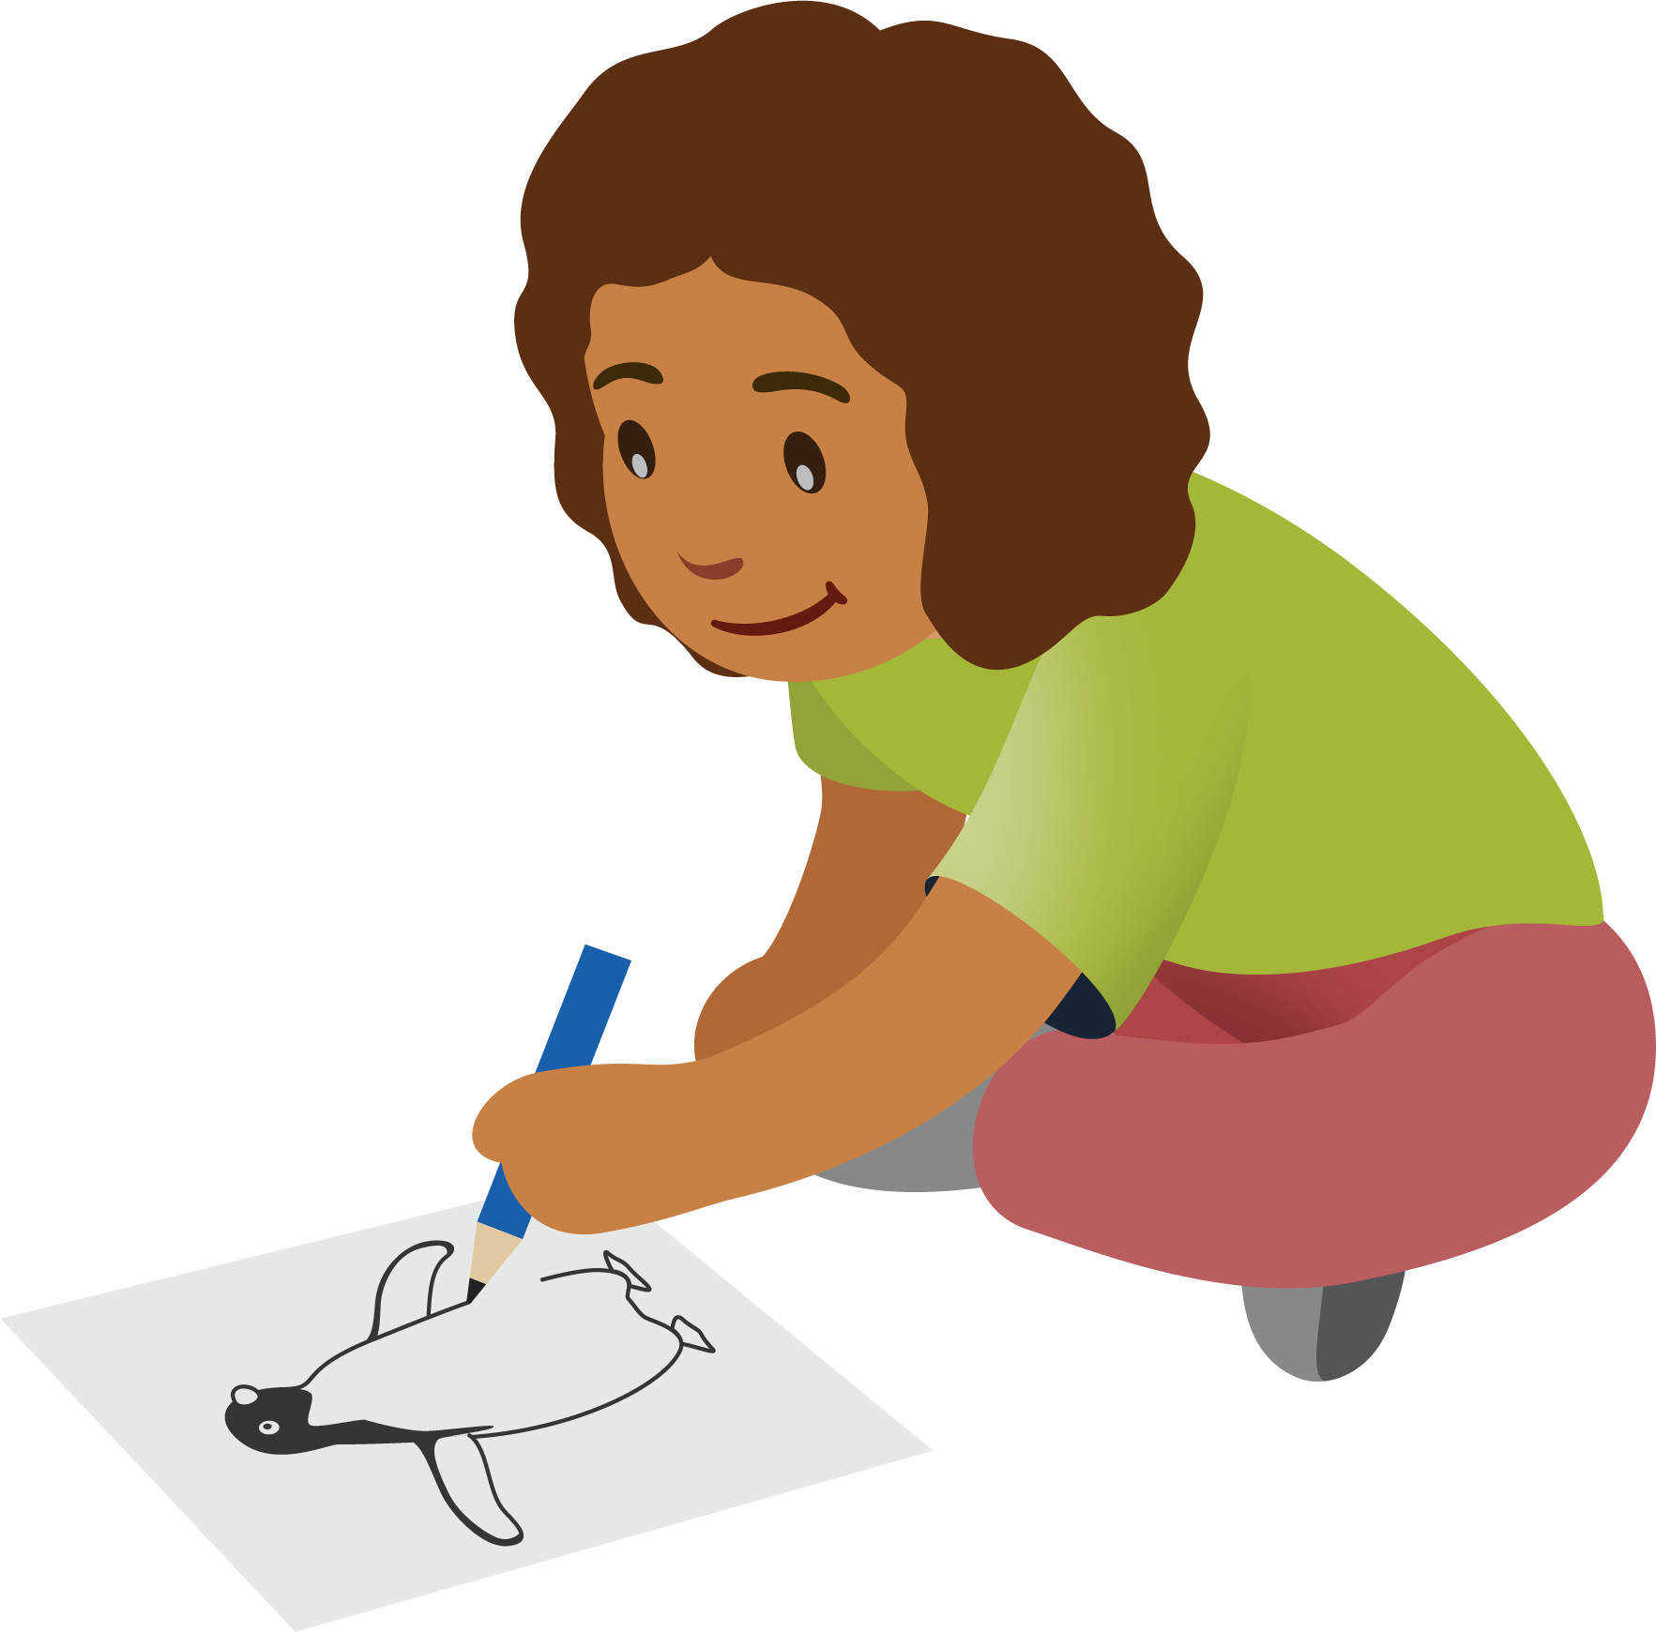
© CC BY 2021 Illustrative Mathematics®

