Unit 6 Lesson 1: Compare Lengths

WU Notice and Wonder: Pencils (Warm up)

Student Task Statement
What do you notice?
What do you wonder?
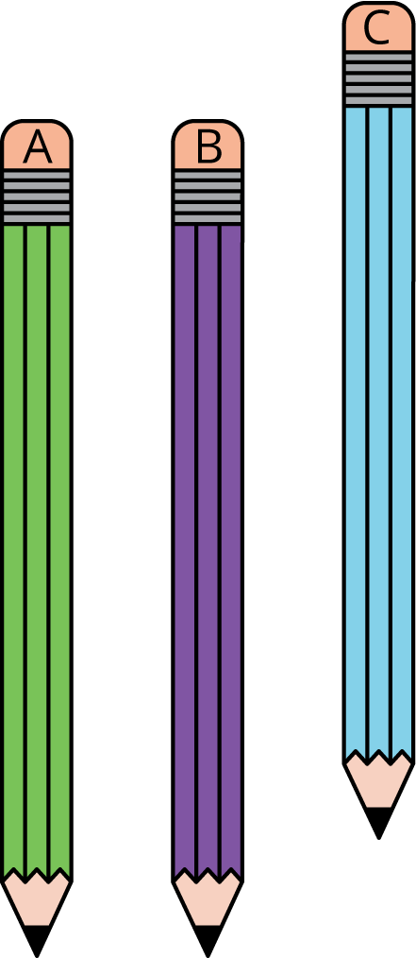

1 Is it Longer or Shorter?

Student Task Statement
Share your thinking with your partner.
- Choose 2 objects and compare their lengths.
- Choose 2 different objects and compare their lengths.
Write down your answers.
- Choose an object that you could write with and find the tower of 3 connecting cubes.
- Which is longer?
- Draw the 2 objects to show which is longer.
- Choose a different object and find the tower of 8 connecting cubes.
- Which is shorter?
- Draw the 2 objects to show which is shorter.
- Find an object from the collection that is shorter than your foot.
- Fill in the blank.
- The ________________________________ is shorter than my foot.
- Find an object from the collection that is longer than your pointer finger.
- Fill in the blank.
- The ________________________________ is longer than my pointer finger.

2 Order Objects

Student Task Statement
- Pick 3 objects.
- With your partner, put the objects in order from shortest to longest.
- Trace or draw your objects.
- Pick 3 new objects.
- With your partner, put them in order from longest to shortest.
- Write the names of the objects in order from longest to shortest.

3 Centers: Choice Time

Student Task Statement
Choose a center.
Target Numbers
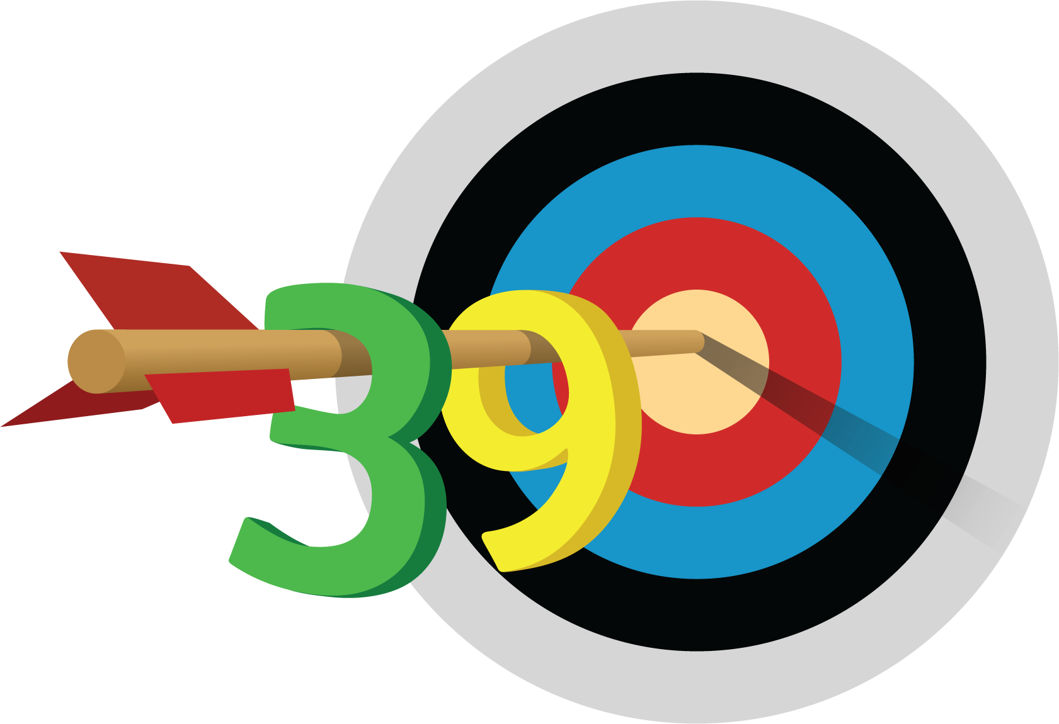
Five in a Row
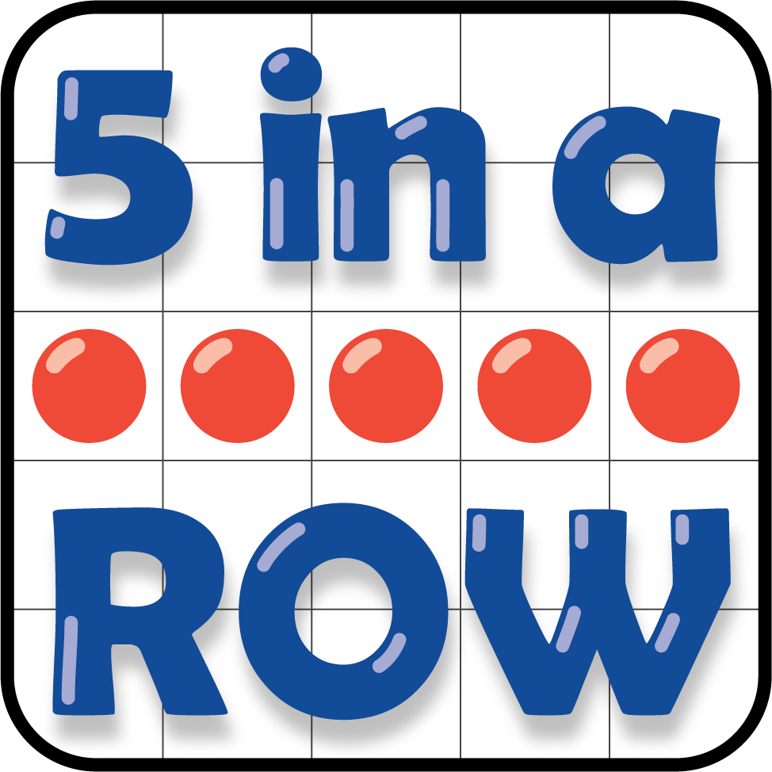
Get Your Numbers in Order
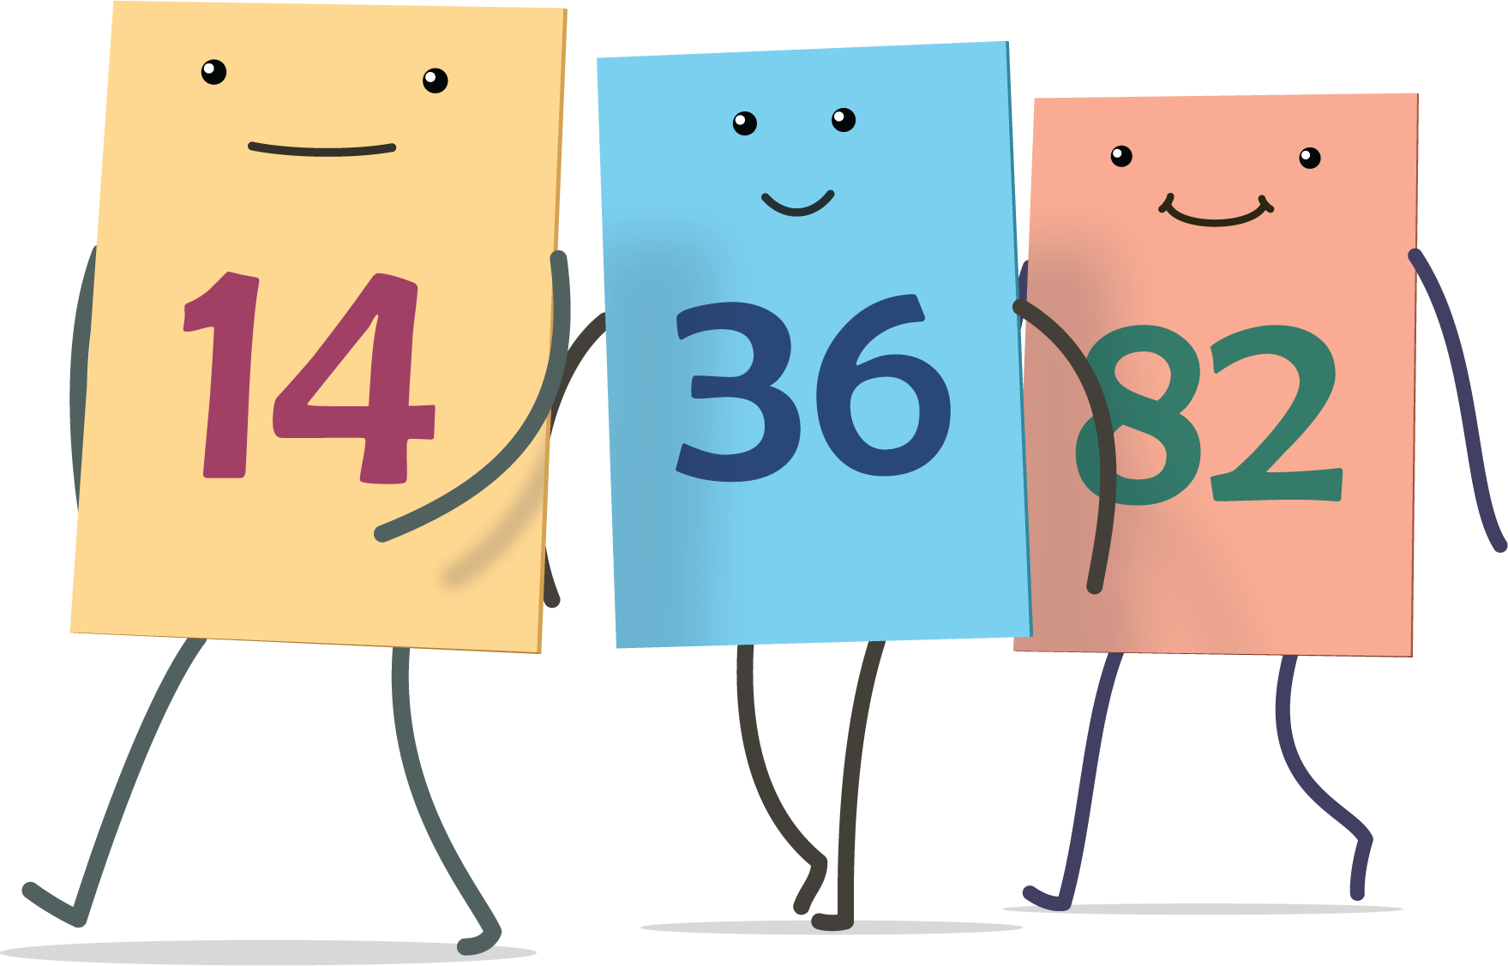
© CC BY 2021 Illustrative Mathematics®

