Lesson 2: Human Dot plot
- Let’s recall how to create dot plots.

2.1: Notice and Wonder: Flipping Coins
200 students flip a coin 100 times and record the number of heads that are flipped.
What do you notice? What do you wonder?
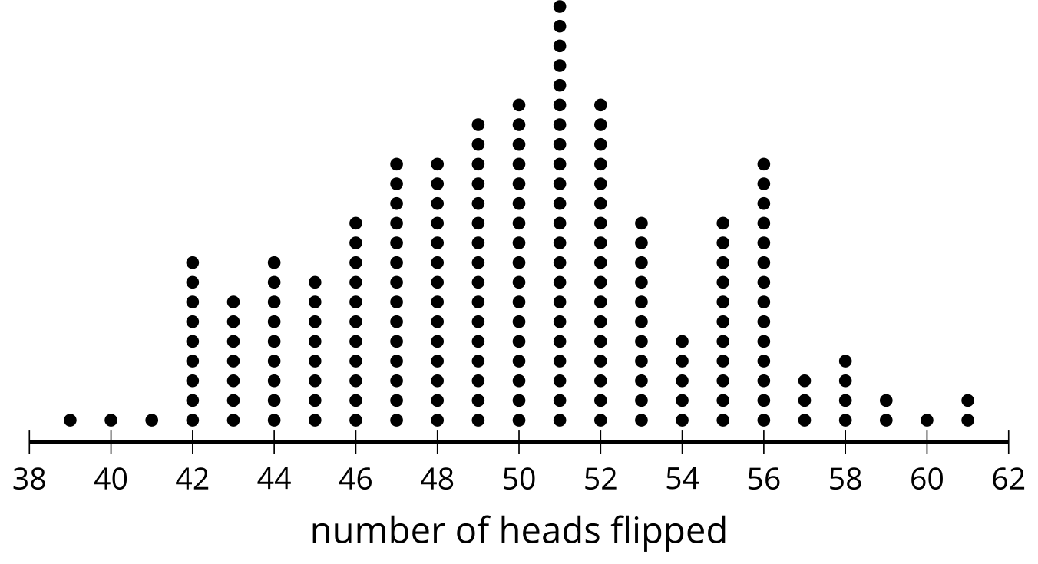
number of heads flipped | frequency
39 | 1
40 | 1
41 | 1
42 | 9
43 | 7
44 | 9
45 | 8
46 | 11

number of heads flipped | frequency
47 | 14
48 | 14
49 | 16
50 | 17
51 | 22
52 | 17
53 | 11
54 | 5

number of heads flipped | frequency
55 | 11
56 | 14
57 | 3
58 | 4
59 | 2
60 | 1
61 | 2

2.2: Human Dot Plot
- Follow your teacher’s directions to create a human dot plot.
- Create a dot plot that represents the same data as the human dot plot.

2.3: Constructing a Dot Plot
Using the class data, construct a dot plot.
Use your dot plot to answer the following questions:
- What is the largest value in the data set? The smallest? What do these numbers represent?
- What is a typical amount of sleep for a student in your class?
- It is recommended that teenagers get 8–10 hours of sleep each night to perform at their best the following day. Based on the data, how well do you think your class would perform on a test? Explain your reasoning.
- What would the dot plot look like for a class that has the same number of students, but those students tend to get less sleep than students in your class?
© CC BY 2019 by Illustrative Mathematics®

