Lesson 18: Compare Without Multiplying

Standards Alignments
Addressing | 5.NF.B.5.a

Teacher-facing Learning Goals
- Recognize that the product of a fraction and a whole number is less than, equal to, or greater than the whole number when the fraction is correspondingly less than, equal to, or greater than 1.

Student-facing Learning Goals
- Let’s compare expressions, without evaluating them.

Lesson Purpose
The purpose of this lesson is for students to compare the size of a product to the size of one factor on the basis of the size of the other factor.
In this lesson, students continue to compare the size of a product to the size of one of the factors based on the size of the other factor. They also continue to represent these comparisons on the number line. In this lesson there is no longer a context and students interpret the number line diagram in situations where both factors are fractions. Just as they observed in previous lessons, the size of a number becomes greater when multiplied by a fraction greater than 1 and smaller when multiplied by a fraction less than 1. In the next lesson, students will work toward giving a general explanation for these patterns.

Access for:

Students with Disabilities
- Representation (Activity 1)

English Learners
- MLR7 (Activity 2)

Instructional Routines
Notice and Wonder (Warm-up)

Lesson Timeline
Warm-up | 10 min
Activity 1 | 15 min
Activity 2 | 20 min
Lesson Synthesis | 10 min
Cool-down | 5 min

Teacher Reflection Question
It is important that students convince themselves that mathematics makes sense. Today, students were noticing patterns and determining whether or not the patterns were generalizable. In what ways did each of your students convince themselves that mathematics makes sense?

Cool-down
(to be completed at the end of the lesson) 5min
Comparison Statements

Standards Alignments
Addressing | 5.NF.B.5.a

Student-facing Task Statement
- The number N is shown on the number line.
- 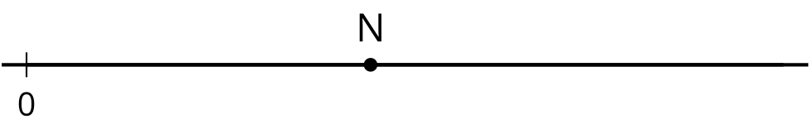
  - Locate and label $\frac{4}{3}×\text{N}$ on the number line.
  - Is $\frac{4}{3}×\text{N}$ less than, equal to, or greater than N? Explain how you know.

Student Responses
Sample responses:

  - 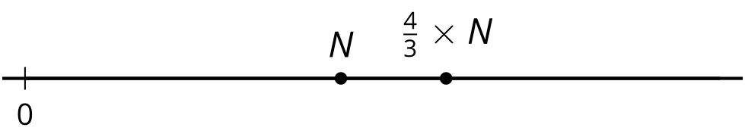
  - $\frac{4}{3}×\text{N}>\text{N}$ because it is to the right on the number line. It is N and then an extra $\frac{1}{3}$ of N.

