Lesson 18: Patterns in Addition
- Let’s look for and use patterns to help us add within 20.

Warm-up: How Many Do You See: More Double 10-frames
How many do you see?
How do you see them?
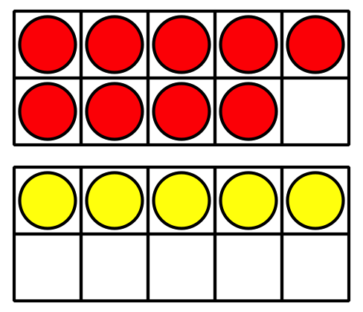
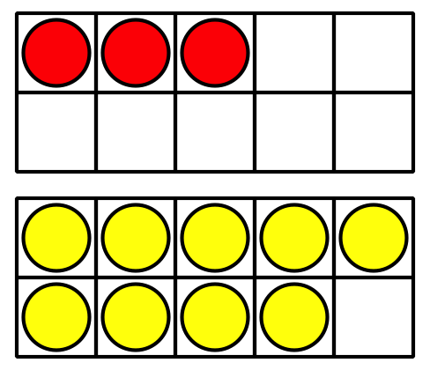
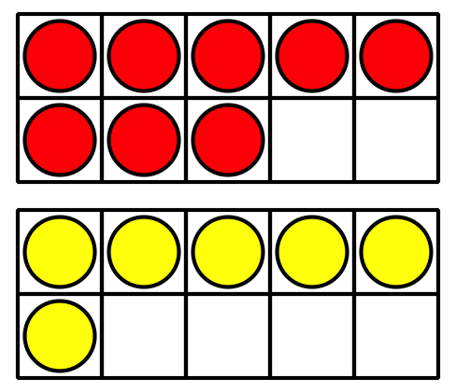

18.1: Expression Match
- Take out all the expression cards that have the number 10.
- Mix up the rest of the cards.
- Pick a card.
- Place the card under the expression with 10 that it is equal to.
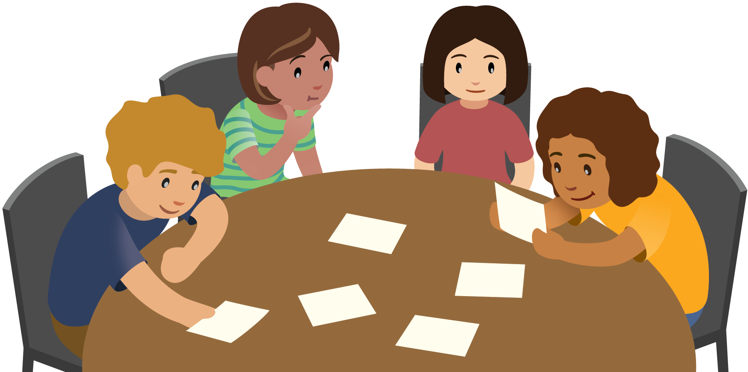

18.3: Centers: Choice Time
Choose a center.
Shake and Spill
Compare
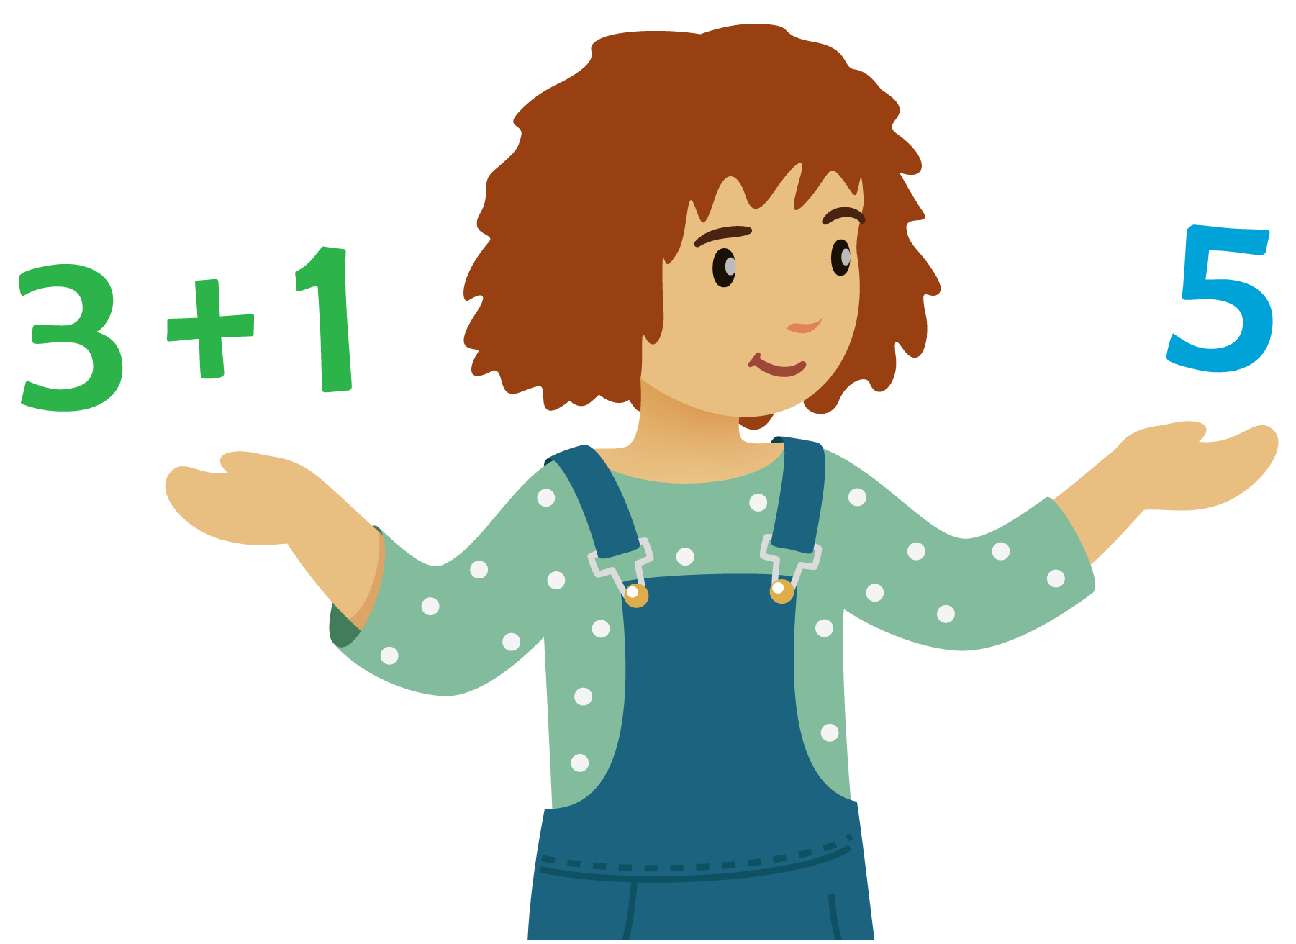
Number Puzzles
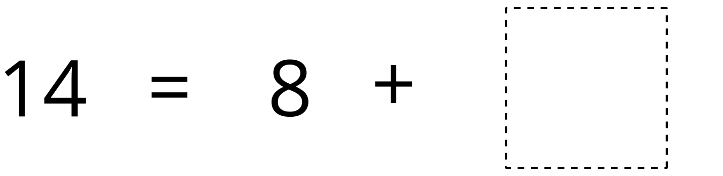
© CC BY 2021 Illustrative Mathematics®

