Unit 6 Lesson 2: Compare the Length of Objects Indirectly

WU Number Talk: Add within 100 (Warm up)

Student Task Statement
Find the value of each expression mentally.
- $35+20$
- $35+25$
- $30+45$
- $37+45$

1 Which is Longer? Which is Shorter?

Student Task Statement
Find 2 objects that are longer and 2 objects that are shorter than the unsharpened pencil.
Write a sentence that compares each object to the pencil.
Example: The bulletin board is longer than the pencil.

2 Measure Your Desk

Student Task Statement
Compare the length of the side of your desk and the length of one of the legs of your desk using the string.
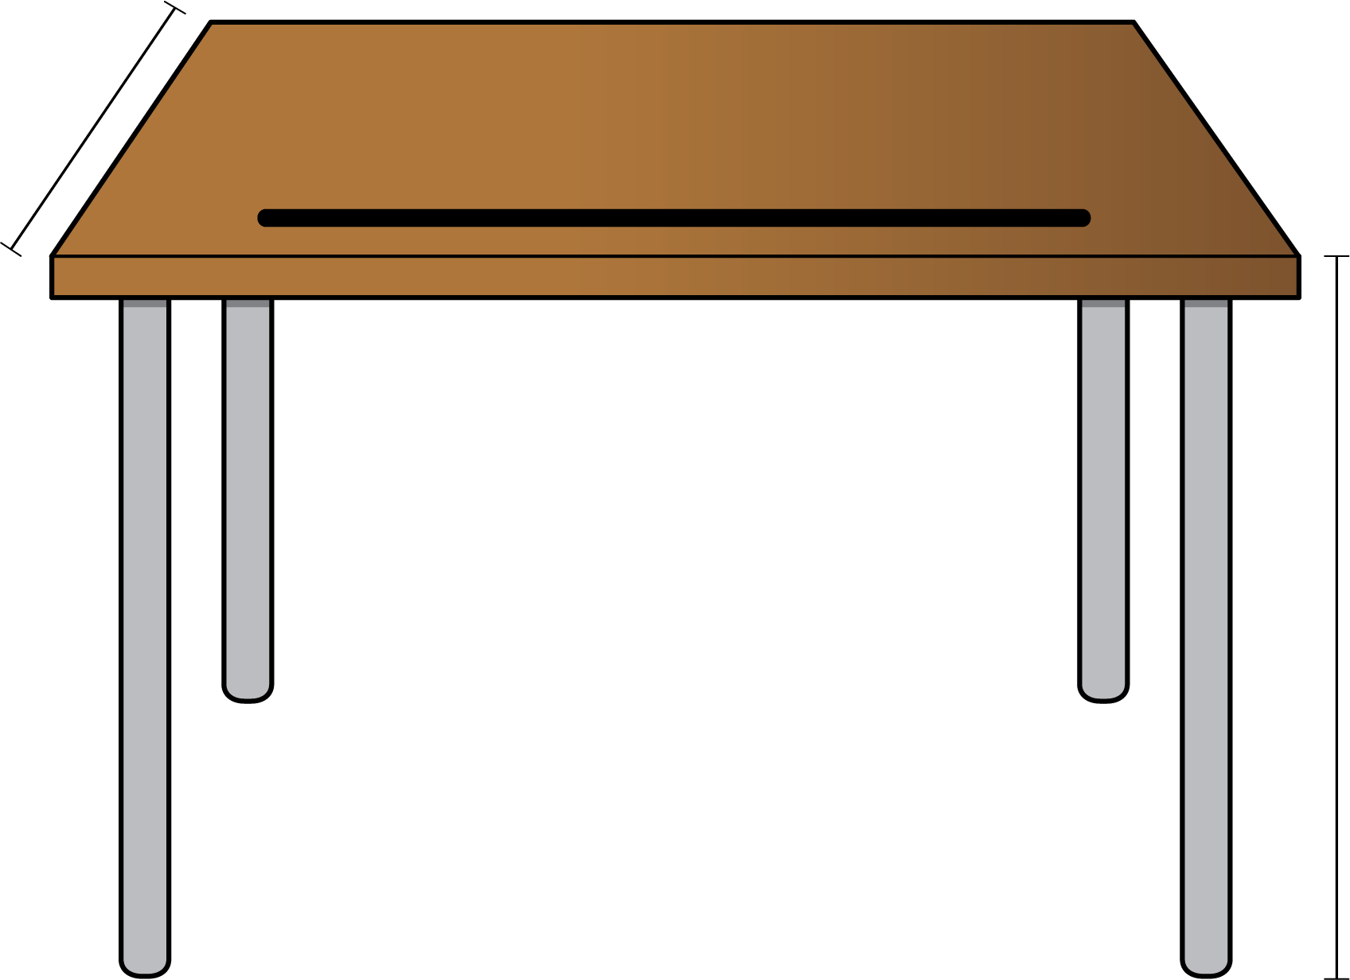
Use a drawing or words to explain how you know which is longer.
© CC BY 2021 Illustrative Mathematics®

