Unit 2 Lesson 5: Creating Scale Drawings

1 Number Talk: Which is Greater? (Warm up)

Student Task Statement
Without calculating, decide which quotient is larger.
$11÷23$ or $7÷13$
$0.63÷2$ or $0.55÷3$
$15÷\frac{1}{3}$ or $15÷\frac{1}{4}$

2 Bedroom Floor Plan

Student Task Statement
Here is a rough sketch of Noah’s bedroom (not a scale drawing).
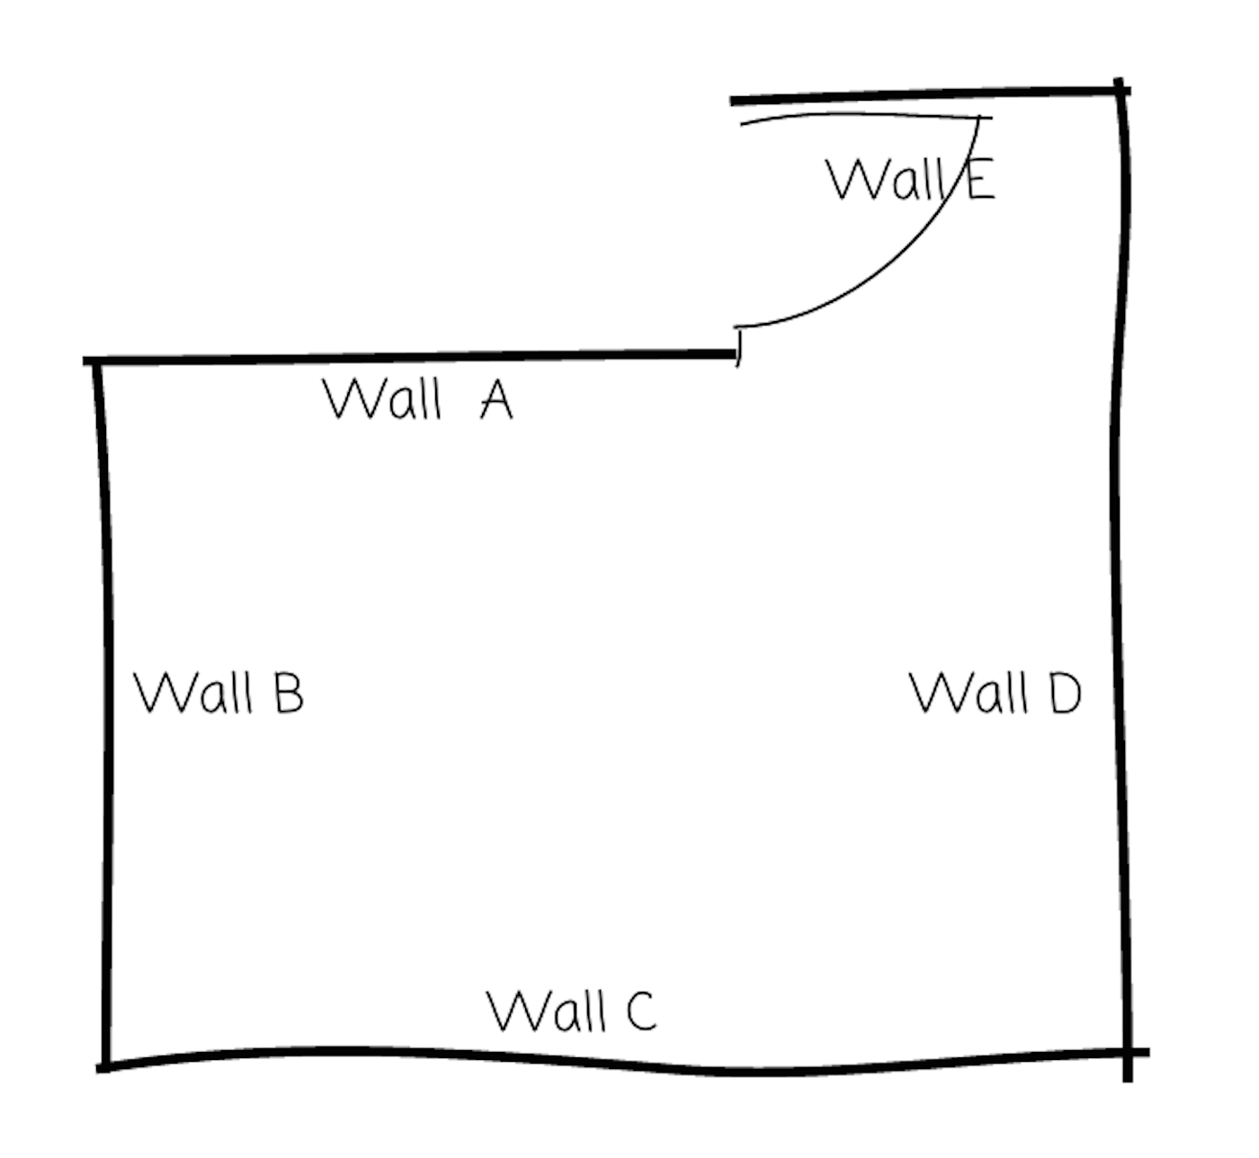
Noah wants to create a floor plan that is a scale drawing.
- The actual length of Wall C is 4 m. To represent Wall C, Noah draws a segment 16 cm long. What scale is he using? Explain or show your reasoning.
- Find another way to express the scale.
- Discuss your thinking with your partner. How do your scales compare?
- The actual lengths of Wall A and Wall D are 2.5 m and 3.75 m. Determine how long these walls will be on Noah’s scale floor plan. Explain or show your reasoning.

3 Two Maps of Utah

Images for Launch
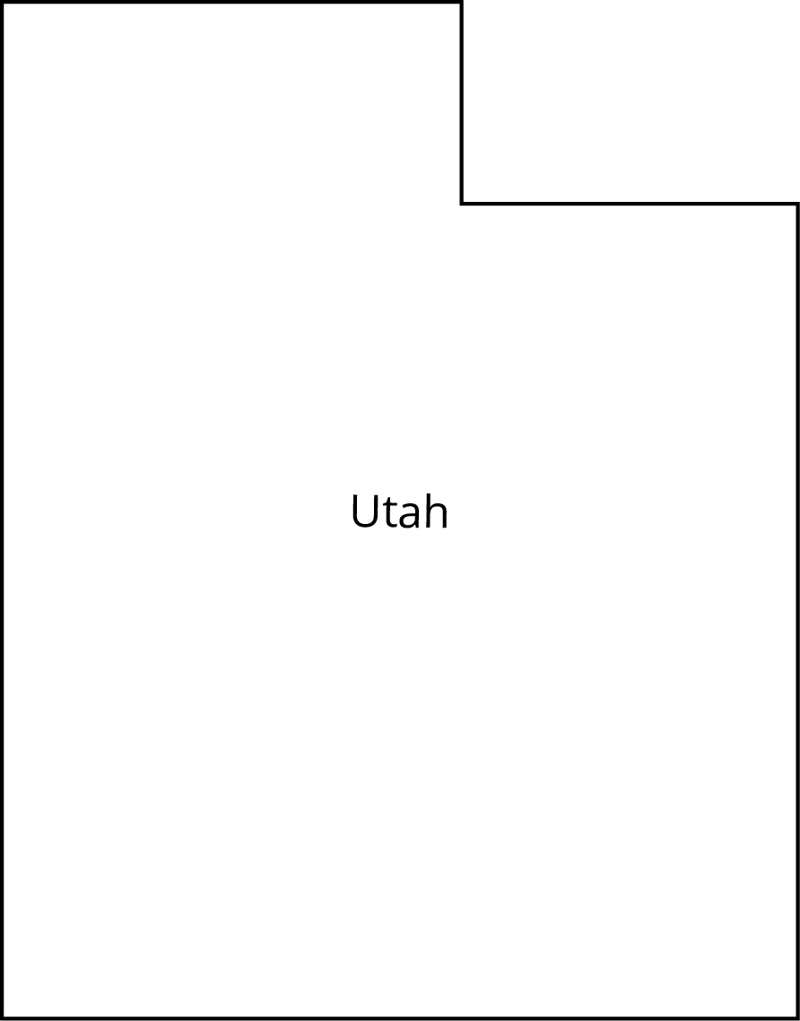

Student Task Statement
A rectangle around Utah is about 270 miles wide and about 350 miles tall. The upper right corner that is missing is about 110 miles wide and about 70 miles tall.
- Make a scale drawing of Utah where 1 centimeter represents 50 miles.
- Make a scale drawing of Utah where 1 centimeter represents 75 miles.
- How do the two drawings compare? How does the choice of scale influence the drawing?
© CC BY Open Up Resources. Adaptations CC BY IM.

