Unit 3 Lesson 1: What We Know About Shapes

WU Which One Doesn’t Belong: Teddy Bears (Warm up)

Student Task Statement
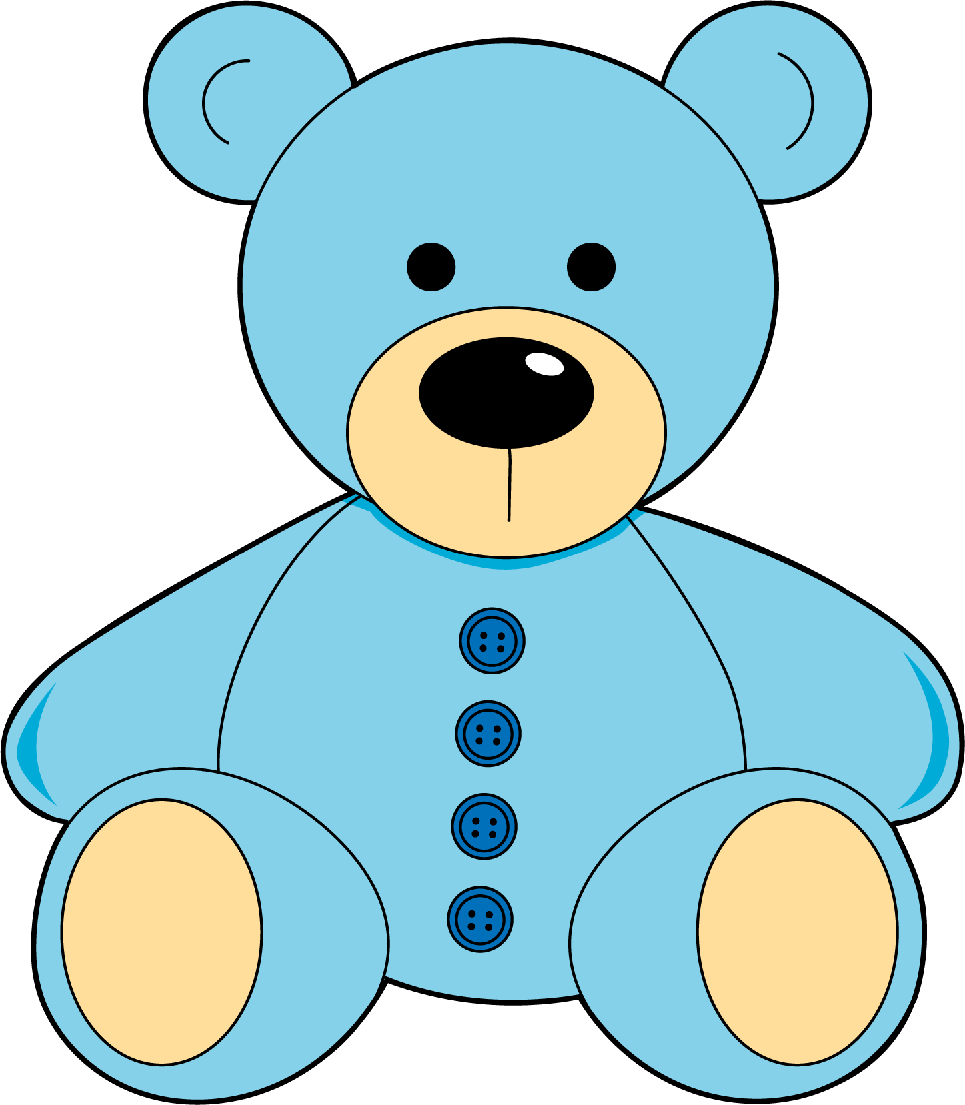
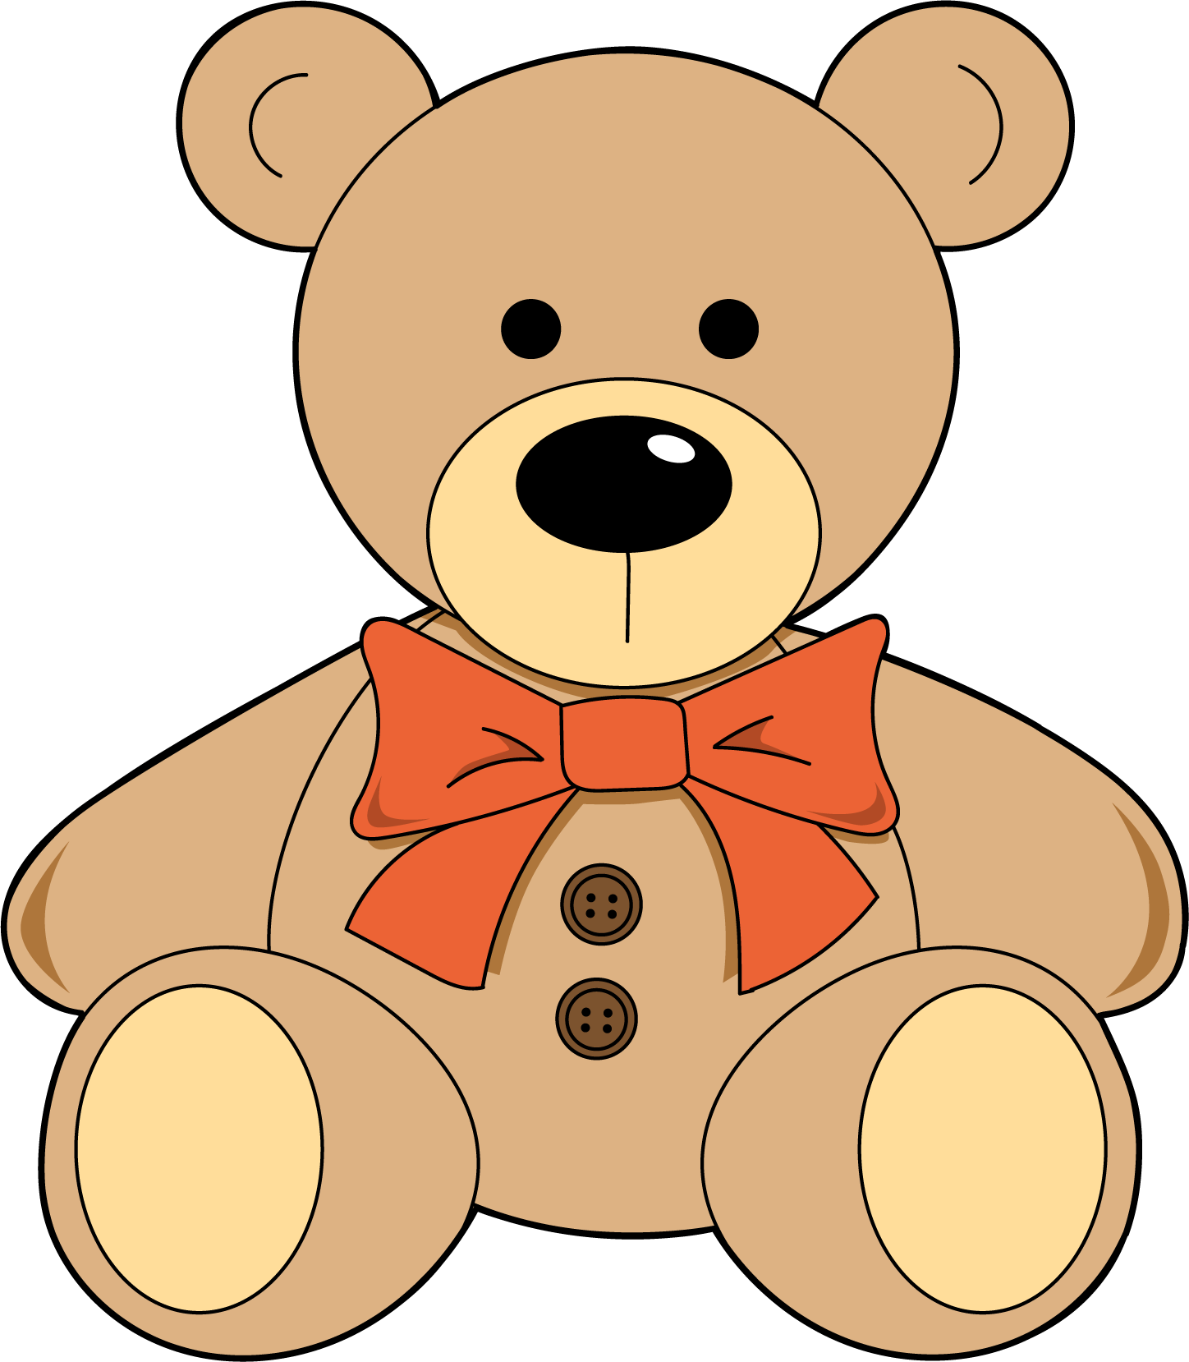
Which one doesn’t belong?
A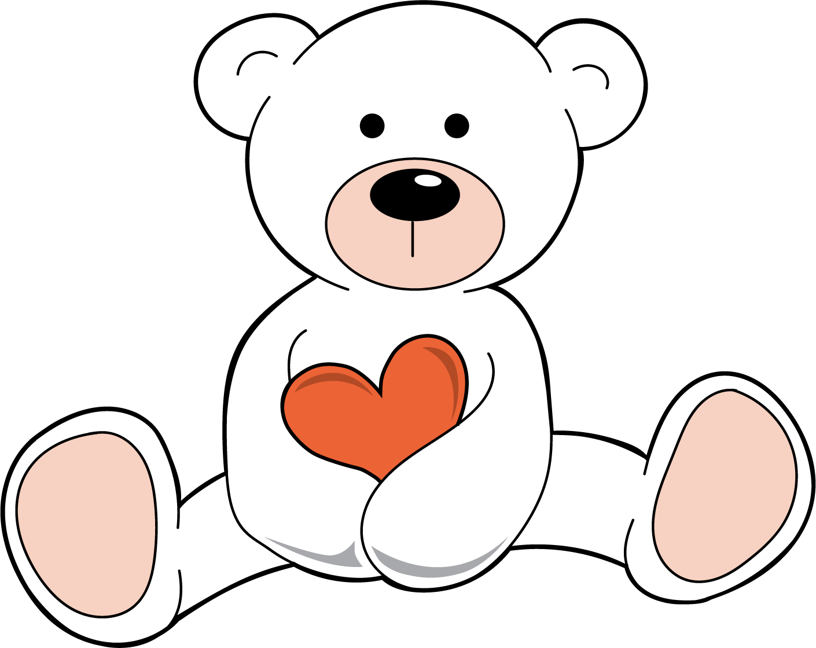
B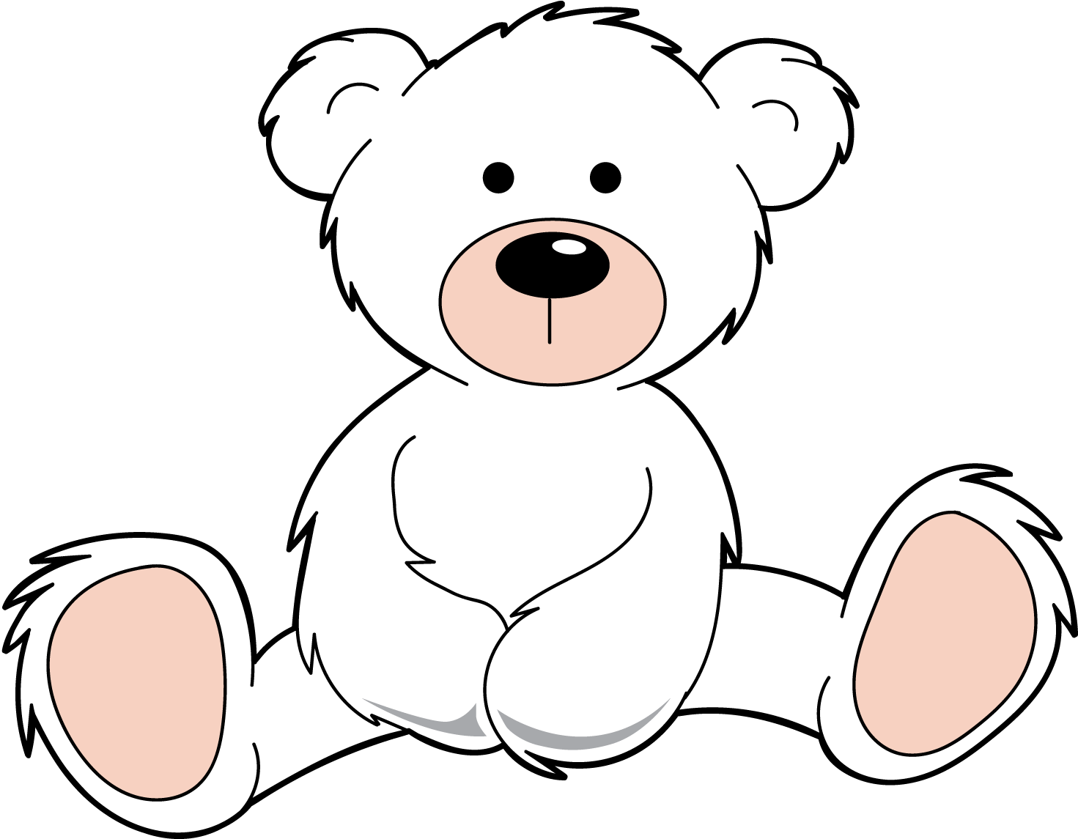
C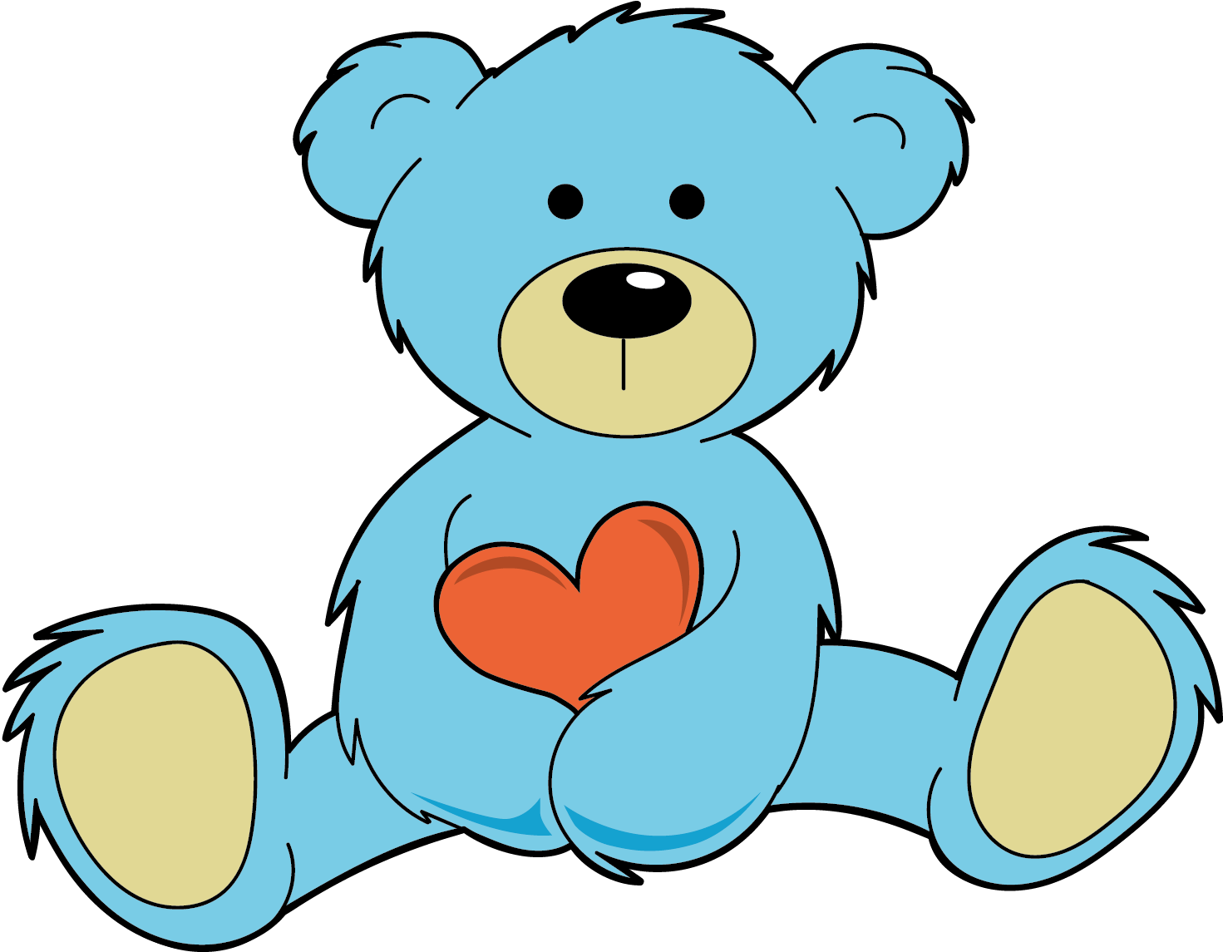

1 Introduce Picture Books, Find Shapes in Books

Student Task Statement

2 Shapes in a Picture

Student Task Statement
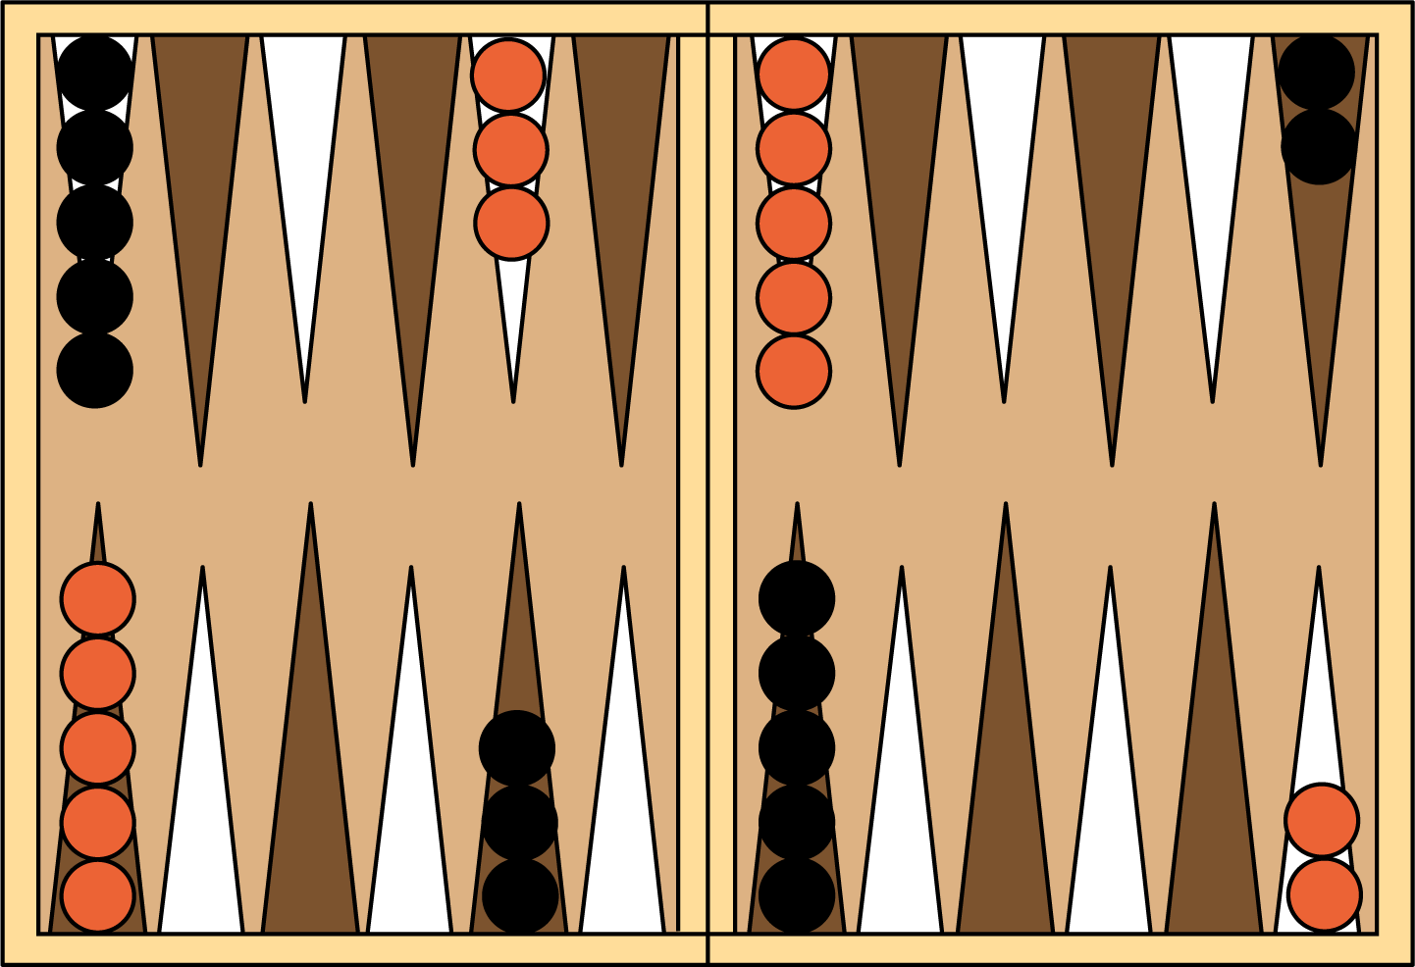

3 Centers: Choice Time

Student Task Statement
Choose a center.
Picture Books
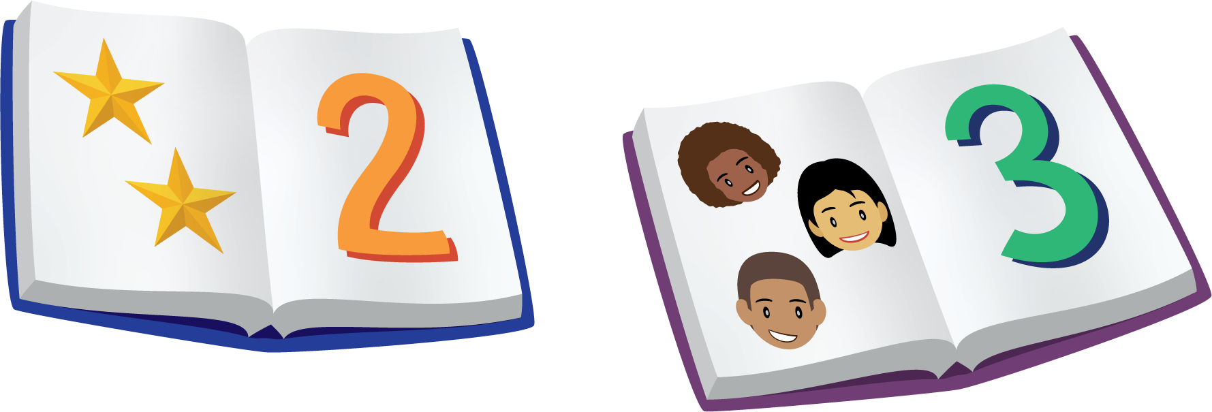
Bingo
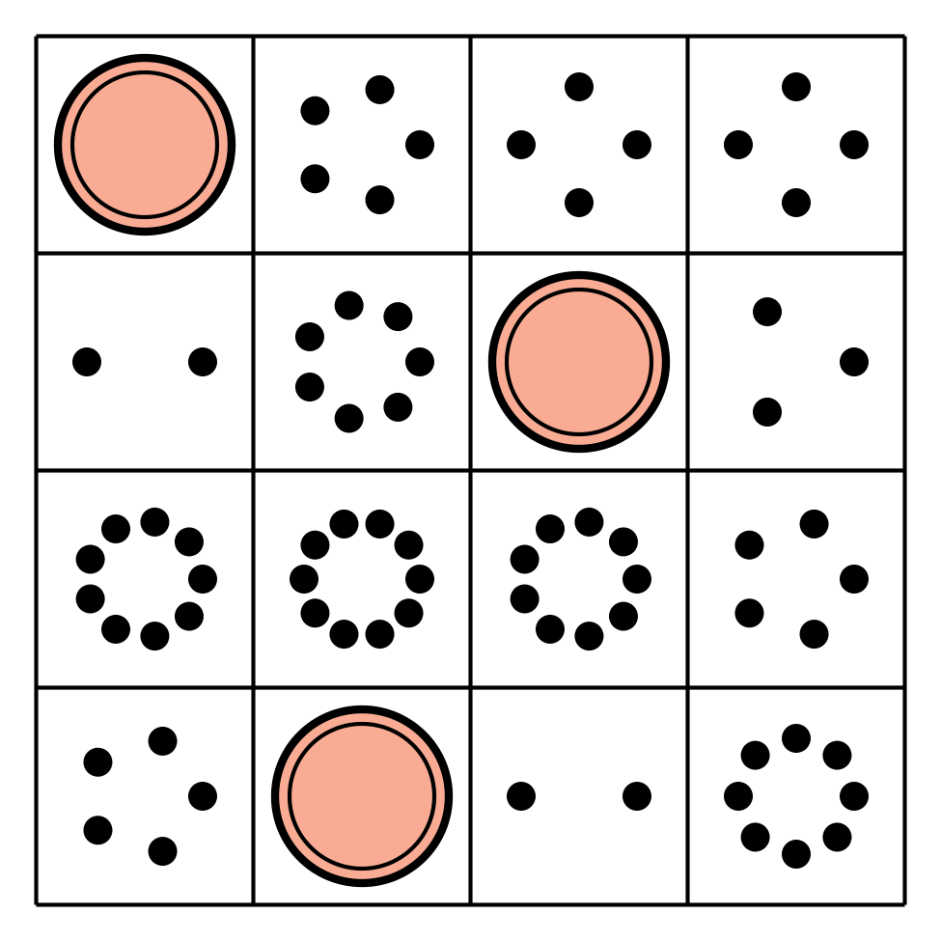
Shake and Spill
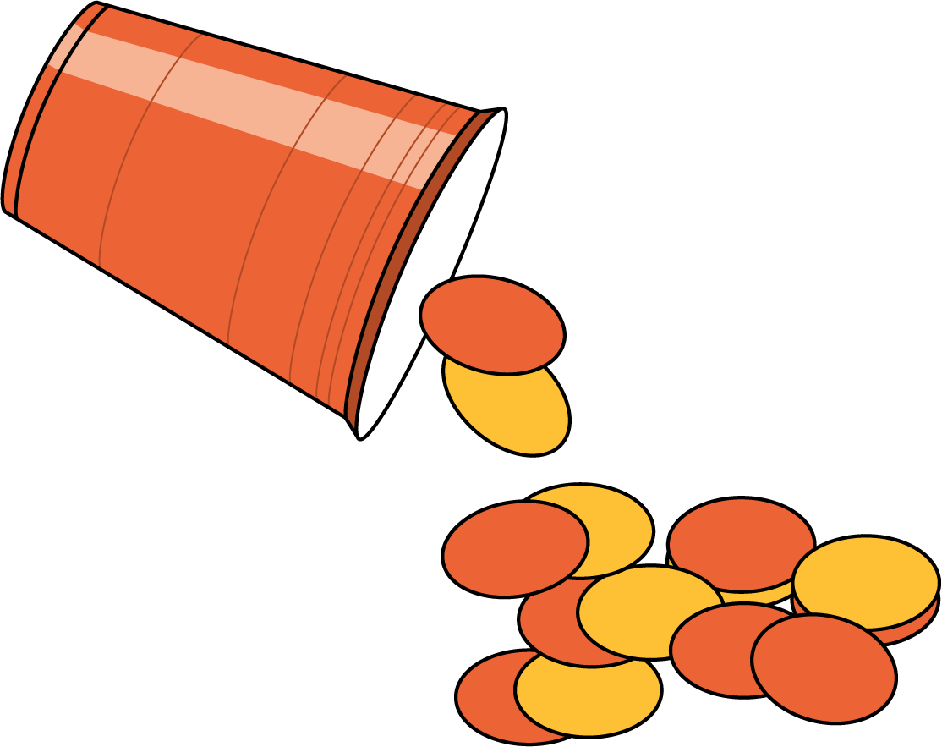

Images for Activity Synthesis
© CC BY 2021 Illustrative Mathematics®

