Unit 2 Lesson 22: Situations with Constraints

1 Graph Features of Inequalities (Warm up)

Student Task Statement
For each inequality:
- What is the $x$-intercept of the graph of its boundary line?
- What is the $y$-intercept of the graph of its boundary line?
- Plot both intercepts, and then use a ruler to graph the boundary of the inequality.
$2y≥4x−8$
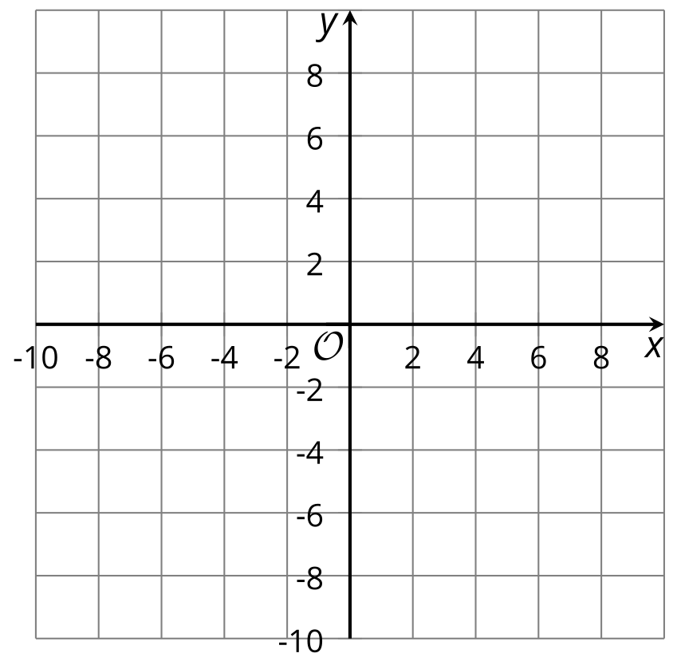
$2x+3y<12$

2 Fruits and Running

Student Task Statement
Write an equation that helps to answer the question about the situation. Then draw a graph that represents the equation.
- Jada goes to an orchard to pick plums and apricots to make jam. She picks 20 pounds of fruit altogether. If she picks $a$ pounds of apricots, how many pounds of plums does she pick?
- 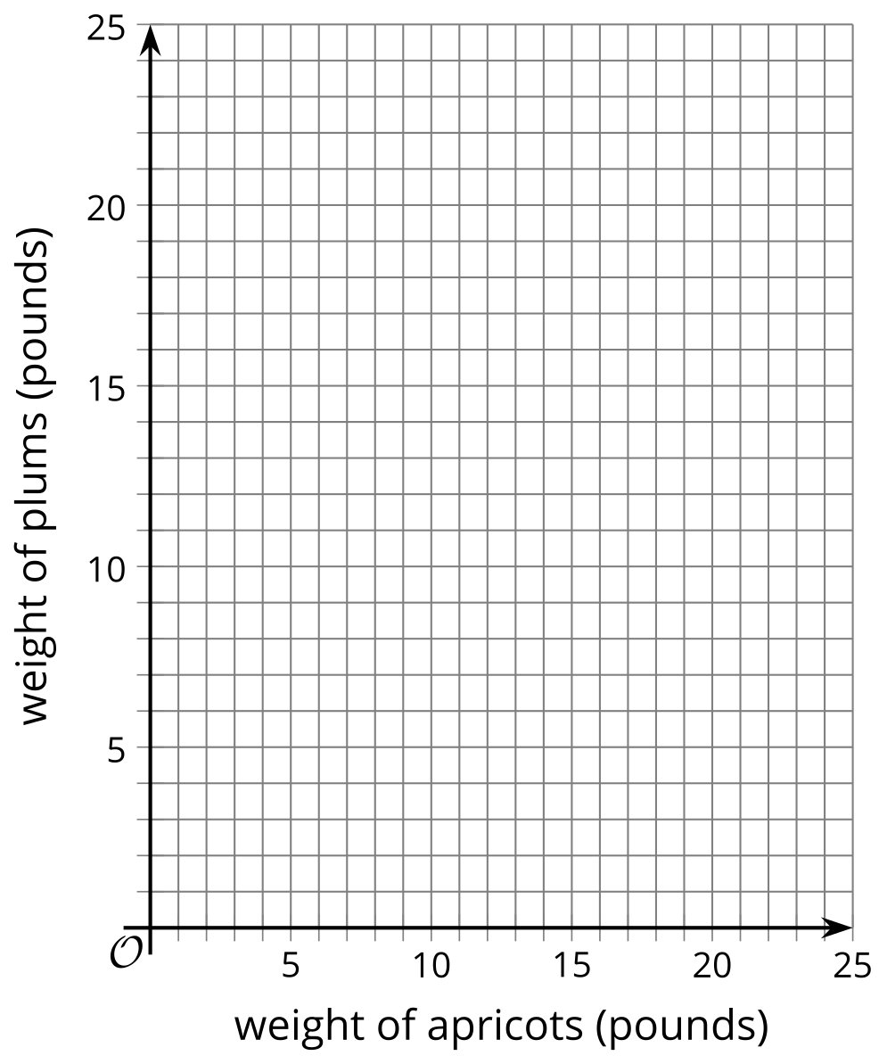
  - Consider the point $\left(5,16\right)$. Is it possible for the weight of the fruit to be represented by that point in this situation? Explain your reasoning.
- In a video game, a character can run at a top speed of 30 miles per hour, but each additional pound that the character carries lowers the maximum running speed by 1 mile per hour. What is the maximum running speed of the character when they are carrying $w$ pounds?
- 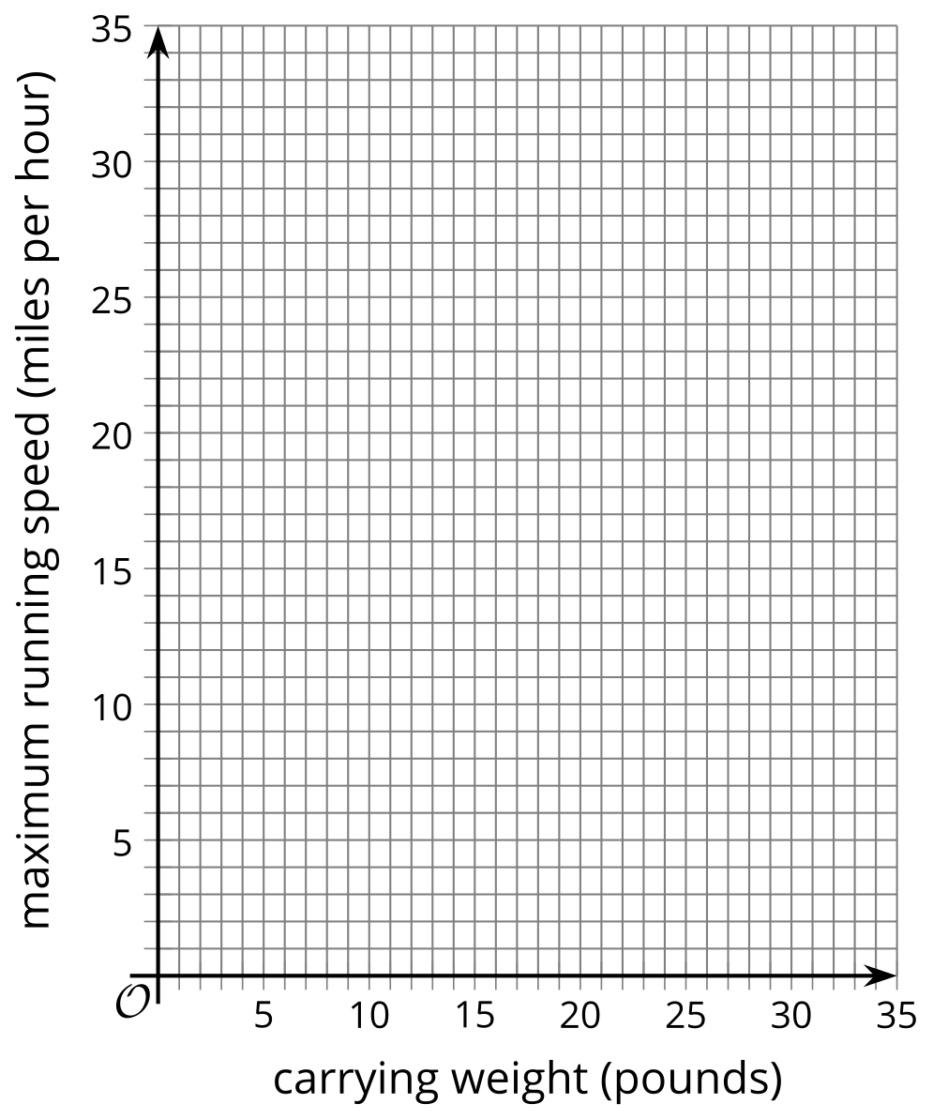
  - Consider the point $\left(10,15\right)$. Is it possible for a character in this game to be represented by that point in this situation? Explain your reasoning.

3 Matching Graphs and Inequalities

Student Task Statement
- Take turns with your partner to match graphs, inequalities, and constraints.
  - For each match that you find, explain to your partner how you know it’s a match.
  - For each match that your partner finds, listen carefully to their explanation. If you disagree, discuss your thinking and work to reach an agreement.
© CC BY 2019 by Illustrative Mathematics®

