Lesson 2 Practice Problems
- Which of the following is true?
- 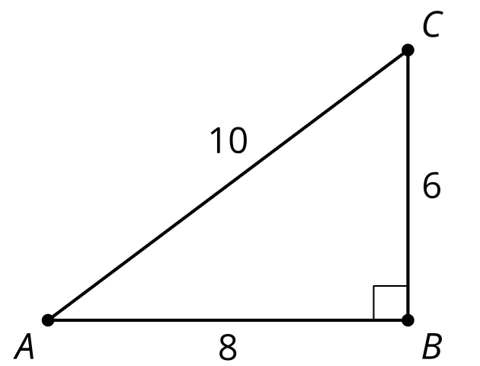
  - $sin\left(A\right)=\frac{6}{10}$
  - $cos\left(A\right)=\frac{6}{10}$
  - $sin\left(C\right)=\frac{6}{10}$
  - $cos\left(C\right)=\frac{8}{10}$
- Here is triangle ABC:
  - Express the length of segment $AB$ using sine or cosine.
  - Express the length of segment $BC$ using sine or cosine.
- 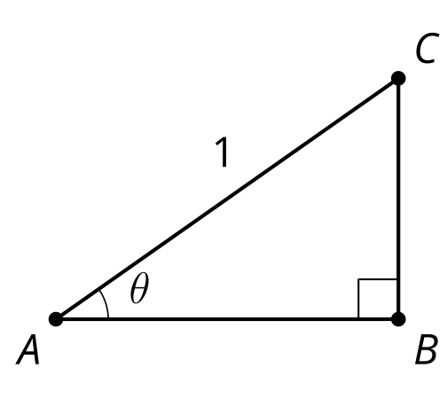
- Triangle DEF is similar to triangle ABC.
- 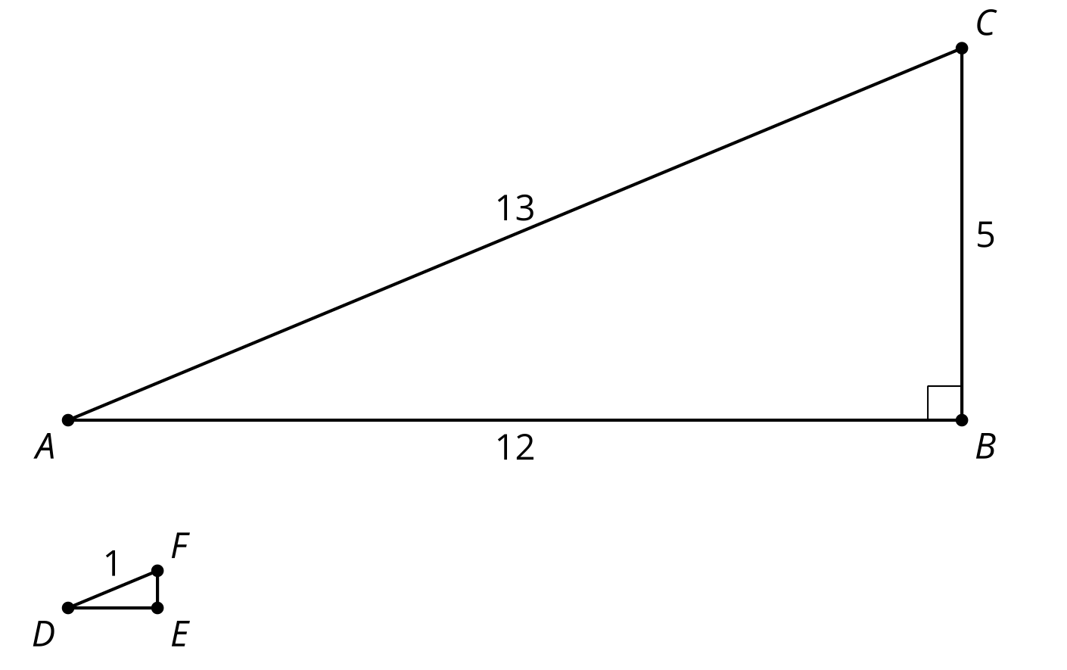
  - What is the length of segment $DE$? What is the length of segment $EF$? Explain how you know.
  - Explain why the length of segment $DE$ is $cos\left(D\right)$ and the length of segment $EF$ is $sin\left(D\right)$.
- Here is a triangle.
- Find $cos\left(A\right)$, $sin\left(A\right)$, and $tan\left(A\right)$. Explain your reasoning.
- 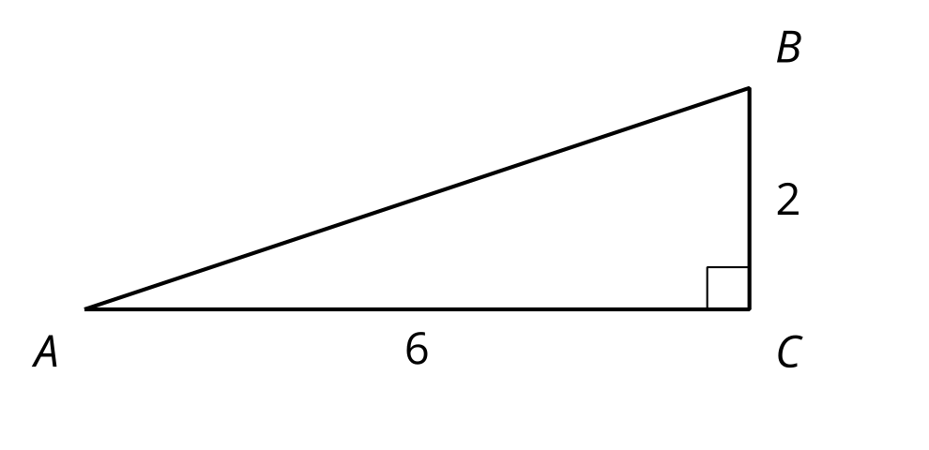
- Sketch and label a right triangle $ABC$ with $tan\left(A\right)=2$.
- 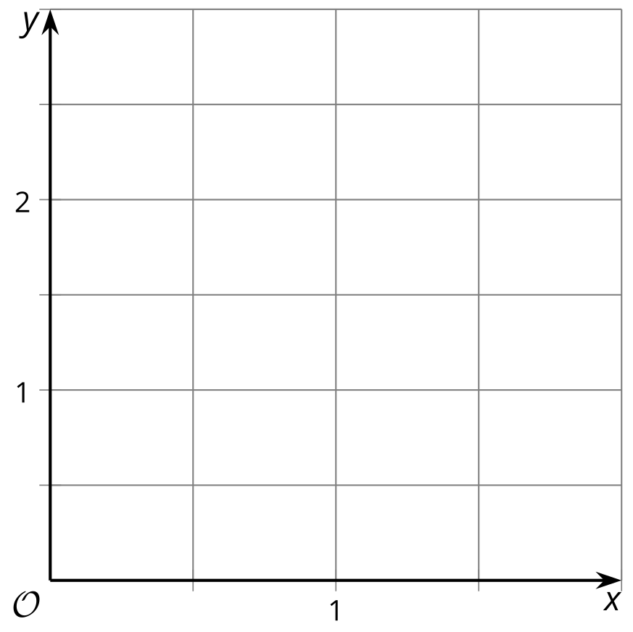
- The point $\left(1,4\right)$ lies on a circle with center $\left(0,0\right)$. Name at least one point in each quadrant that lies on the circle.
- (From Unit 6, Lesson 1.)
© CC BY 2019 by Illustrative Mathematics®

