Unit 1 Lesson 3: Volumes of Prism Drawings

WU Number Talk: Multiplication (Warm up)

Student Task Statement
Find the value of each expression mentally.
- $6×4$
- $3×2×4$
- $3×2×5$
- $3×2×6$
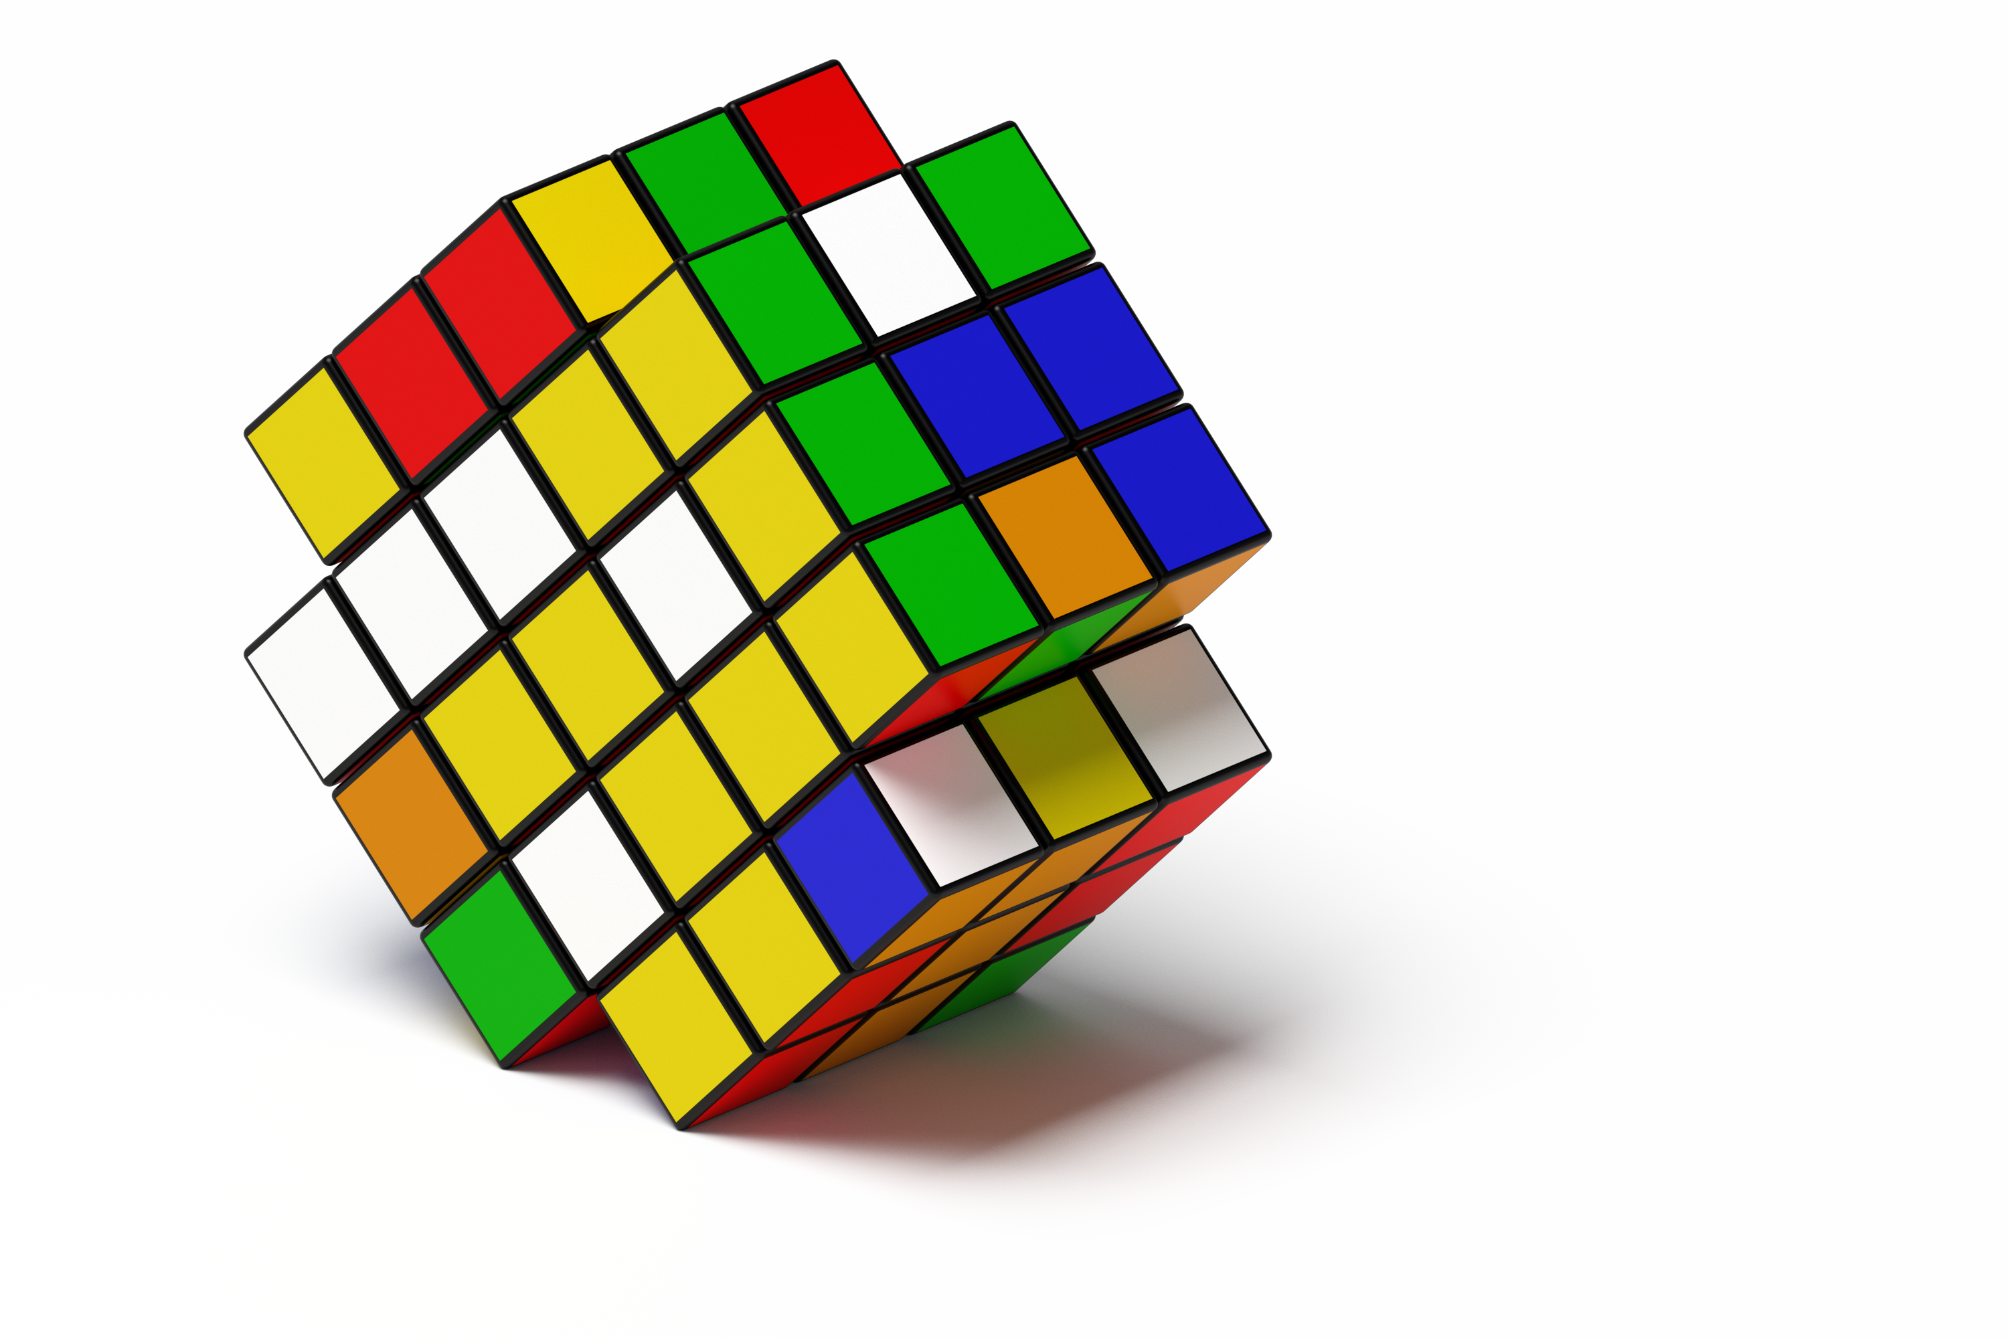

1 Build Rectangular Prisms

Student Task Statement
The prisms on the cards are completely packed with unit cubes.
- Pick a card.
- Build the rectangular prism.
- Find the volume. Explain how you found the volume to your partner.
- Repeat.
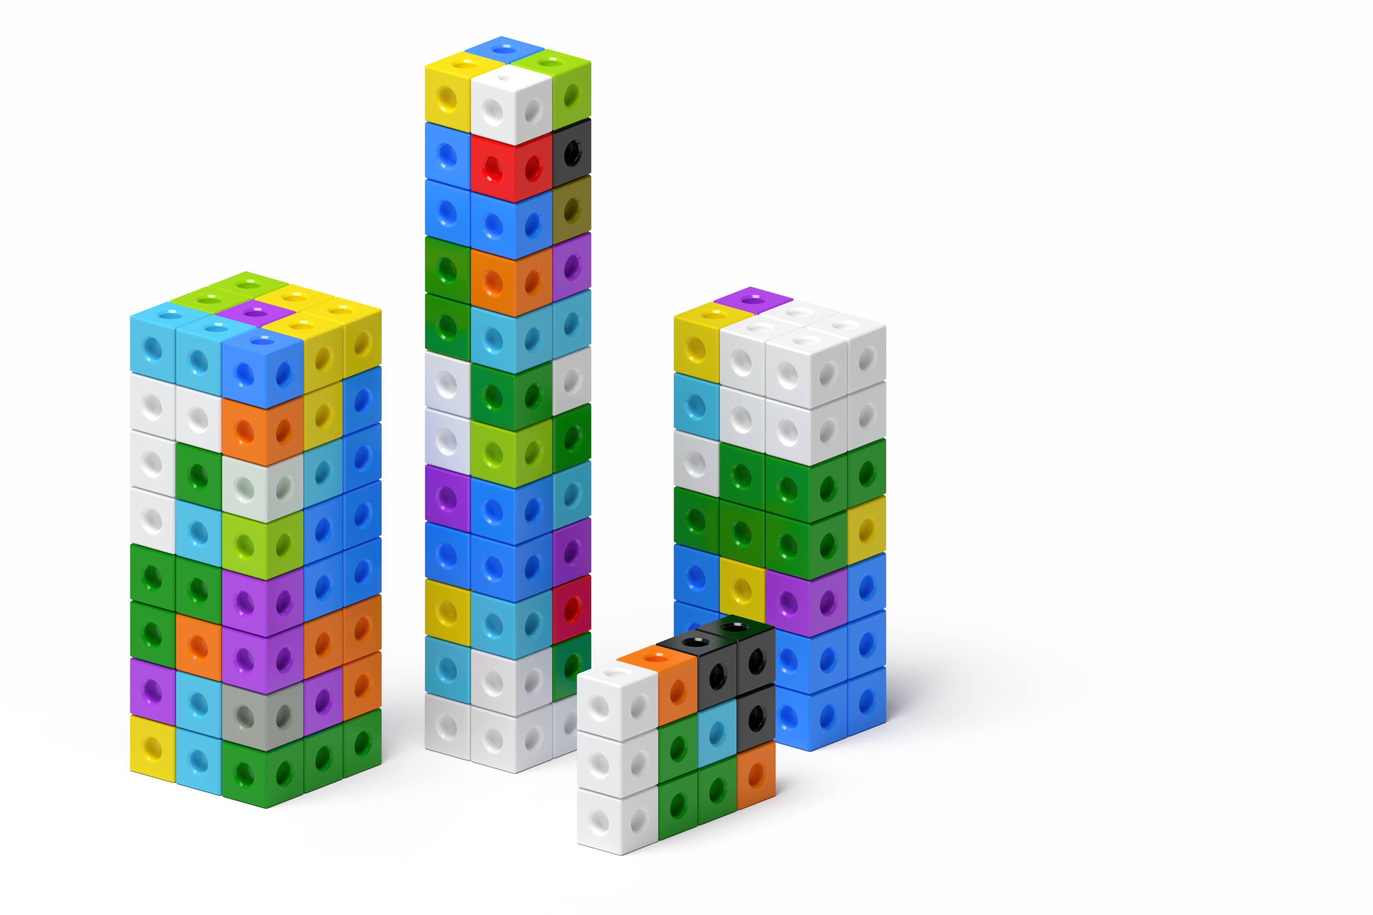

2 Layers, layers, and more layers

Student Task Statement
The prisms are completely packed with unit cubes. Determine the volume of each prism. Explain or show your reasoning.

- 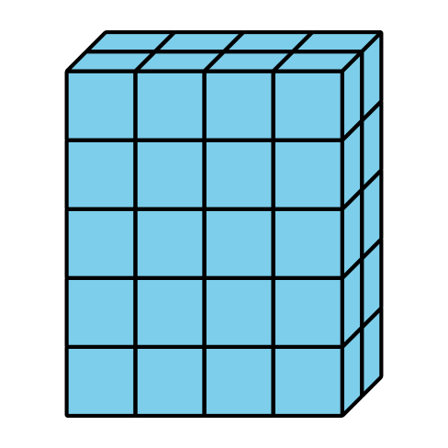

- 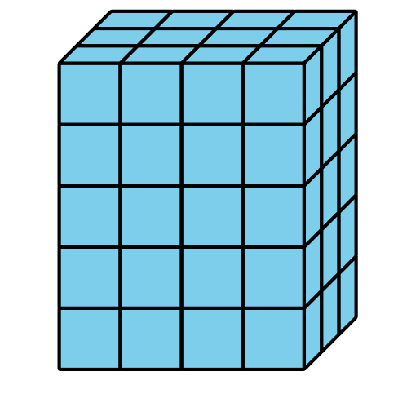

- 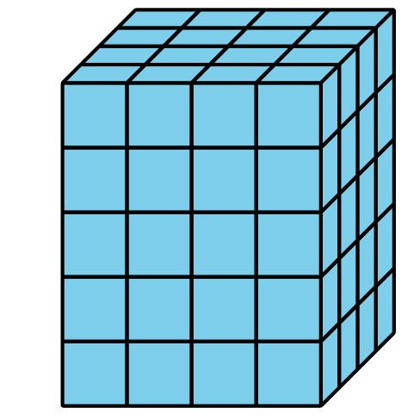
© CC BY 2021 Illustrative Mathematics®

