Lesson 12: Add it Up
- Let’s add two-digit numbers and write equations.

Warm-up: Number Talk: Make a Ten
Find the value of each expression mentally.
- $7+3$
- $37+3$
- $7+8$
- $57+8$

12.1: Add Two-digit Numbers Within 100
Find the value of each sum using any method that you want.
Show your thinking using drawings, numbers, or words.
Write equations to represent your thinking.
- $48+15$
- $57+36$

12.2: Reason About Addition
37
22
18
56
41
Choose 2 numbers from above and write an addition expression to make each statement true.
- This sum has the smallest possible value.
Expression:_______________________
- This sum has the largest possible value.
Expression:_______________________
- You do not need to make a new ten to find the value of this sum.
Expression:_______________________
- If you make a new ten to find the value of this sum, you will still have some more ones.
Expression:_______________________
- If you make a new ten to find the value of this sum, you will have no more ones.
Expression:_______________________
Be ready to explain your thinking in a way that others will understand.
If you have time: Choose 2 numbers from above and write an addition expression where the value is closest to 95.
How do you know the value is closest to 95?
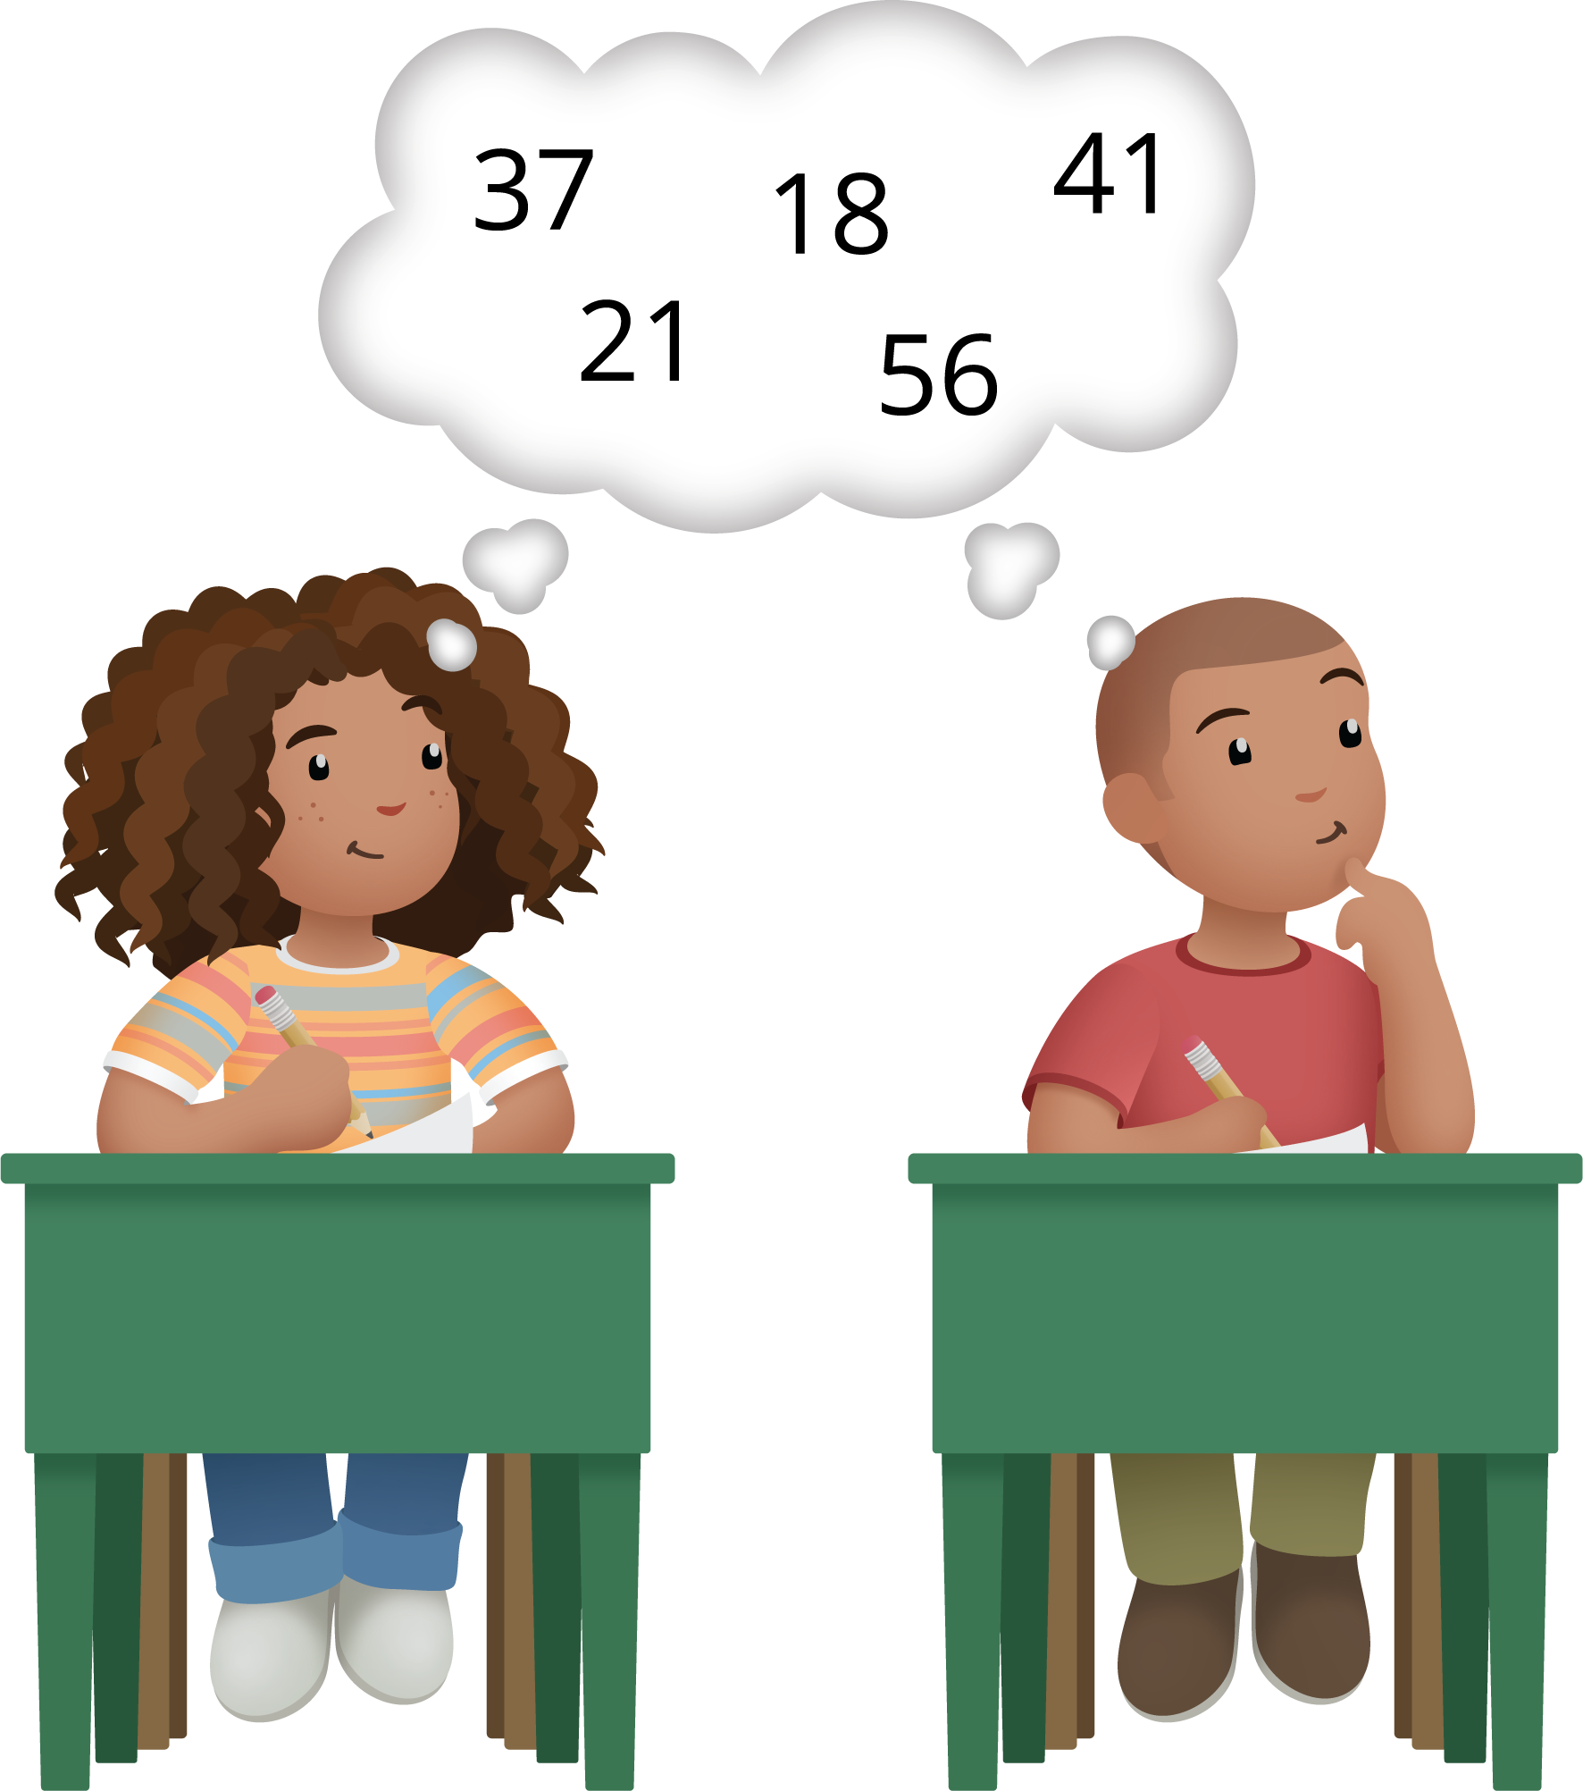

12.3: Ways We Volunteer
- Mai’s school is having a book drive.
They collect 48 children’s books.
They collect 27 adult books.
How many books do they collect all together?
Show your thinking using drawings, numbers, or words.
- The community soup kitchen has lots of volunteers who help serve food.
They have 35 volunteers during the week and 56 volunteers on the weekend.
How many volunteers do they have all together?
Show your thinking using drawings, numbers, or words.
- Elena and her mother volunteer to plant a community garden in their neighborhood.
They plant 18 strawberry plants and 24 cucumber plants.
How many plants did they plant all together?
Show your thinking using drawings, numbers, or words.

Section Summary
Section Summary
We learned to add any 2 two-digit numbers within 100 and write equations to represent our methods.
We added tens and tens and ones and ones.
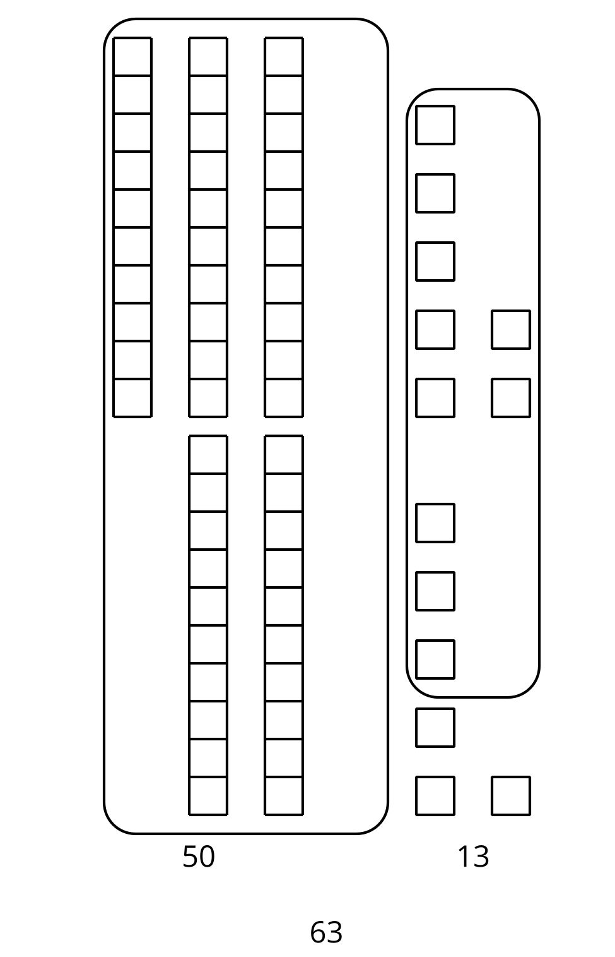
$37+26$
$30+20=50$
$7+6=13$
$50+13=63$
We added ones first to make a new ten.
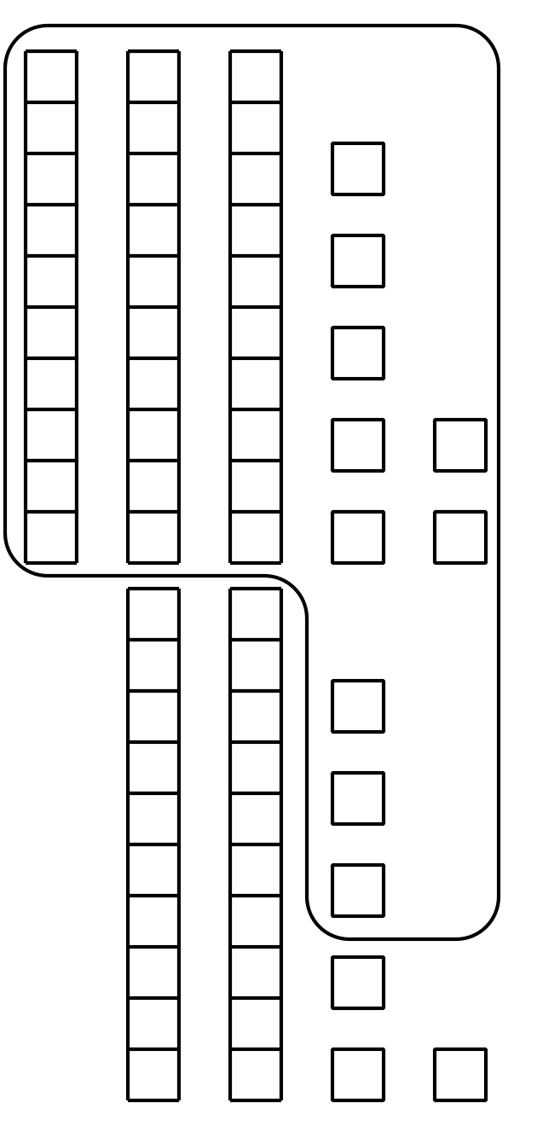
$37+26$
$37+3+3=43$
$43+20=63$
© CC BY 2021 Illustrative Mathematics®

