## Unit 3 Lesson 20: More Practice to Represent and Solve

### WU Number Talk: Two Steps (Warm up)

#### Student Task Statement

Find the value of each expression mentally.

### 1 Info Gap: Introduction

#### Student Task Statement

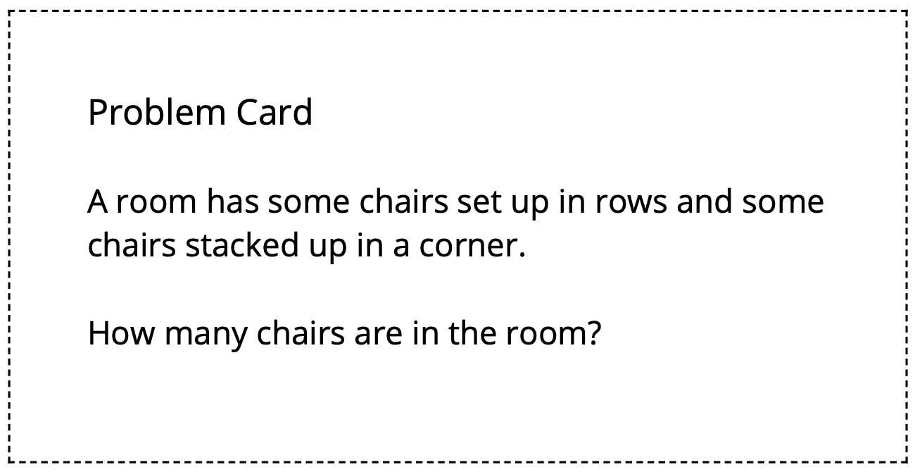

### 2 Info Gap: Bake Sale

#### Student Task Statement

Your teacher will give you either a problem card or a data card. Do not show or read your card to your partner.

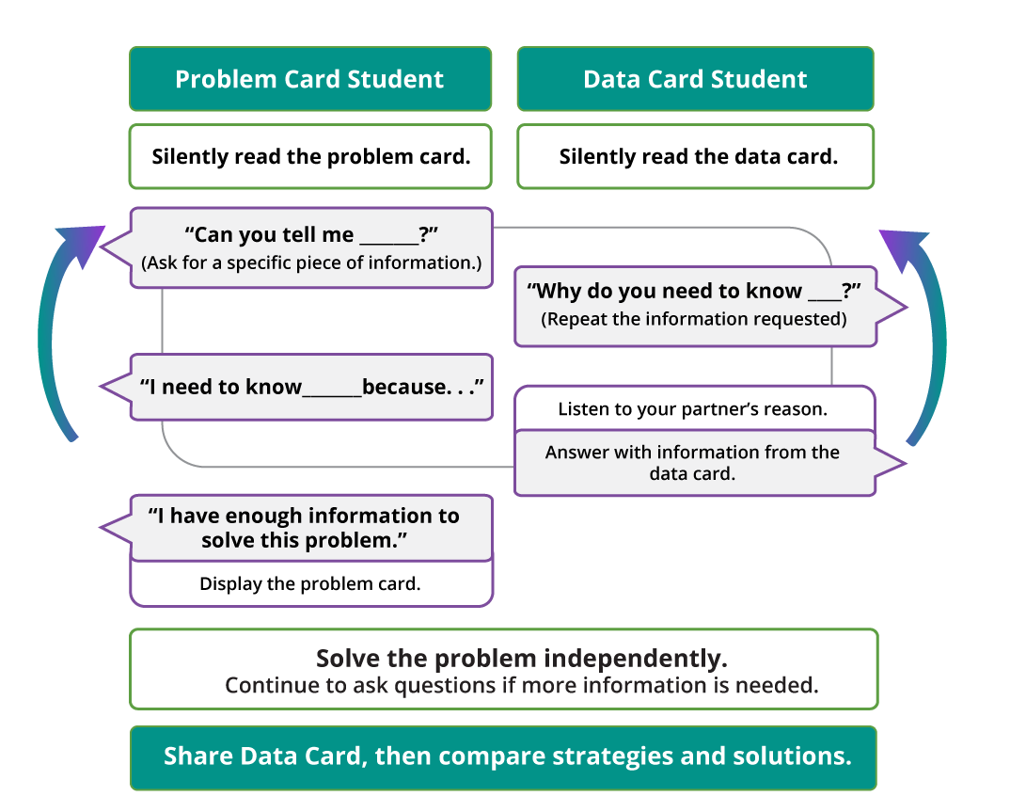

Pause here so your teacher can review your work.

Ask your teacher for a new set of cards and repeat the activity, trading roles with your partner.



© CC BY 2021 Illustrative Mathematics®