Lesson 19: Methods for Addition Within 20
- Let’s add within 20.

Warm-up: Number Talk: Related Expressions
Find the value of each expression mentally.
- $5+8$
- $6+7$
- $8+7$
- $6+9$

19.1: Lin, Han, and Kiran Add
Lin, Han, and Kiran are finding the value of $8+7$.
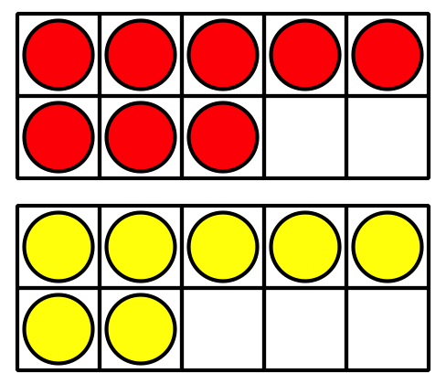
Lin thinks about $8+2+5$ .
Han thinks about $7+7+1$.
Kiran thinks about $8+8−1$.
Explain how each student’s method works.
Show your thinking using drawings, numbers, or words.

19.2: How Did You Add?
- Choose an addition card.
- Each partner finds the value independently.
- Each partner gives a signal when they are ready to explain their thinking.
- Each partner shares their thinking.
- Each partner writes the equation.
Choose your favorite equation.
Show how you found the value using drawings, numbers, or words.
© CC BY 2021 Illustrative Mathematics®

