Unit 1 Lesson 4: Use Layers to Determine Volume

WU Estimation Exploration: How Many Cubes? (Warm up)

Student Task Statement
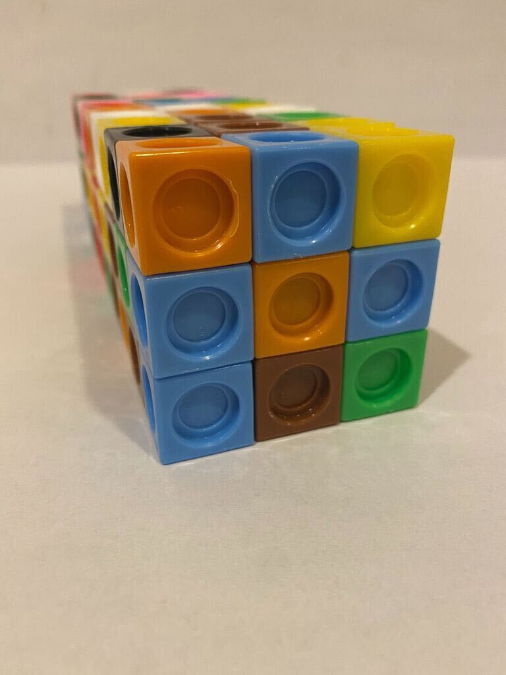
About how many cubes were used to build this prism?
Record an estimate that is:
too low | about right | too high

Activity Synthesis
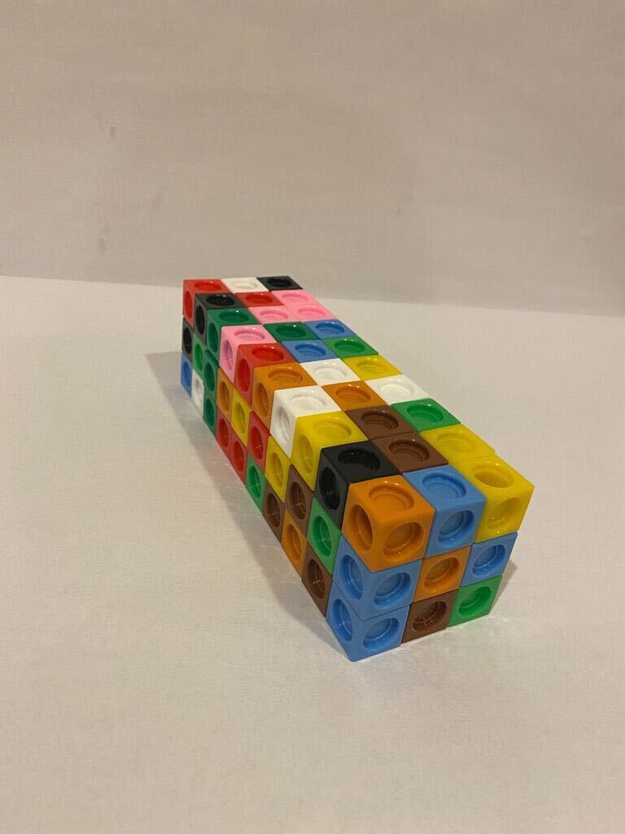

1 Layers in Rectangular Prisms

Student Task Statement
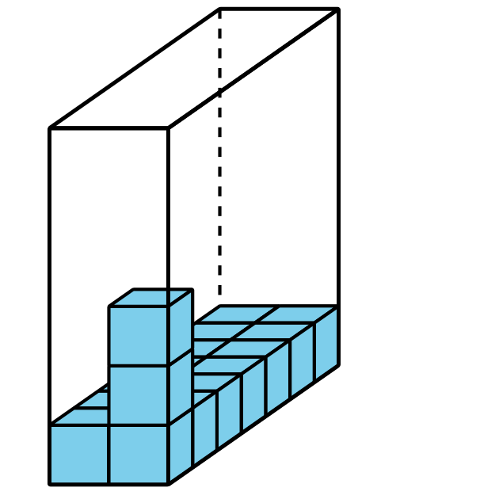
- Complete the table. Be prepared to explain your reasoning.
- prism | - number of cubes in one layer | - number of layers | - volume
- A
- B
- C
- D

- Prism A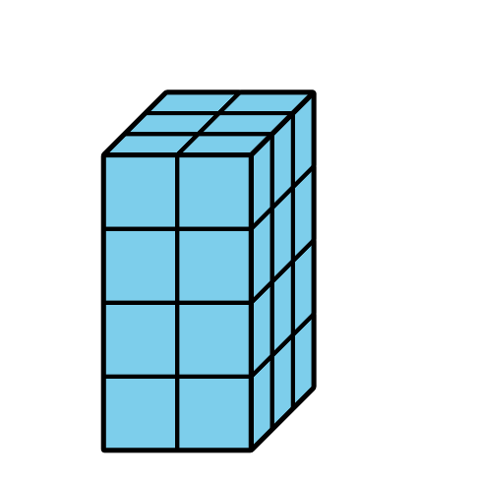
- Prism B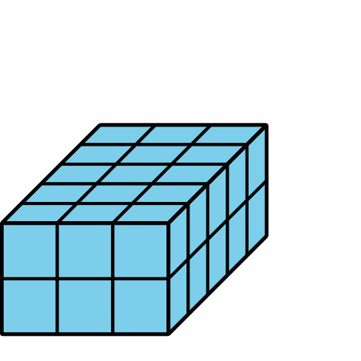
- Prism C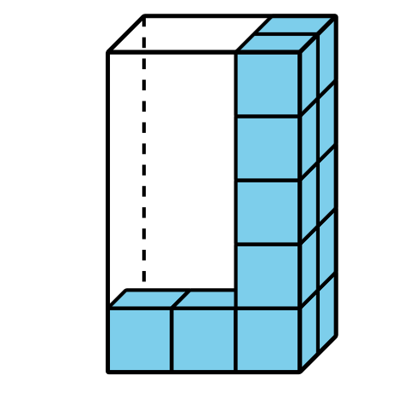
- Prism D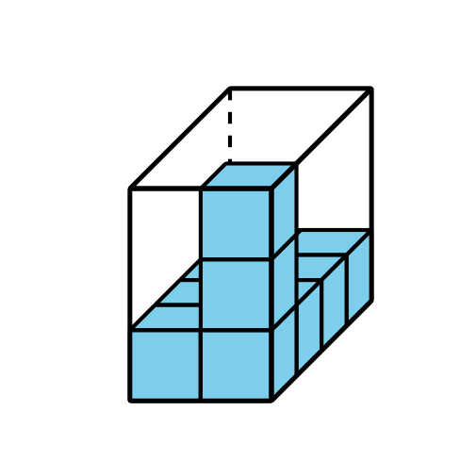
- Find the volume of each prism. Explain or show your reasoning.
- Prism E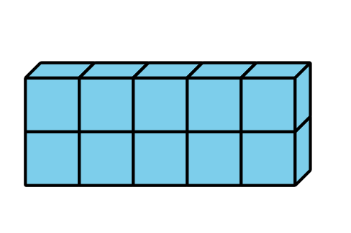

- Prism F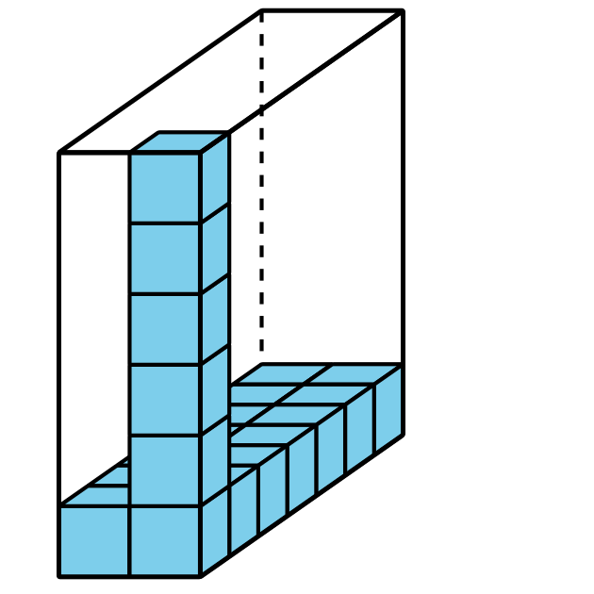
- How can you find the volume of any rectangular prism?

2 Finding Volume in Different Ways

Student Task Statement
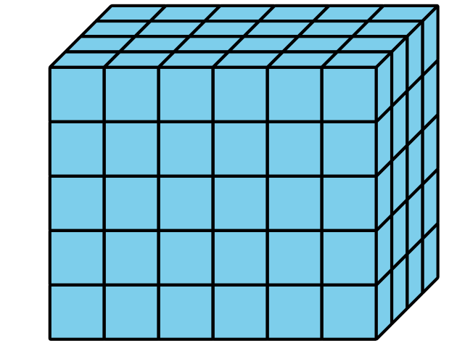
- Explain or show how the expression $5×24$ represents the volume of this rectangular prism.
- Explain or show how the expression $6×20$ represents the volume of this rectangular prism.
- Find a different way to calculate the volume of this rectangular prism. Explain or show your thinking.
- Write an expression to represent the way you calculated the volume.
© CC BY 2021 Illustrative Mathematics®

