Lesson 13: Center Day 3
- Let’s add 2 two-digit numbers.

13.1: Introduce Target Numbers, Add Two-Digit Numbers
Choose a center.
Target Numbers
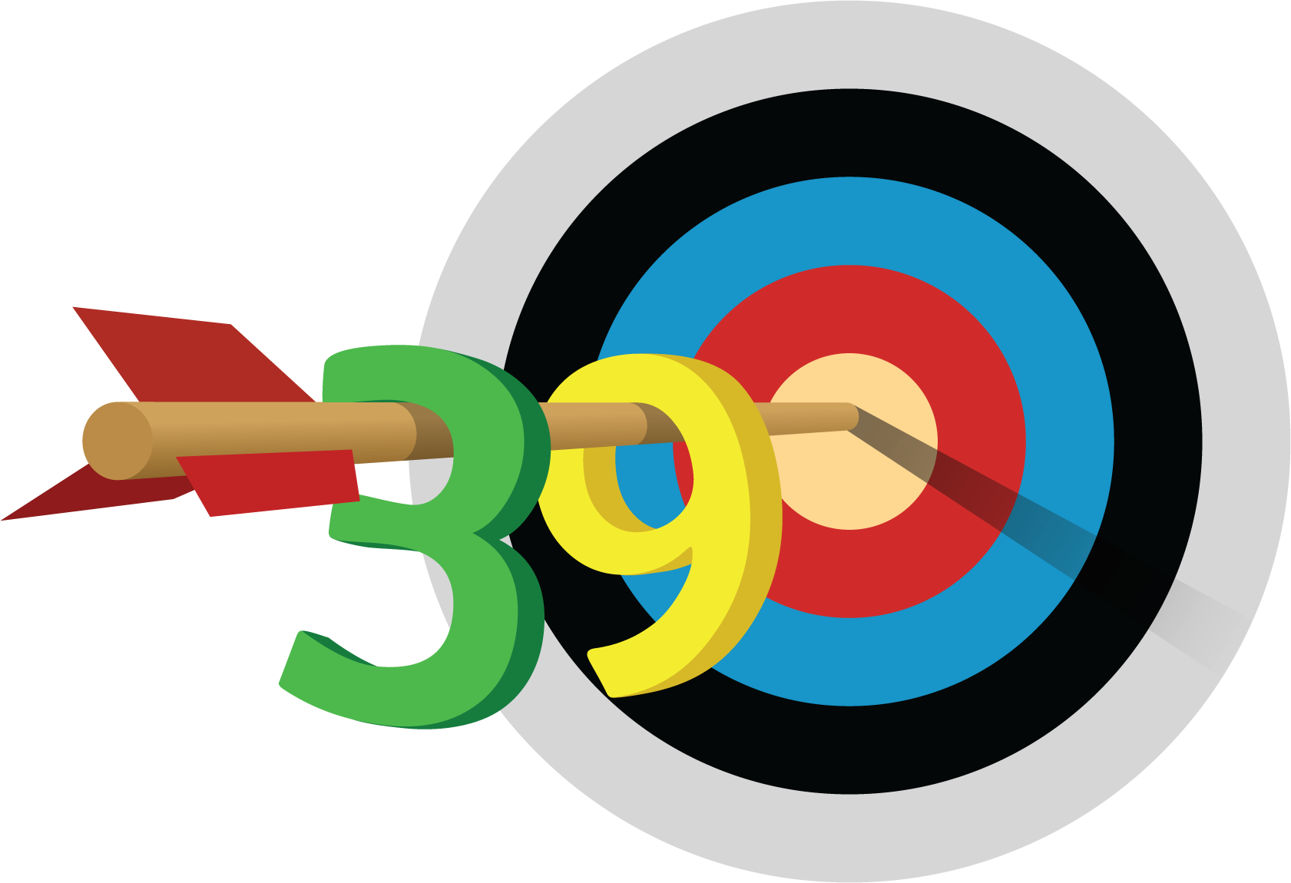
Number Puzzles
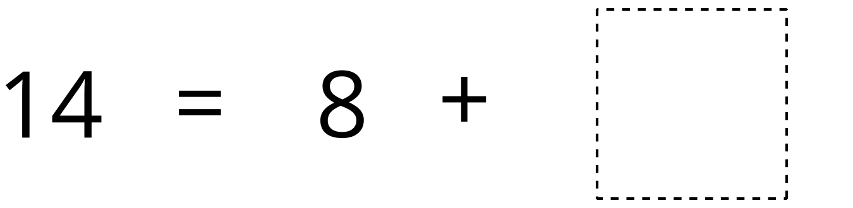
Mystery Number
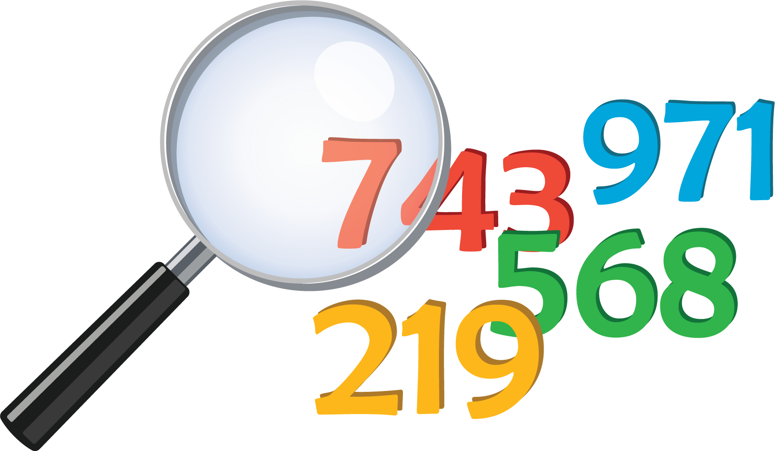

13.2: Introduce Five in a Row, Add within 100 with Composing
Choose a center.
Five in a Row
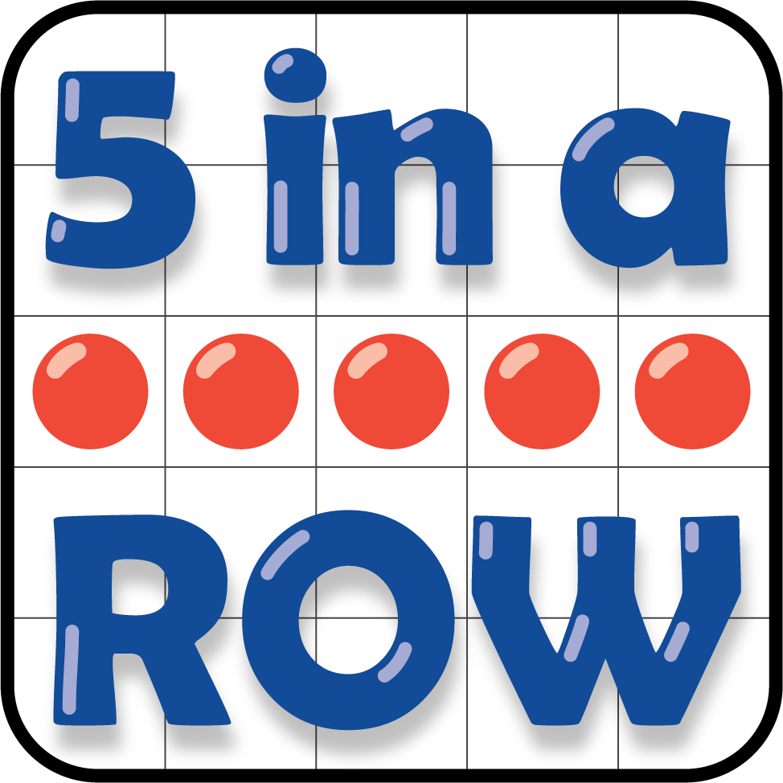
Get Your Numbers in Order
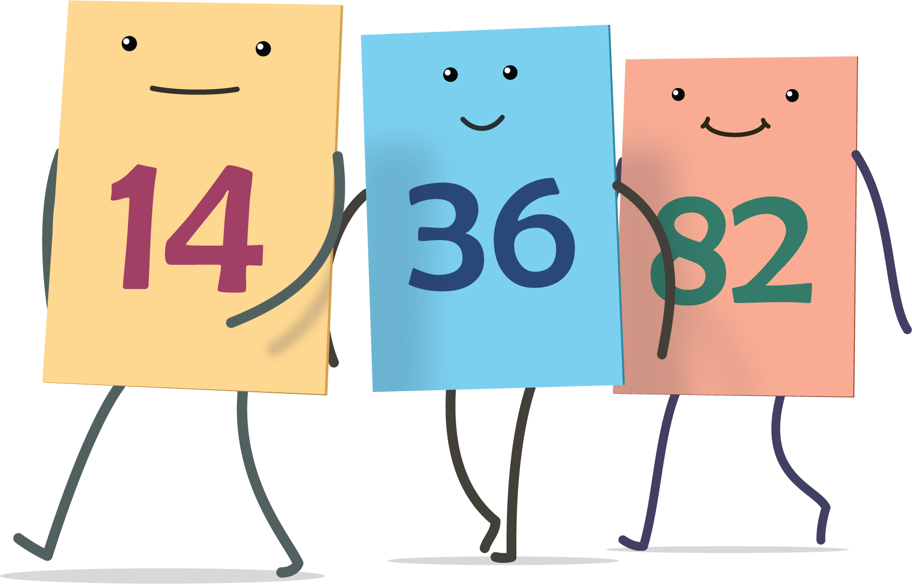
Grab and Count
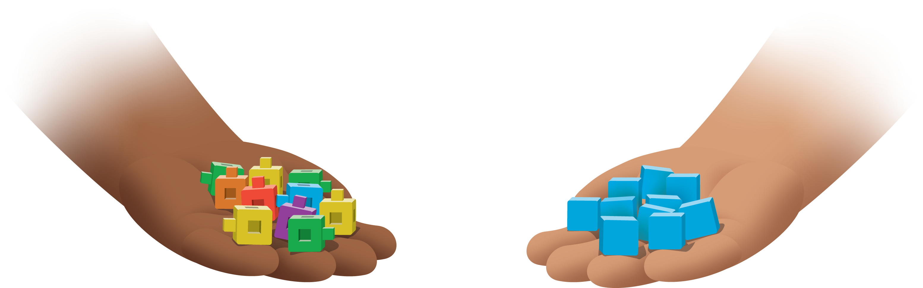
© CC BY 2021 Illustrative Mathematics®

