Unit 5 Lesson 2: Make Hundreds

WU Choral Count: Count by 10 (Warm up)

Student Task Statement

1 Make Hundreds

Student Task Statement
- Build each number using base-ten blocks. Record how many tens blocks you use.
  - Build 90.
  - Build 110.
  - Build 150.
- ____________ tens
- ____________ tens
- ____________ tens
- How many base-ten blocks would you need to build 200?
- ____________ tens
- How many base-ten blocks would you need to build 300?
- ____________ tens
- How many base-ten blocks would you need to build 300 if you could use 1 hundreds block?
- 1 hundred ____________ tens
- How many tens would you need to build 300 if you could use 2 hundreds blocks?
- 2 hundreds ____________ tens
- How many tens would you need to build 300 if you could use only hundreds blocks?
- ____________ hundreds ____________ tens

2 How Many Hundreds?

Student Task Statement
Han and Jada represented the same number using base-ten blocks. They started base-ten diagrams, but ran out of time to finish them.
Jada
Han
I only used hundreds.
I only used tens.
Total value: 700
Total value: 700
- Use base-ten blocks to show what each student’s work would look like if they had time to finish it.
- 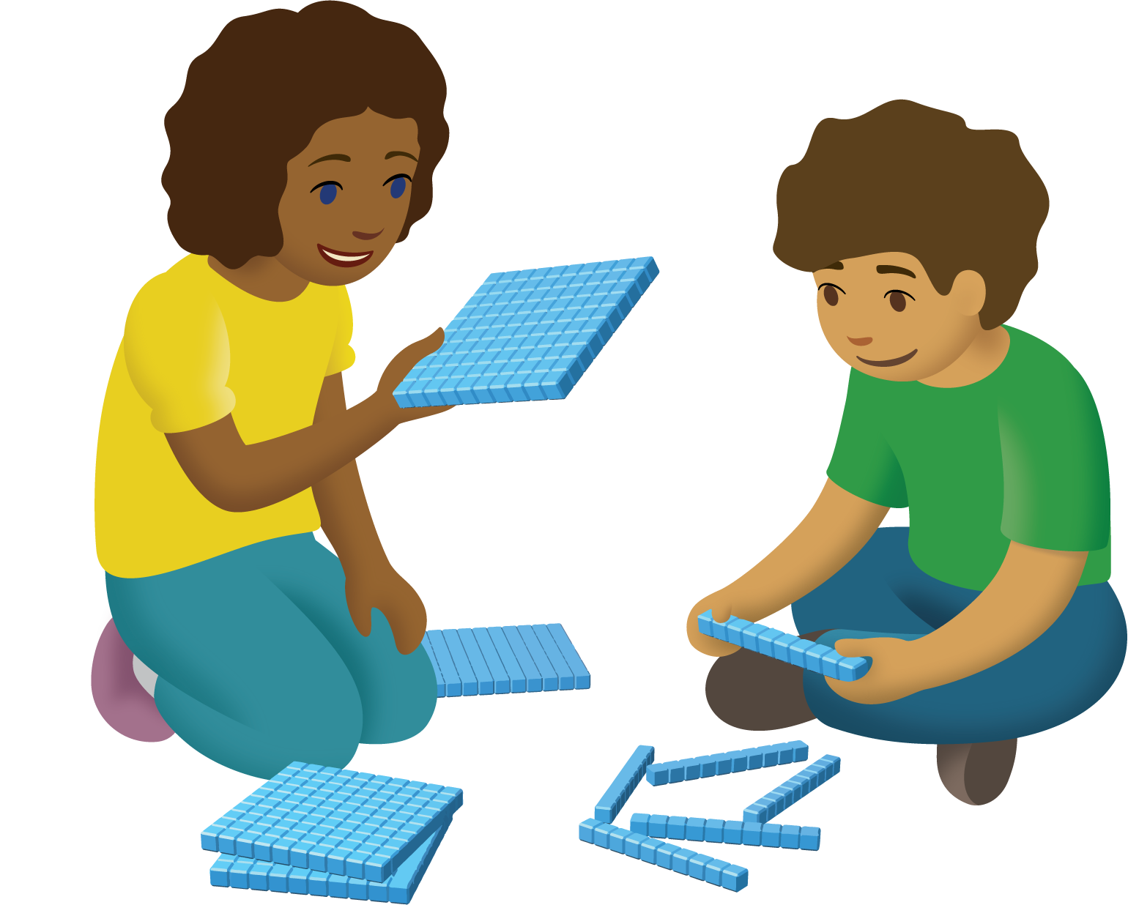
- Explain how you know both ways of using base-ten blocks show 700.
- Complete Jada’s base-ten diagram.
- Explain why you think Han ran out of time to finish his diagram.
© CC BY 2021 Illustrative Mathematics®

