Unit 6 Lesson 4: Center Day 1

WU Number Talk: Use Tens to Add (Warm up)

Student Task Statement
Find the value of each expression mentally.
- $9+6$
- $29+6$
- $39+7$
- $39+9$

1 Introduce How Close? Add to 100

Student Task Statement

2 Centers: Choice Time

Student Task Statement
Choose a center.
Target Numbers
Five in a Row
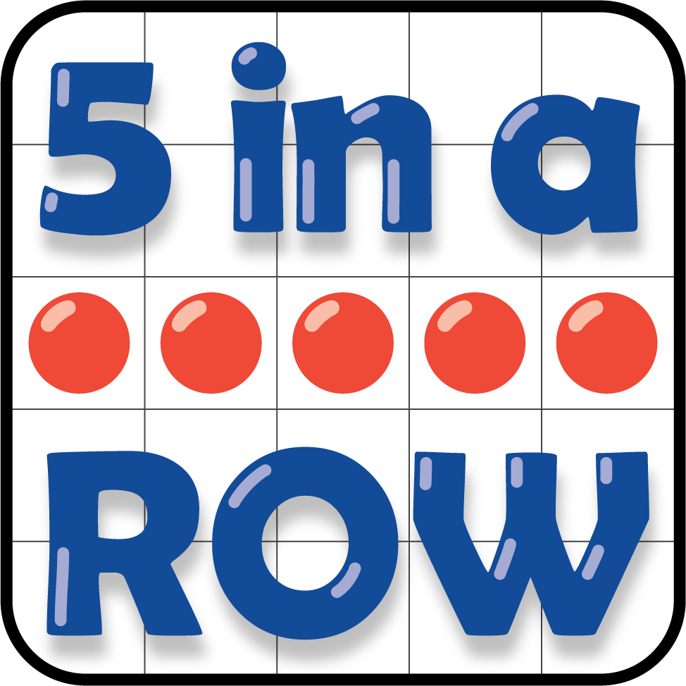
Get Your Numbers in Order
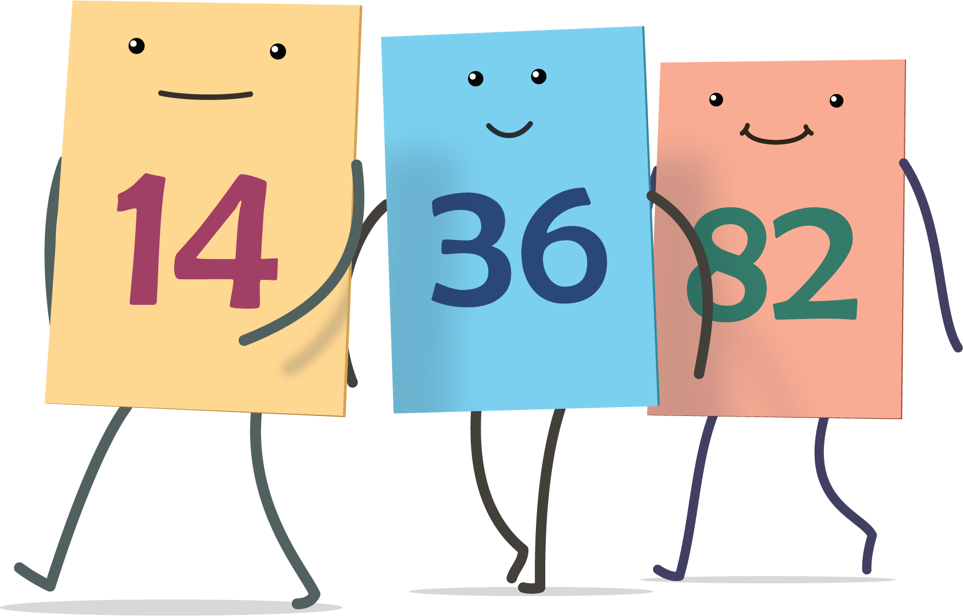
© CC BY 2021 Illustrative Mathematics®

