Unit 6 Lesson 5 Cumulative Practice Problems
- Here are some prices customers paid for different items at a farmer’s market. Find the cost for 1 pound of each item.
  - $5 for 4 pounds of apples
  - $3.50 for $\frac{1}{2}$ pound of cheese
  - $8.25 for $1\frac{1}{2}$ pounds of coffee beans
  - $6.75 for $\frac{3}{4}$ pounds of fudge
  - $5.50 for a $6\frac{1}{4}$ pound pumpkin
- (From Unit 4, Lesson 2.)
- Find the products.
  - $\frac{2}{3}⋅\left(\frac{\text{-}4}{5}\right)$
  - $\left(\frac{\text{-}5}{7}\right)⋅\left(\frac{\text{7}}{5}\right)$
  - $\left(\frac{\text{-}2}{39}\right)⋅39$
  - $\left(\frac{\text{2}}{5}\right)⋅\left(\frac{\text{-}3}{4}\right)$
- (From Unit 5, Lesson 9.)
- Here are two stories:
  - A family buys 6 tickets to a show. They also each spend $3 on a snack. They spend $24 on the show.
  - Diego has 24 ounces of juice. He pours equal amounts for each of his 3 friends, and then adds 6 more ounces for each.
- Here are two equations:
  - $3(x+6)=24$
  - $6(x+3)=24$
  - Which equation represents which story?
  - What does $x$ represent in each equation?
  - Find the solution to each equation. Explain or show your reasoning.
  - What does each solution tell you about its situation?
- Here is a diagram and its corresponding equation. Find the solution to the equation and explain your reasoning.
- 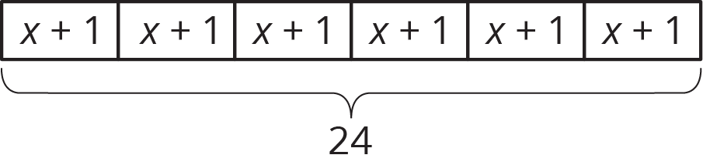
- $6(x+1)=24$
- Below is a set of data about temperatures. The range of a set of data is the distance between the lowest and highest value in the set. What is the range of these temperatures?
- $9^{∘}\text{C},\text{-}3^{∘}\text{C},{22}^{∘}\text{C},\text{-}5^{∘}\text{C},{11}^{∘}\text{C},{15}^{∘}\text{C}$
- (From Unit 5, Lesson 7.)
- A store is having a 25% off sale on all shirts. Show two different ways to calculate the sale price for a shirt that normally costs $24.
- (From Unit 4, Lesson 11.)
© CC BY Open Up Resources. Adaptations CC BY IM.

