Lesson 20 Practice Problems

  - Explain why all of these expressions have the same value.
  - $4.5÷0.09$
  - $45÷0.9$
  - $450÷9$
  - $4500÷90$
  - What is the common value?
- A student said, “To find the value of $109.2÷6$, I can divide 1,092 by 60.”
  - Do you agree with her? Explain your reasoning.
  - Calculate the quotient of $109.2÷6$ using any method of your choice.
- Here is how Han found $31.59÷13$:
- 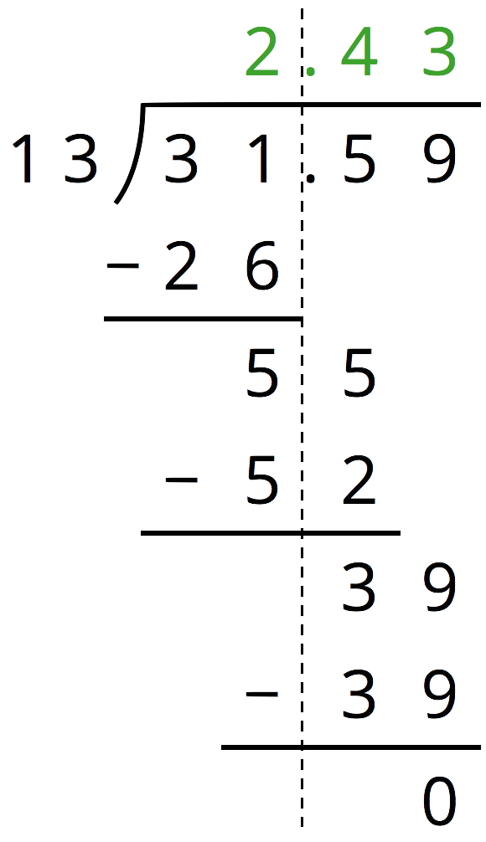
  - At the second step, Han subtracts 52 from 55. How do you know that these numbers represent tenths?
  - At the third step, Han subtracts 39 from 39. How do you know that these numbers represent hundredths?
  - Check that Han’s answer is correct by calculating the product of 2.43 and 13.

  - Write two division expressions that have the same value as $61.12÷3.2$.
  - Find the value of $61.12÷3.2$. Show your reasoning.
- Find each difference. If you get stuck, consider drawing a diagram.
- $2.5−1.6$ $0.72−0.4$ $11.3−1.75$ $73−1.3$
- (From Unit 3, Lesson 15.)
- At a school, 460 of the students walk to school.
  - The number of students who take public transit is 20% of the number of students who walk. How many students take public transit?
  - The number of students who bike to school is 5% of the number of students who walk. How many students bike to school?
  - The number of students who ride the school bus is 110% of the number of students who walk. How many students ride the school bus?
- (From Unit 2, Lesson 23.)
© CC BY Open Up Resources. Adaptations CC BY IM.

