Lesson 12 Practice Problems
- The elevation of a submarine is shown in the table. Draw and label coordinate axes with an appropriate scale and plot the points.
- time after noon (hours) | - elevation (meters)
- 0 | - -567
- 1 | - -892
- 2 | - -1,606
- 3 | - -1,289
- 4 | - -990
- 5 | - -702
- 6 | - -365

- $30+\text{-}30=0$.
  - Write another sum of two numbers that equals 0.
  - Write a sum of three numbers that equals 0.
  - Write a sum of four numbers that equals 0, none of which are opposites.
- (From Unit 7, Lesson 7.)
- The $x$-axis represents the number of hours before or after noon, and the $y$-axis represents the temperature in degrees Celsius.
- 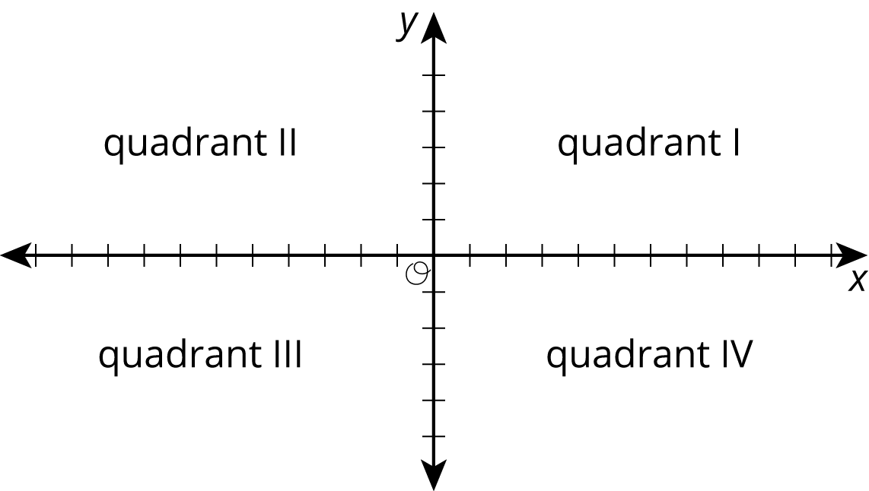
  - At 9 a.m., it was below freezing. In what quadrant would this point be plotted?
  - At 11 a.m., it was ${10}^{∘}\text{C}$. In what quadrant would this point be plotted?
  - Choose another time and temperature. Then tell the quadrant where the point should be plotted.
  - What does the point $\left(0,0\right)$ represent in this context?
- Solve each equation.
- $3a=12$
- $b+3.3=8.9$
- $1=\frac{1}{4}c$
- $5\frac{1}{2}=d+\frac{1}{4}$
- $2e=6.4$
- (From Unit 4, Lesson 4.)
- Crater Lake in Oregon is shaped like a circle with a diameter of about 5.5 miles.
  - How far is it around the perimeter of Crater Lake?
  - What is the area of the surface of Crater Lake?
- (From Unit 5, Lesson 19.)
- A type of green paint is made by mixing 2 cups of yellow with 3.5 cups of blue.
  - Find a mixture that will make the same shade of green but a smaller amount.
  - Find a mixture that will make the same shade of green but a larger amount.
  - Find a mixture that will make a different shade of green that is bluer.
  - Find a mixture that will make a different shade of green that is more yellow.
- (From Unit 5, Lesson 1.)
© CC BY Open Up Resources. Adaptations CC BY IM.

