Unit 2 Lesson 7: Units in Scale Drawings

1 One to One Hundred (Warm up)

Student Task Statement
A map of a park says its scale is 1 to 100.
- What do you think that means?
- Give an example of how this scale could tell us about measurements in the park.

2 Apollo Lunar Module

Images for Launch
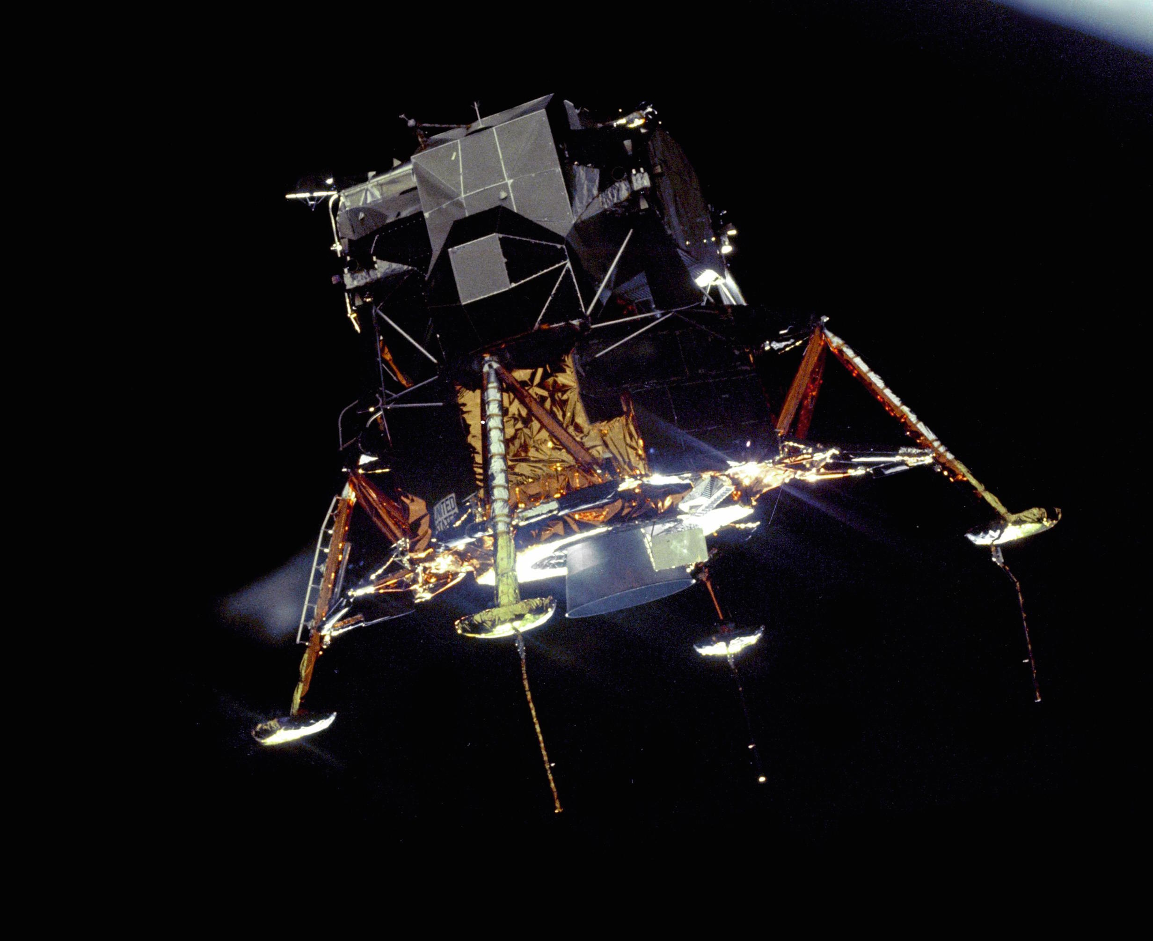

Student Task Statement
Your teacher will give you a drawing of the Apollo Lunar Module. It is drawn at a scale of 1 to 50.
- The “legs” of the spacecraft are its landing gear. Use the drawing to estimate the actual length of each leg on the sides. Write your answer to the nearest 10 centimeters. Explain or show your reasoning.
- Use the drawing to estimate the actual height of the Apollo Lunar Module to the nearest 10 centimeters. Explain or show your reasoning.
- Neil Armstrong was 71 inches tall when he went to the surface of the Moon in the Apollo Lunar Module. How tall would he be in the drawing if he were drawn with his height to scale? Show your reasoning.
- Sketch a stick figure to represent yourself standing next to the Apollo Lunar Module. Make sure the height of your stick figure is to scale. Show how you determined your height on the drawing.

Activity Synthesis
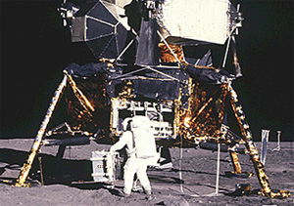

3 The World’s Largest Flag

Images for Launch
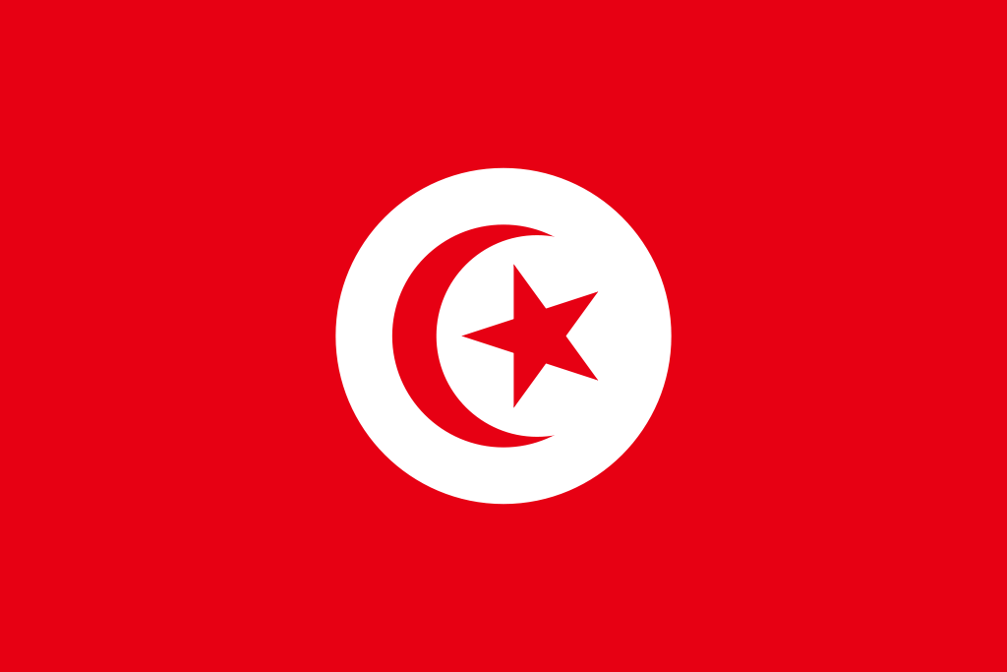

Student Task Statement
As of 2016, Tunisia holds the world record for the largest version of a national flag. It was almost as long as four soccer fields. The flag has a circle in the center, a crescent moon inside the circle, and a star inside the crescent moon.
- Complete the table. Explain or show your reasoning.
 | - flag length | - flag height | - height of  crescent moon
- actual | - 396 m |  | - 99 m
- at 1 to 2,000 scale |  | - 13.2 cm
- Complete each scale with the value that makes it equivalent to the scale of 1 to 2,000. Explain or show your reasoning.
  - 1 cm to ____________ cm
  - 1 cm to ____________ m
  - 1 cm to ____________ km
  - 2 m to _____________ m
  - 5 cm to ___________ m
  - ____________ cm to 1,000 m
  - ____________ mm to 20 m

  - What is the area of the large flag?
  - What is the area of the smaller flag?
  - The area of the large flag is how many times the area of the smaller flag?
© CC BY Open Up Resources. Adaptations CC BY IM.

