Unit 3 Lesson 3: Describe and Compare Shapes

WU Which One Doesn’t Belong: Compare Shapes (Warm up)

Student Task Statement
Which one doesn’t belong?
A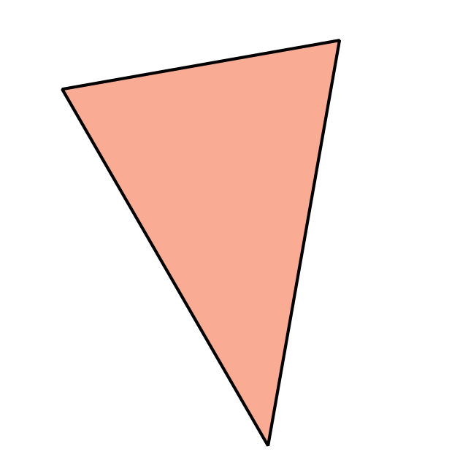
B
C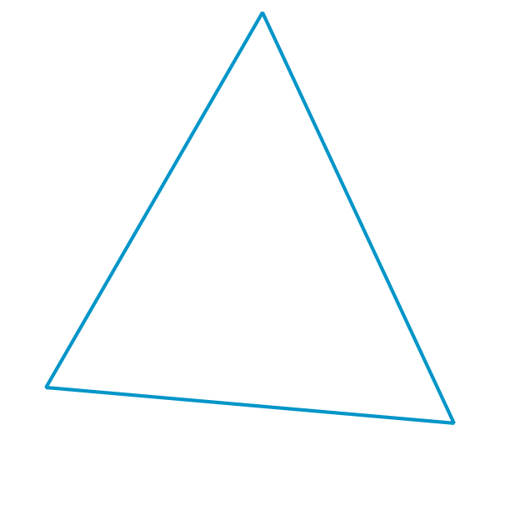
D

1 Hunt for Shapes to Compare

Student Task Statement

2 Alike and Different

Student Task Statement

3 Introduce Which One, Shapes

Student Task Statement
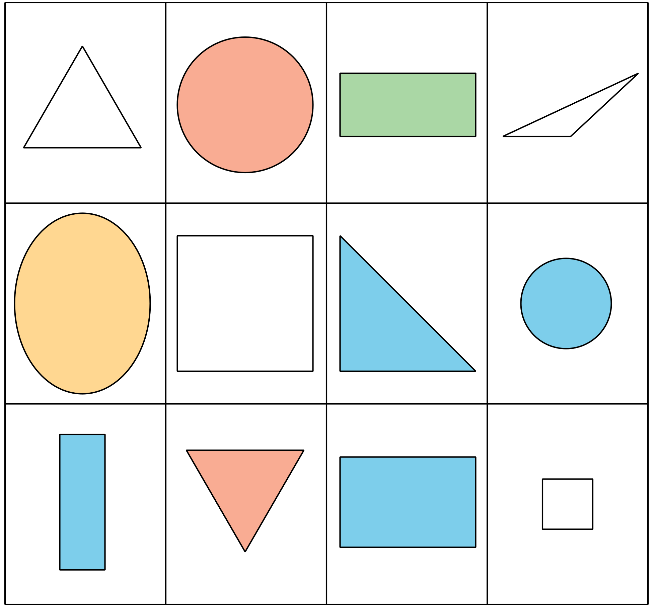
Choose a center.
Which One
Picture Books
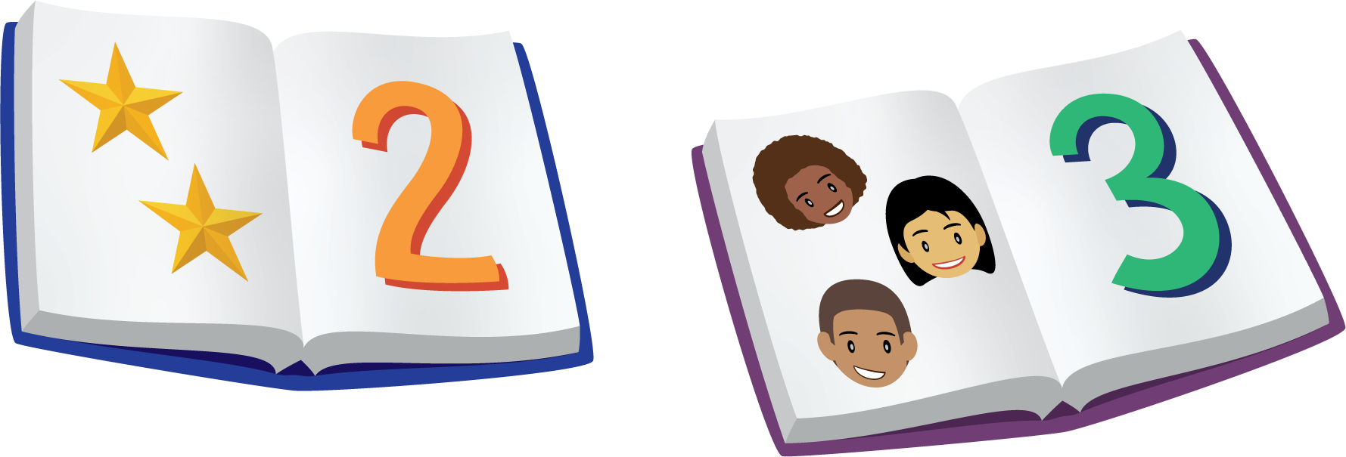
Bingo
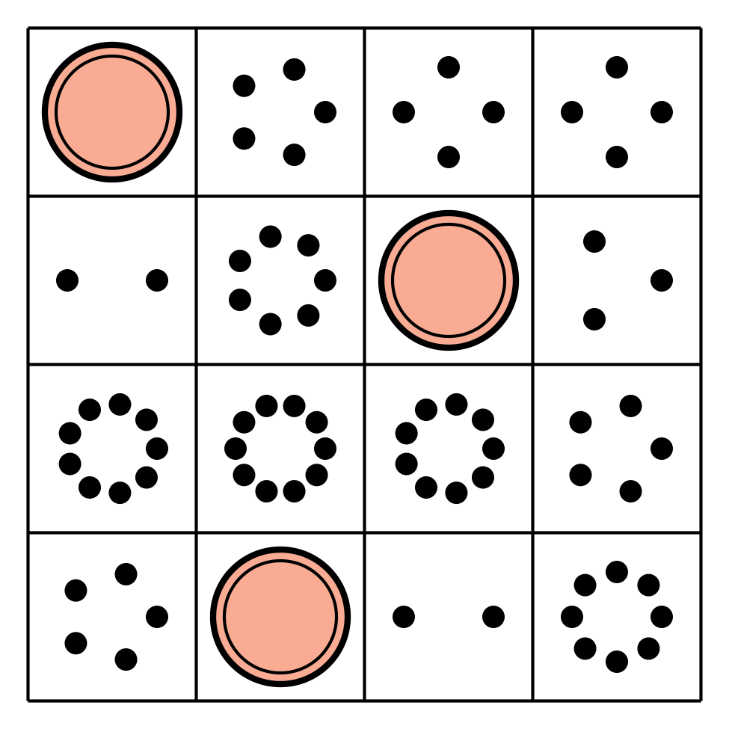
Shake and Spill
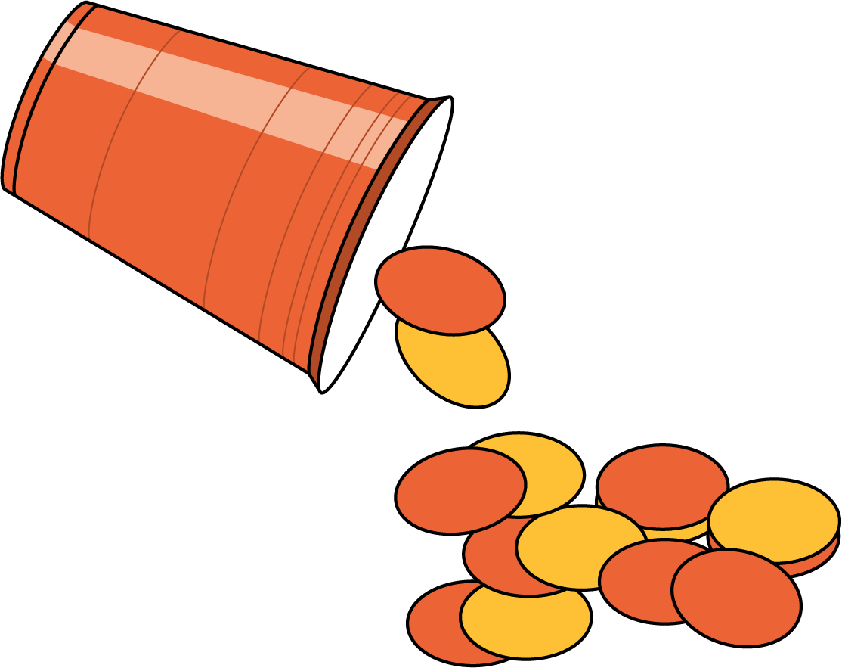

Images for Activity Synthesis
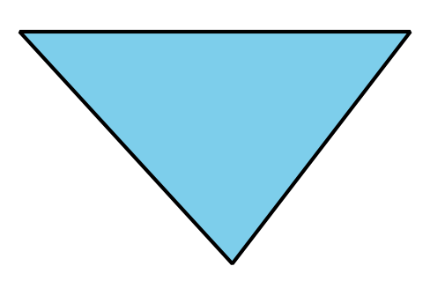
© CC BY 2021 Illustrative Mathematics®

