Unit 2 Lesson 24: Reasoning with Graphs of Inequalities

1 Notice and Wonder: Shady Graphs (Warm up)

Student Task Statement
What do you notice? What do you wonder?
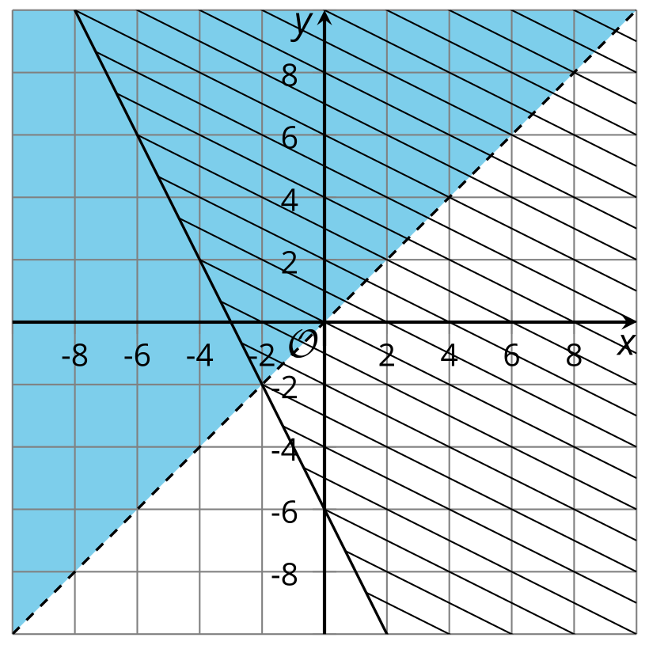

2 Some (Admittedly Silly) Riddles

Student Task Statement
Each riddle consists of two conditions. For each riddle,
- find a pair of numbers that satisfy the first condition.
- find a pair of numbers that satisfy the second condition.
- find a pair of numbers that satisfy both conditions.
- determine whether there could be more than one solution.
- write a system of equations or inequalities that represent the riddle.
- I’m thinking of two numbers. Their sum is 15. Their difference is 1.
- I’m thinking of two numbers. Their sum is more than 15. Their difference is more than 1.
- I’m thinking of two numbers. One is more than twice the other. Their sum is less than 30.
- Think of your own riddles about a pair of numbers.
  - Make a riddle with multiple pairs of numbers that will work.
  - Make a riddle with one pair of numbers that will work.

Activity Synthesis
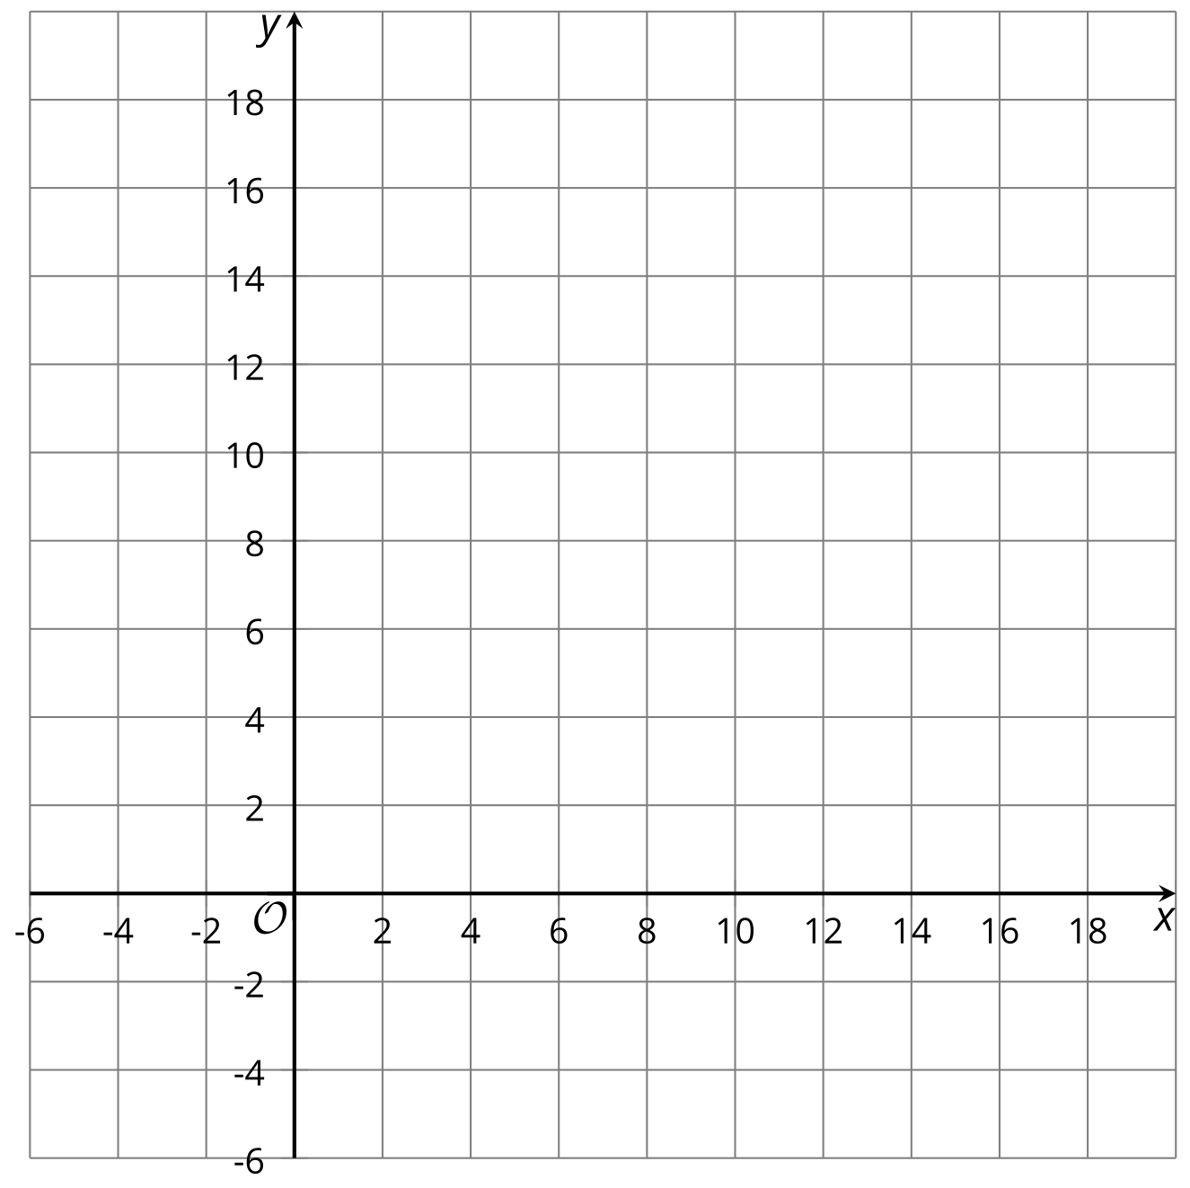
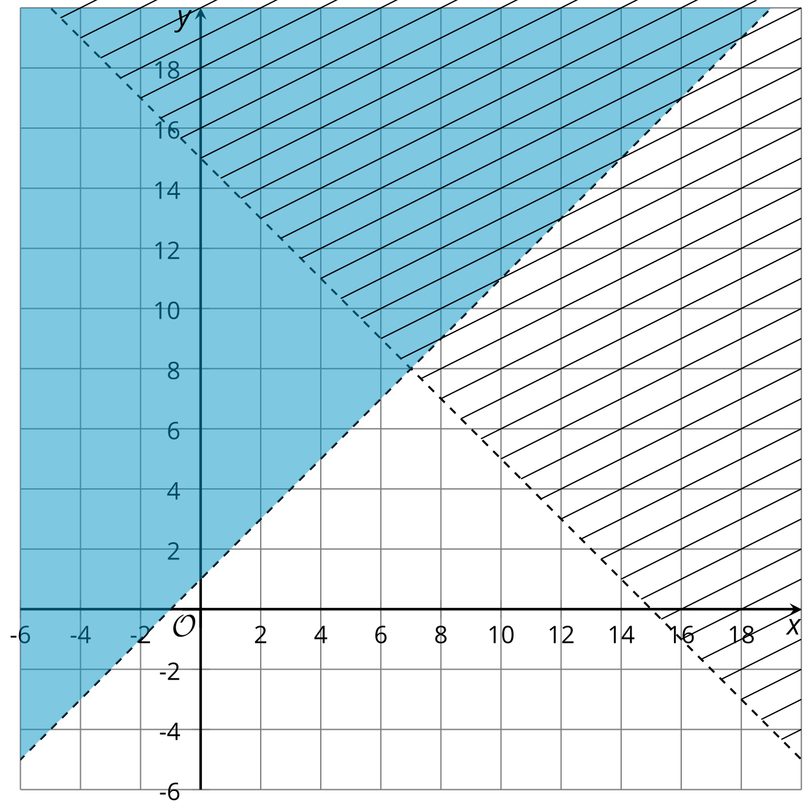

3 Which Side Are You On?

Student Task Statement
For each question:
- Draw a graph that represents the equation or equations.
- Determine how many regions the lines split the plane into.
- Play a game with your partner
  - Partner A: Think of one of the regions.
  - Partner B: Without pointing to the coordinate plane, use the lines to ask questions of your partner about the region they have chosen. When you think you know which region they are thinking of, point to the region and ask your partner if you are correct. If you are correct, shade the entire region.
  - Change roles for the next question.
- $x=3$
- 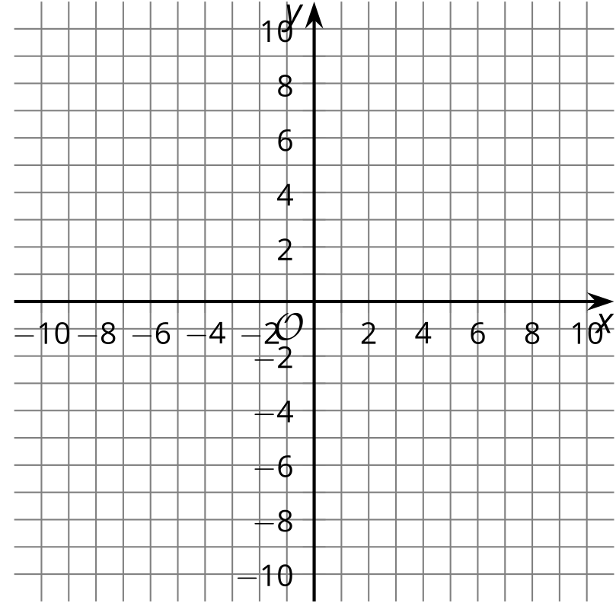
- $y=\text{-}1$ and $x=2$
- $y=x$ and $y=\text{-}x$
- $y=2x+2$ and $y=2x−3$
- $x+y=4$ and $x−y=6$
© CC BY 2019 by Illustrative Mathematics®

