Lesson 4 Practice Problems
- Angle $ABC$ measures $\frac{π}{3}$ radians, and the coordinates of $C$ are about $\left(0.5,0.87\right)$.
- 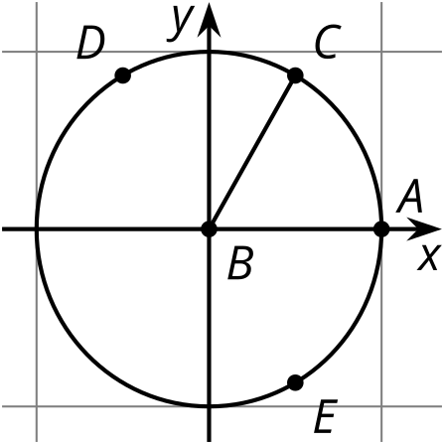
  - The measure of angle $ABD$ is $\frac{2π}{3}$ radians. What are the approximate coordinates of $D$? Explain how you know.
  - The measure of angle $ABE$ is $\frac{5π}{3}$ radians. What are the approximate coordinates of $E$? Explain how you know.
- Give an angle of rotation centered at the origin that sends point $P$ to a location whose $\left(x,y\right)$ coordinates satisfy the given conditions.
  - $x>0$ and $y<0$
  - $x<0$ and $y>0$
  - $y<0$ and $x<0$
- 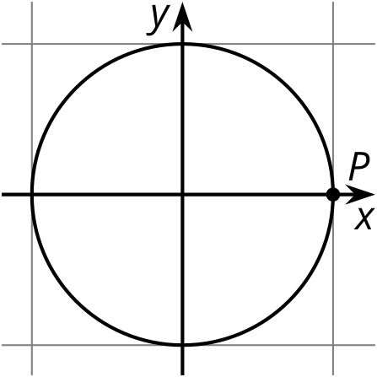
- Lin calculates ${0.97}^{2}+{0.26}^{2}$ and finds that it is 1.0085.
  - Explain why $\left(0.97,0.26\right)$ is not on the unit circle.
  - Is $\left(0.97,0.26\right)$ a good estimate for the coordinates of a point on the unit circle? Explain how you know.
- The $x$-coordinate of a point $P$ on the unit circle is 0. If point $P$ is the result of rotating the point $\left(1,0\right)$ by $θ$ radians counterclockwise about the origin, what angle could $θ$ represent? Select all that apply.
  - 0
  - $\frac{π}{2}$
  - $π$
  - $\frac{3π}{2}$
  - $2π$
- Here is triangle $ABC$. $BC$ is shorter than $AC$. Which statements are true? Select all that apply.
- 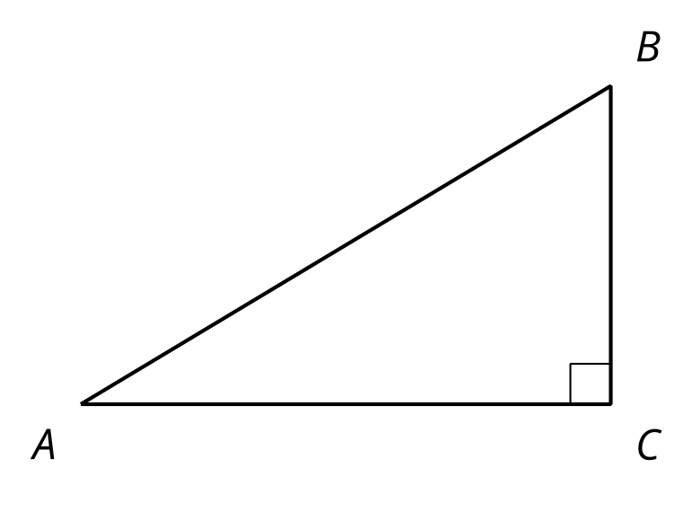
  - $sin\left(A\right)>1$
  - $tan\left(A\right)<1$
  - $cos\left(A\right)<1$
  - $sin\left(A\right)<sin\left(B\right)$
  - $cos\left(A\right)<cos\left(B\right)$
  - $tan\left(A\right)<tan\left(B\right)$
- (From Unit 6, Lesson 2.)
- Angle $POQ$ measures one radian. The radius of the circle is 1 unit.
  - What is the length of arc $PQ$?
  - Explain why the length of arc $PQ$ is less than $\frac{1}{6}$ of the full circle.
- 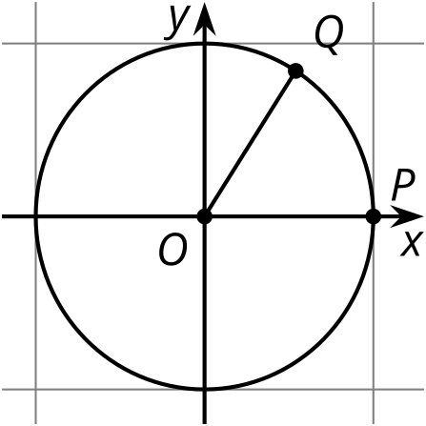
- (From Unit 6, Lesson 3.)
- Label these points on the unit circle:
- 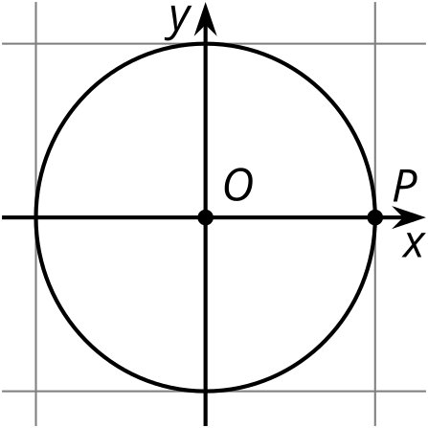
  - $Q$ is the image of $P$ after a $\frac{11π}{6}$ rotation with center $O$.
  - $R$ is the image of $P$ after a $\frac{3π}{2}$ rotation with center $O$.
  - $U$ is the image of $P$ after a $\frac{2π}{3}$ rotation with center $O$.
  - $V$ is the image of $P$ after a $\frac{π}{3}$ rotation with center $O$.
- (From Unit 6, Lesson 3.)
© CC BY 2019 by Illustrative Mathematics®

