Lesson 20 Practice Problems
- Whenever the input of a function $f$ increases by 1, the output increases by 5. Which of these equations could define $f$?
  - $f\left(x\right)=3x+5$
  - $f\left(x\right)=5x+3$
  - $f\left(x\right)=5^{x}$
  - $f\left(x\right)=x^{5}$
- The function $f$ is defined by $f\left(x\right)=2^{x}$. Which of the following statements is true about the values of $f$? Select all that apply.
  - When the input $x$ increases by 1, the value of $f$ increases by 2.
  - When the input $x$ increases by 1, the value of $f$ increases by a factor of 2.
  - When the input $x$ increases by 3, the value of $f$ increases by 8.
  - When the input $x$ increases by 3, the value of $f$ increases by a factor of 8.
  - When the input $x$ increases by 4, the value of $f$ increases by a factor of 4.
- The two lines on the coordinate plane are graphs of functions $f$ and $g$.
  - Use the graph to explain why the value of $f$ increases by 2 each time the input $x$ increases by 1.
  - Use the graph to explain why the value of $g$ increases by 2 each time the input $x$ increases by 1.
- 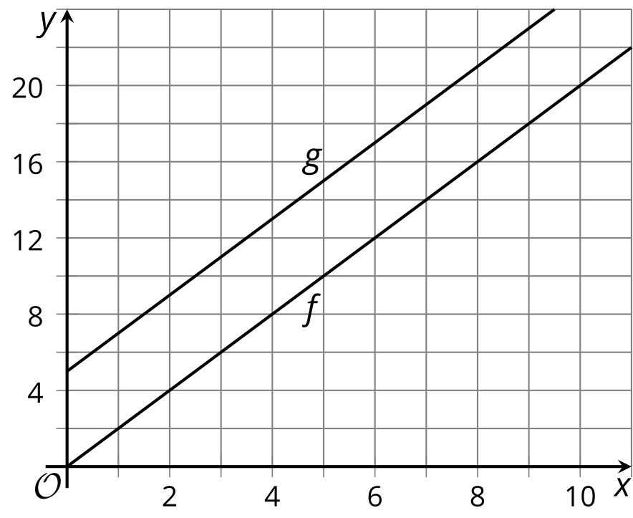
- ​​​​​​
- The function $h$ is given by $h\left(x\right)=5^{x}$.
  - Find the quotient $\frac{h\left(x+2\right)}{h\left(x\right)}$.
  - What does this tell you about how the value of $h$ changes when the input is increased by 2?
  - Find the quotient $\frac{h\left(x+3\right)}{h\left(x\right)}$.
  - What does this tell you about how the value of $h$ changes when the input is increased by 3?
- For each of the functions $f,g,h,p,$ and $q$, the domain is $0≤x≤100$. For which functions is the average rate of change a good measure of how the function changes for this domain? Select all that apply.
  - $f\left(x\right)=x+2$
  - $g\left(x\right)=2^{x}$
  - $h\left(x\right)=111x−23$
  - $p\left(x\right)=50,​000⋅3^{x}$
  - $q\left(x\right)=87.5$
- (From Unit 5, Lesson 10.)
- The average price of a gallon of regular gasoline in 2016 was $2.14. In 2017, the average price was $2.42 a gallon—an increase of 13%.
- At that rate, what will the average price of gasoline be in 2020?
- (From Unit 5, Lesson 16.)
- A credit card charges a 14% annual nominal interest rate and has a balance of $500.
- If no payments are made and interest is compounded quarterly, which expression could be used to calculate the account balance, in dollars, in 3 years?
  - $500⋅{\left(1+0.14\right)}^{3}$
  - $500⋅{\left(1+\frac{0.14}{4}\right)}^{3}$
  - $500⋅{\left(1+\frac{0.14}{4}\right)}^{12}$
  - $500⋅{\left(1+\frac{0.14}{4}\right)}^{48}$
- (From Unit 5, Lesson 17.)
- Here are equations that define four linear functions. For each function, write a verbal description of what is done to the input to get the output, and then write the inverse function.
  - $a\left(x\right)=x−4$
  - $b\left(x\right)=2x−4$
  - $c\left(x\right)=2\left(x−4\right)$
  - $d\left(x\right)=\frac{x}{4}$
- (From Unit 4, Lesson 17.)
© CC BY 2019 by Illustrative Mathematics®

