Lesson 11: Splitting Triangle Sides with Dilation, Part 2
- Let’s investigate parallel segments in triangles.

11.1: Notice and Wonder: Parallel Segments
What do you notice? What do you wonder?

$\overset{↔}{AC}∥\overset{↔}{MN}$
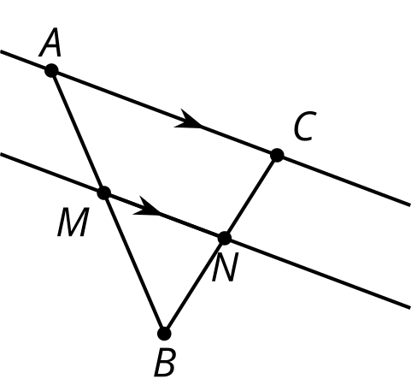

11.2: Prove It: Parallel Segments
Does a line parallel to one side of a triangle always create similar triangles?
- Create several examples. Decide if the conjecture is true or false. If it’s false, make a more specific true conjecture.
- Find any additional information you can be sure is true.
Label it on the diagram.

- $\overset{↔}{AC}∥\overset{↔}{MN}$
- Write an argument that would convince a skeptic that your conjecture is true.

11.3: Preponderance of Proportional Relationships
Find the length of each unlabelled side.
- Segments $AB$ and $EF$ are parallel.

- $\overset{¯}{AB}∥\overset{¯}{EF},\overset{¯}{AD}⊥\overset{¯}{DB}$
- 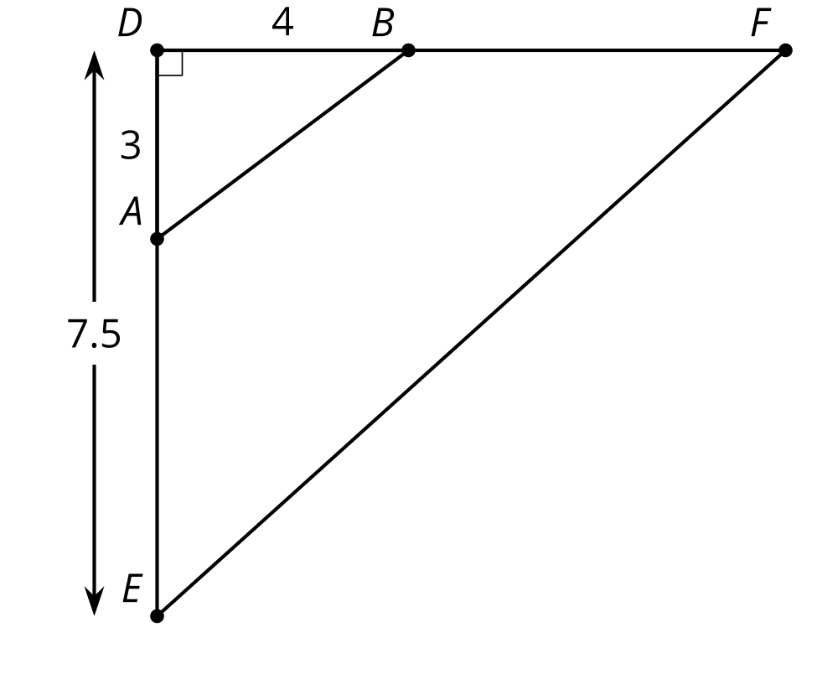
- Segments $BD$ and $FG$ are parallel. Segment $EG$ is 12 units long. Segment $EB$ is 2.5 units long.

- $\overset{¯}{BD}∥\overset{¯}{FG}$
- 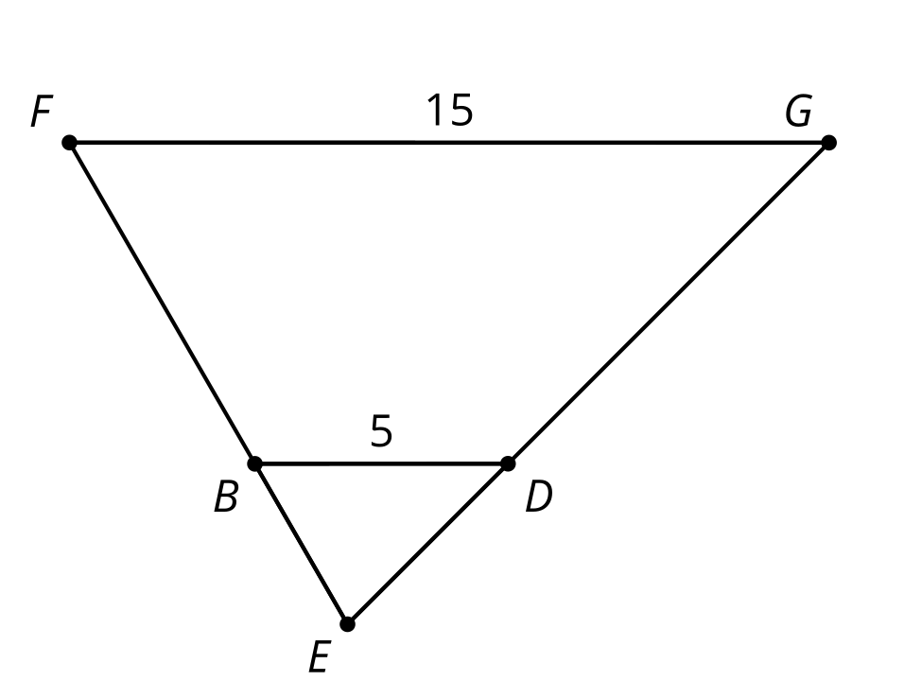

Are you ready for more?
Find the lengths of sides $CE,CB$, and $CA$ in terms of $x,y,$ and $z$. Explain or show your reasoning.
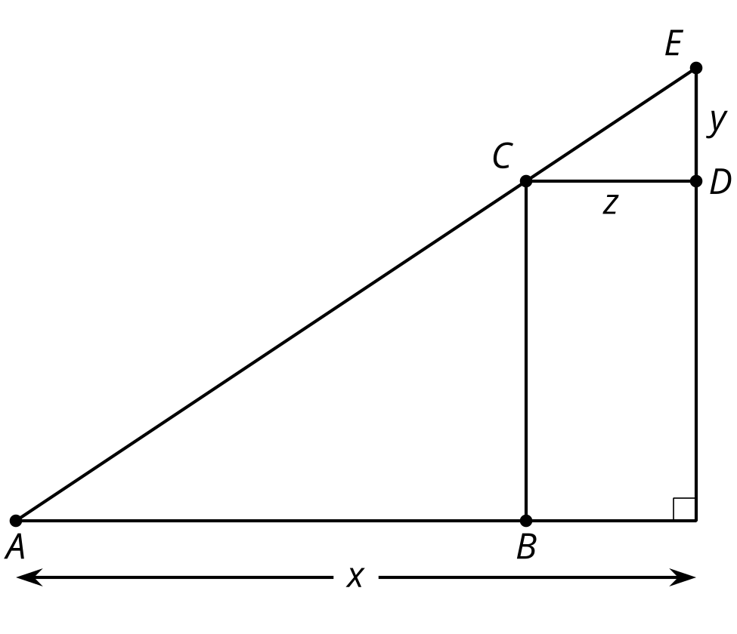

Lesson 11 Summary
In triangle $ABC$, segment $FG$ is parallel to segment $AC$. We can show that corresponding angles in triangle $ACB$ and triangle $GFB$ are congruent, so the triangles are similar by the Angle-Angle Triangle Similarity Theorem. There must be a dilation that sends triangle $GFB$ to triangle $ACB$, and so pairs of corresponding side lengths are in the same proportion. Then we can show that segment $GF$ divides segments $AB$ and $CB$ proportionally. In other words, $\frac{BG}{GA}$=$\frac{BF}{FC}$.

$\overset{↔}{FG}∥\overset{↔}{AC}$
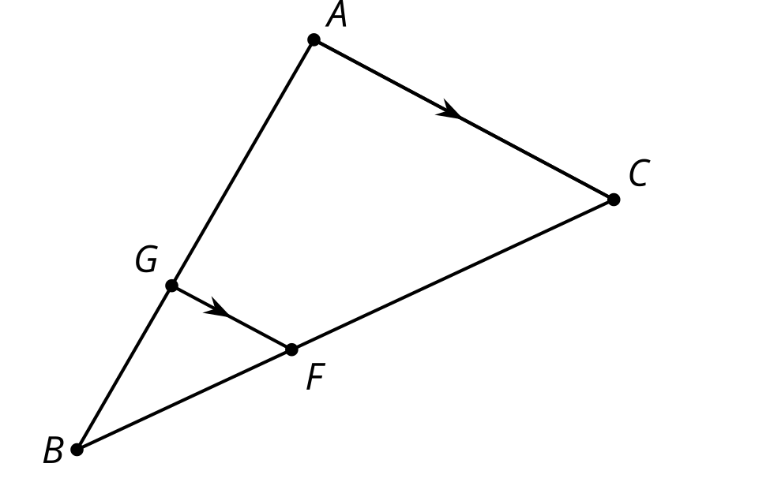
For example, suppose $G$ is $\frac{2}{3}$ of the way from $A$ to $B$ and $F$ is $\frac{2}{3}$ of the way from $C$ to $B$. Then if $BA=9$ and $BC=12$, we know that $GA=6$ and $FC=8$. What will $BG$ and $BF$ equal? Since $BG=3$ and $BF=4$, we know that $\frac{3}{6}=\frac{4}{8}$ and can show that $\frac{BG}{GA}$=$\frac{BF}{FC}$.
This argument holds in general. A segment in a triangle that is parallel to one side of the triangle divides the other 2 sides of the triangle proportionally.
© CC BY 2019 by Illustrative Mathematics®

