Unit 8 Lesson 1: Find the Largest Product

WU Notice and Wonder: Digits (Warm up)

Student Task Statement
What do you notice? What do you wonder?

1 Talk About it

Student Task Statement
- Consider the statement below. Decide whether you agree, disagree, or are unsure. Be prepared to explain your reasoning.
 | - agree | - disagree | - unsure
- Given the digits 7, 5, and 2, the largest product you can make is $75×2$ because 75 is the largest number you can make.
- After round 1: Given the digits 7, 5, and 2, the largest product you can make is $75×2$ because 75 is the largest number you can make.
- Write about something new that you learned from your group or something you still wonder about:
- Use the digits 6, 3, and 1 to make the largest possible product. Be prepared to explain your reasoning.

2 More Digits

Student Task Statement
- Use the digits 7, 3, 2, and 5 to make the greatest product.
- Explain or show how you know you have made the greatest product.

Activity Synthesis
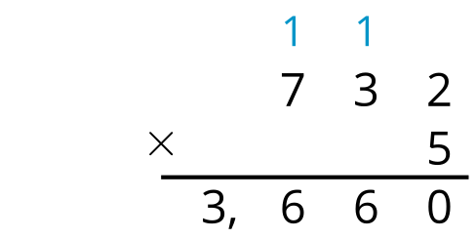
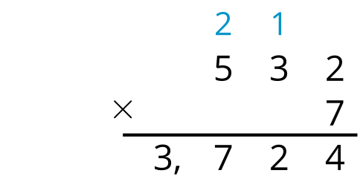
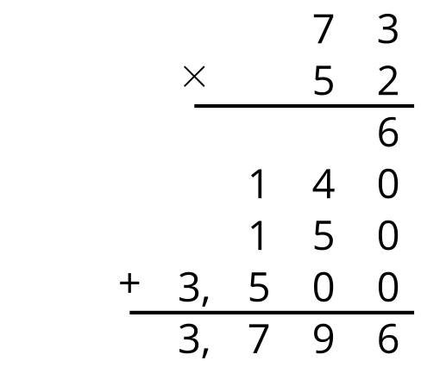
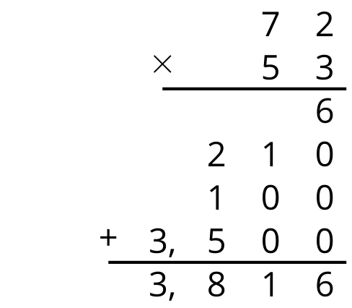

Images for Activity Synthesis
© CC BY 2021 Illustrative Mathematics®

