Unit 6 Lesson 5: Measure with Connecting Cubes

WU Notice and Wonder: Measure a Pencil (Warm up)

Student Task Statement
What do you notice?
What do you wonder?
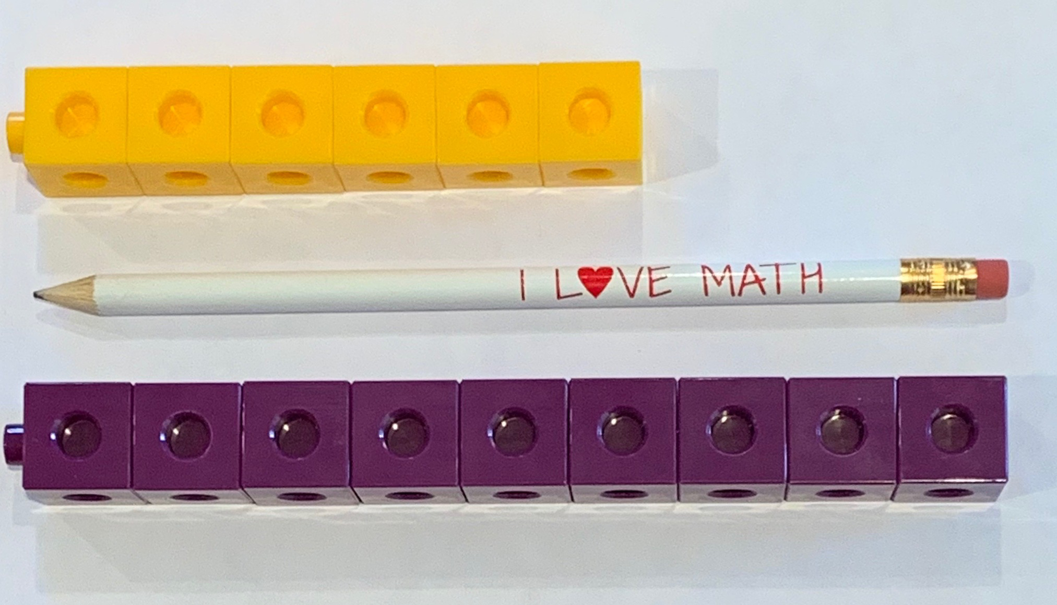

1 Lengths of Creepy, Crawly Things

Student Task Statement

2 Measure More Creepy, Crawly Things

Student Task Statement

3 Centers: Choice Time

Student Task Statement
Choose a center.
How Close?
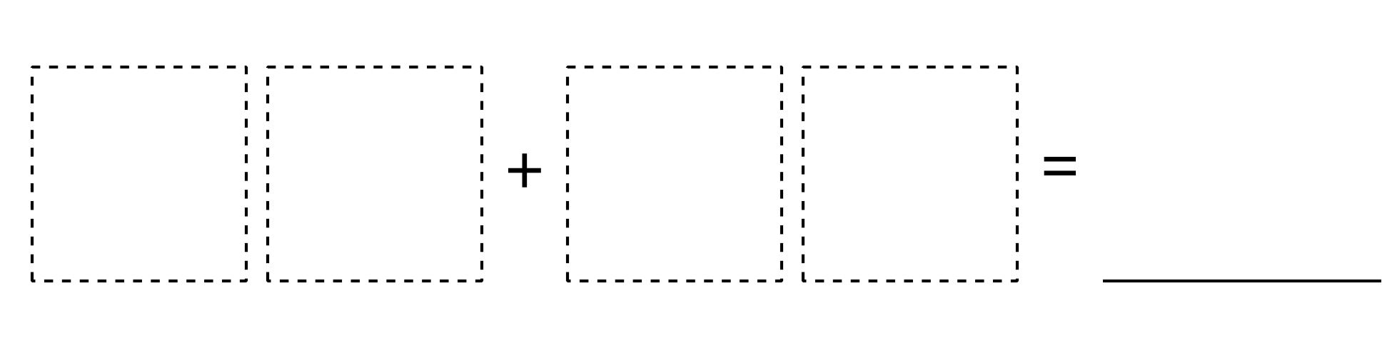
Target Numbers
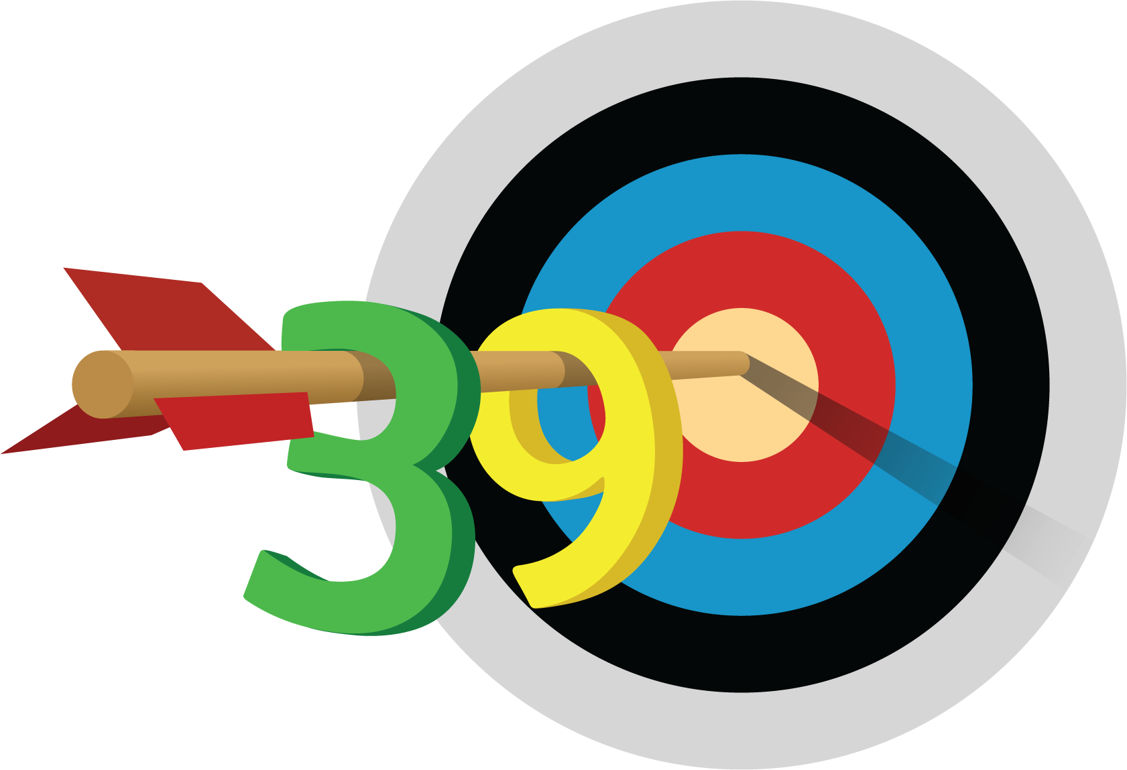
Five in a Row
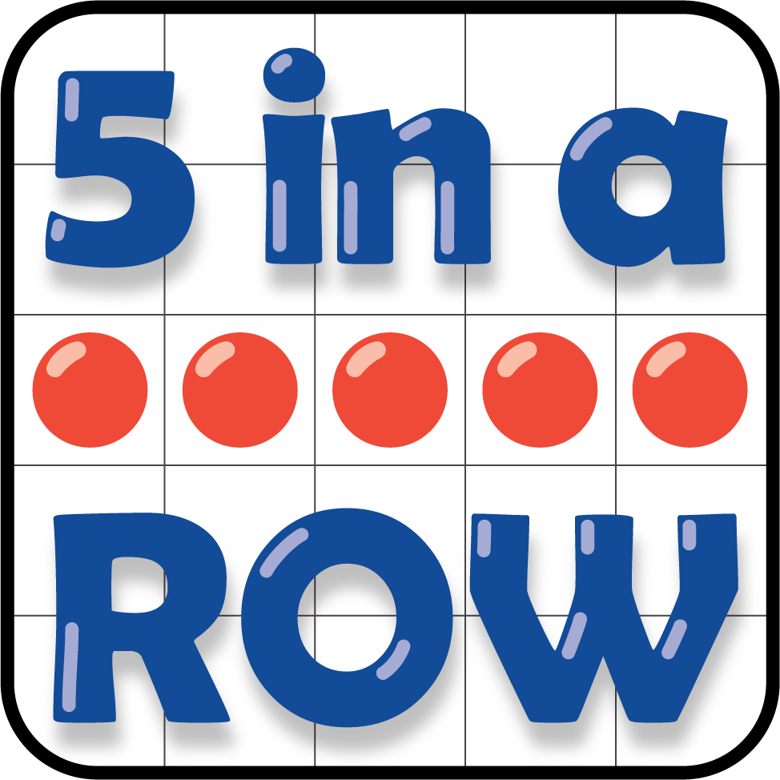

Images for Activity Synthesis
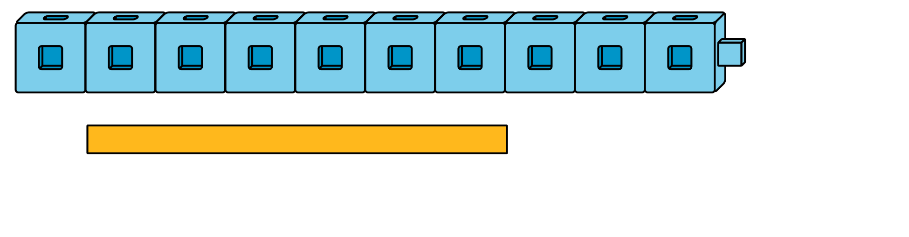
© CC BY 2021 Illustrative Mathematics®

