Unit 5 Lesson 11: Skills for Modeling with Mathematics

1 Which One Doesn’t Belong: Four Graphs (Warm up)

Student Task Statement
Which one doesn’t belong?

A

B
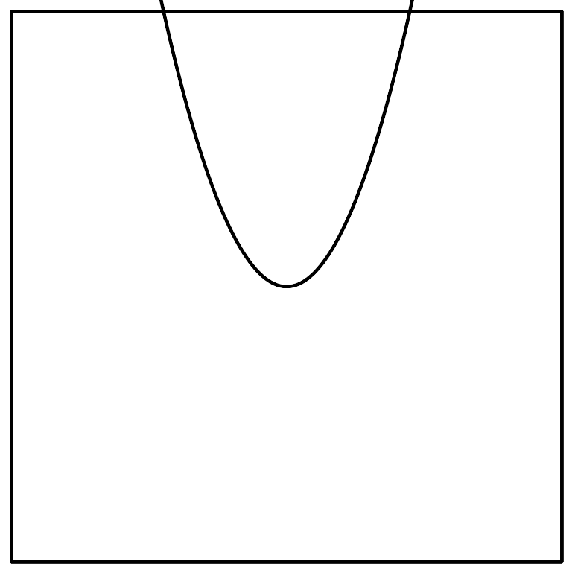

C
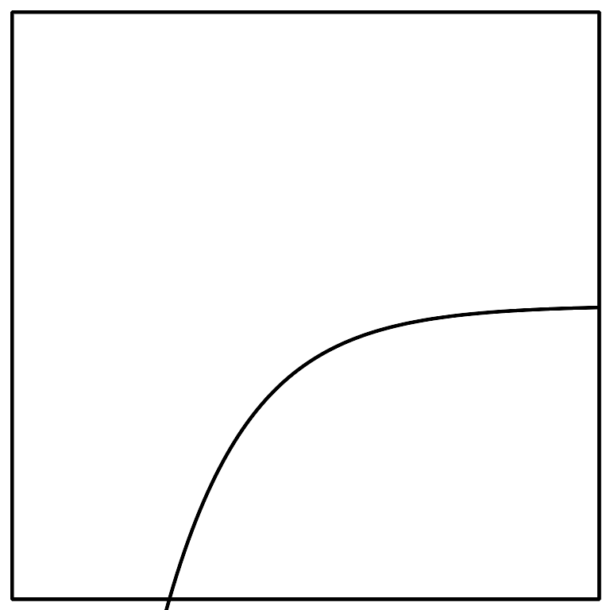

D
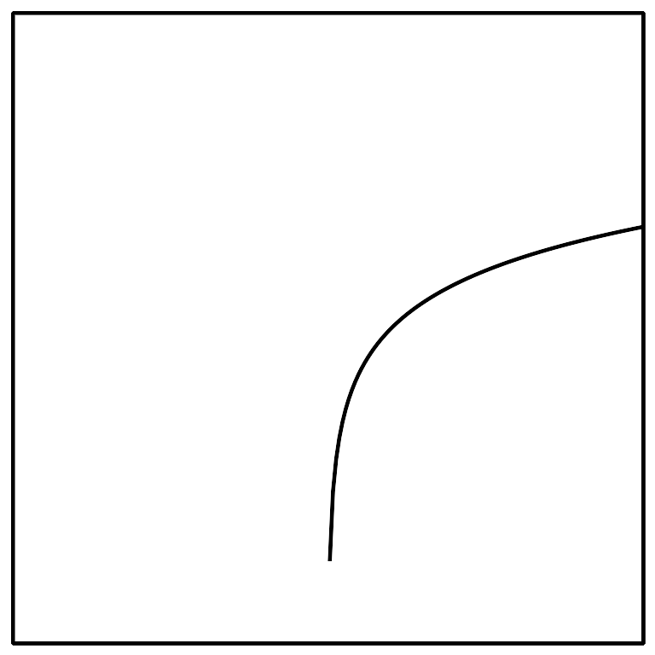

2 Which Model?

Student Task Statement
Consider each situation:
- A person starts with $24,000 in a savings account. Each month, she deposits an additional $2,000 in the account.
- A 30-year old puts $24,000 in a retirement account that increases by 10% each year.
- The value of a car depreciates by a factor of $\frac{4}{5}$ of the car’s value every year. The car initially cost $24,000.
- A farmer has stored 24,000 pounds of grain. His cows eat 4,800 pounds of grain per month.
Match each situation to one of these tables:
A.
$x$ | $y$
0 | 24000
1 | 19200
2 | 15360
3 | 12288
B.
$x$ | $y$
0 | 24000
1 | 26000
2 | 28000
3 | 30000
C.
$x$ | $y$
0 | 24000
1 | 19200
2 | 14400
3 | 9600
D.
$x$ | $y$
0 | 24000
1 | 26400
2 | 29040
3 | 31944

3 Growth of a Small Business

Student Task Statement
Here are two sets of data representing the annual revenue of two different small businesses for the past ten years. One of them had growth that was approximately linear, and one of them had growth that was approximately exponential. The revenue is expressed in thousands of dollars.
Business A:
year | 0 | 1 | 2 | 3 | 4 | 5 | 6 | 7 | 8 | 9
revenue | 61.2 | 68.4 | 74.9 | 83.1 | 88.5 | 96.4 | 104.1 | 109.9 | 117.0 | 125.2
Business B:
year | 0 | 1 | 2 | 3 | 4 | 5 | 6 | 7 | 8 | 9
revenue | 40 | 47.9 | 57 | 70.1 | 82.4 | 99.5 | 118.9 | 144.1 | 172.0 | 205.8
- Which company’s growth could be modeled by a linear function, and which by an exponential function?
- For the company with exponential growth:
  - What was the growth factor?
  - What is an equation that represents the relationship between year and revenue?
  - Use technology to make a scatter plot of the data and also graph your equation. If your equation does not look like a good model for the data, adjust it until you have a good model.
- For the company with linear growth:
  - What was the rate of change?
  - What is an equation that represents the relationship between year and revenue?
  - Use technology to make a scatter plot of the data and also graph your equation. If your equation does not look like a good model for the data, adjust it until you have a good model.
© CC BY 2019 by Illustrative Mathematics®

