Lesson 13 Practice Problems
- On the coordinate plane, plot four points that are each 3 units away from point $P=\left(\text{-}2,\text{-}1\right)$. Write the coordinates of each point.
- 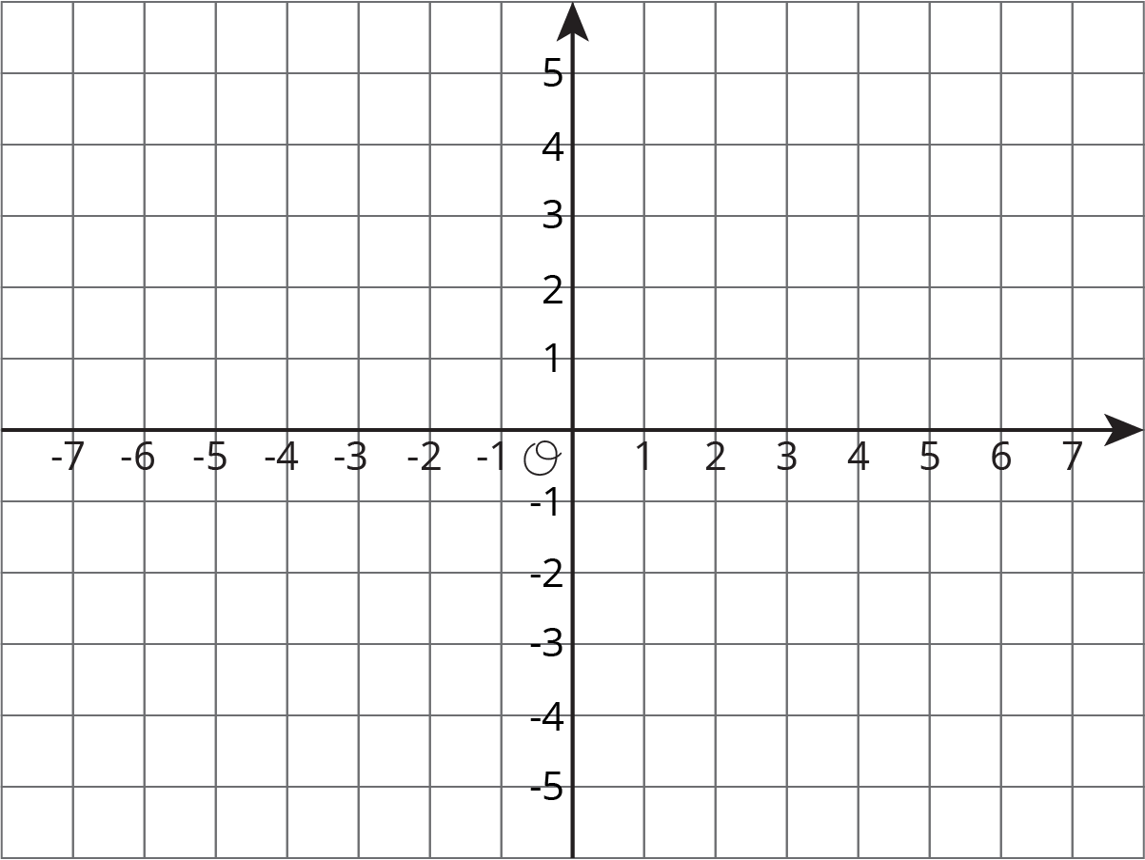
- Each set of points are connected to form a line segment. What is the length of each?
  - A = $\left(3,5\right)$ and B = $\left(3,6\right)$
  - C = $\left(\text{-}2,\text{-}3\right)$ and D = $\left(\text{-}2,\text{-}6\right)$
  - E = $\left(\text{-}3,1\right)$ and F = $\left(\text{-}3,\text{-}1\right)$

  - How much higher is 500 than 400 m?
  - How much higher is 500 than -400 m?
  - What is the change in elevation from 8,500 m to 3,400 m?
  - What is the change in elevation between 8,500 m and -300 m?
  - How much higher is -200 m than 450 m?
- (From Unit 7, Lesson 10.)

  - Plot and connect the following points to form a polygon.
  - $\left(\text{-}3,2\right),\left(2,2\right),\left(2,\text{-}4\right),\left(\text{-}1,\text{-}4\right),\left(\text{-}1,\text{-}2\right),\left(\text{-}3,\text{-}2\right),\left(\text{-}3,2\right)$
  - Find the perimeter of the polygon.
- For each situation, select all the equations that represent it. Choose one equation and solve it.
  - Jada’s cat weighs 3.45 kg. Andre’s cat weighs 1.2 kg more than Jada’s cat. How much does Andre’s cat weigh?
  - $x=3.45+1.2$
  - $x=3.45−1.2$
  - $x+1.2=3.45$
  - $x−1.2=3.45$
  - Apples cost $1.60 per pound at the farmer’s market. They cost 1.5 times as much at the grocery store. How much do the apples cost per pound at the grocery store?
  - $y=\left(1.5\right)⋅\left(1.60\right)$
  - $y=1.60÷1.5$
  - $\left(1.5\right)y=1.60$
  - $\frac{y}{1.5}=1.60$
- (From Unit 4, Lesson 4.)
© CC BY Open Up Resources. Adaptations CC BY IM.

