Lesson 14: Formas de representar la multiplicación de números del 11 al 19

Standards Alignments
Addressing | 3.OA.B.5
Building Towards | 3.OA.C.7

Teacher-facing Learning Goals
- Make sense of representations of multiplication (base-ten blocks and area diagrams) where one factor is a teen number.

Student-facing Learning Goals
- Démosle sentido a algunas formas de representar la multiplicación de números del 11 al 19.

Lesson Purpose
The purpose of this lesson is for students to make sense of representations of the multiplication of teen numbers.
The work of this lesson connects to previous work because students have solved problems involving multiplication of teen numbers in ways that make sense to them. In the previous section they also used the distributive property to find products of single-digit factors using facts they know. In this lesson, students consider and connect different representations of a strategy used in the previous section that can also be used to multiply a teen number. This will be helpful in the next lesson when students solve these types of problems and choose how to represent the problem.

Access for:

Students with Disabilities
- Representation (Activity 2)

English Learners
- MLR8 (Activity 2)

Instructional Routines
Notice and Wonder (Warm-up)

Materials to Gather
- Base-ten blocks: Activity 1

Lesson Timeline
Warm-up | 10 min
Activity 1 | 20 min
Activity 2 | 15 min
Lesson Synthesis | 10 min
Cool-down | 5 min

Teacher Reflection Question
How did their previous work with area diagrams support students in their work today with multiplying teen numbers?

Cool-down
(to be completed at the end of the lesson) 5min
Multiplica y explica

Standards Alignments
Addressing | 3.OA.B.5

Student-facing Task Statement
Encuentra el valor de $5×15$ y explica cómo está representado esto en el diagrama.
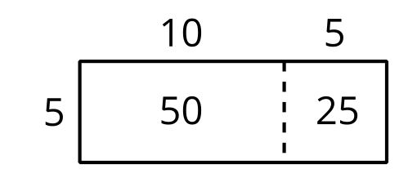

Student Responses
75. Sample response: I can see $5×10$ in the large part of the rectangle and $5×5$ in the smaller part. If we add those parts of the rectangle, we get the product of $5×15$, which is 75.

