Lesson 19: Compongamos y descompongamos para sumar y restar

Standards Alignments
Addressing | 4.NBT.B.4, 4.NF.B.3.c

Teacher-facing Learning Goals
- Add and subtract multi-digit numbers, with composing or decomposing, using the standard algorithm.

Student-facing Learning Goals
- Compongamos y descompongamos unidades en base diez para sumar y restar.

Lesson Purpose
The purpose of this lesson is for students to review how to add and subtract multi-digit numbers with composition and decomposition.
In earlier grades, students encountered subtraction problems which required decomposing a unit. In this lesson, students review this idea of decomposition and revisit how it is recorded when using the standard algorithm to subtract numbers through the thousands place. Students also use composition to add multi-digit numbers through the hundred-thousands place.

Access for:

Students with Disabilities
- Representation (Activity 2)

Instructional Routines
MLR7 Compare and Connect (Activity 2), Number Talk (Warm-up)

Materials to Gather
- Grid paper: Activity 1

Lesson Timeline
Warm-up | 10 min
Activity 1 | 15 min
Activity 2 | 20 min
Lesson Synthesis | 10 min
Cool-down | 5 min

Teacher Reflection Question
Who got to do math today in class? How do you know? What norms or routines allowed those students to engage? How can you adjust these norms and routines so all students do math tomorrow?

Cool-down
(to be completed at the end of the lesson) 5min
Unas diferencias y luego una suma

Standards Alignments
Addressing | 4.NBT.B.4

Student-facing Task Statement
- Usa el algoritmo estándar para encontrar cada diferencia.
  - $1,​993−118$
  - $1,​897−116$
- Encuentra el valor de esta suma.
- 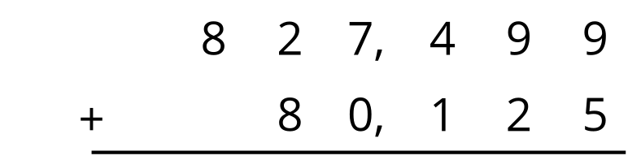

Student Responses

  - 1,875
  - 1,781
- 907,624

