Unit 2 Lesson 8: Projecting and Scaling

1 Number Talk: Remembering Fraction Division (Warm up)

Student Task Statement
Find each quotient. Write your answer as a fraction or a mixed number.
$6\frac{1}{4}÷2$
$10\frac{1}{7}÷5$
$8\frac{1}{2}÷11$

2 Sorting Rectangles

Student Task Statement
Rectangles were made by cutting an $8\frac{1}{2}$-inch by 11-inch piece of paper in half, in half again, and so on, as illustrated in the diagram. Find the lengths of each rectangle and enter them in the appropriate table.
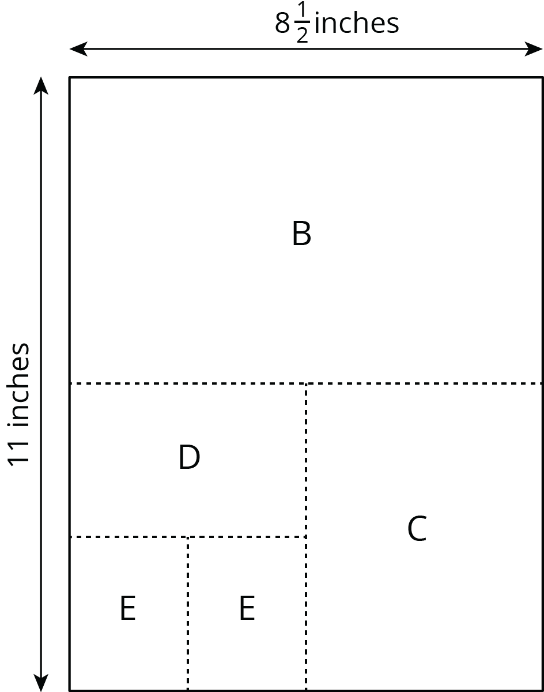

- Some of the rectangles are scaled copies of the full sheet of paper (Rectangle A). Record the measurements of those rectangles in this table.
- rectangle | - length of short side (inches) | - length of long side (inches)
- A | - $8\frac{1}{2}$ | - 11
- Some of the rectangles are not scaled copies of the full sheet of paper. Record the measurements of those rectangles in this table.
- rectangle | - length of short side (inches) | - length of long side (inches)
- Look at the measurements for the rectangles that are scaled copies of the full sheet of paper. What do you notice about the measurements of these rectangles? Look at the measurements for the rectangles that are not scaled copies of the full sheet. What do you notice about these measurements?
- Stack the rectangles that are scaled copies of the full sheet so that they all line up at a corner, as shown in the diagram. Do the same with the other set of rectangles. On each stack, draw a line from the bottom left corner to the top right corner of the biggest rectangle. What do you notice?
- 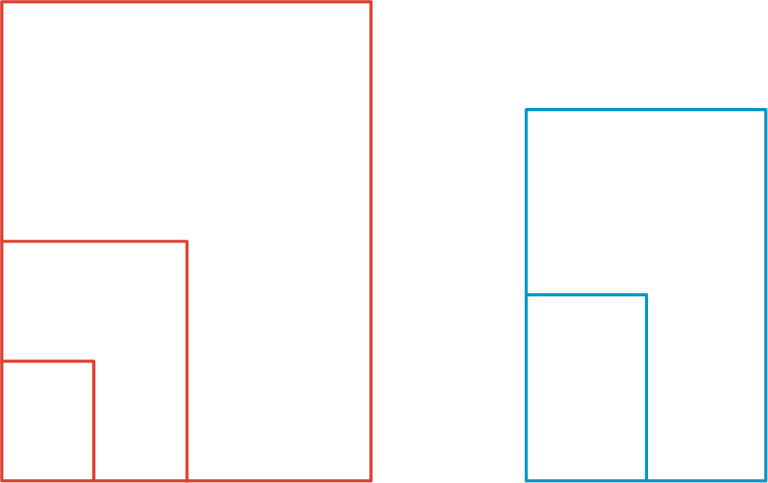
- Stack all of the rectangles from largest to smallest so that they all line up at a corner. Compare the lines that you drew. Can you tell, from the drawn lines, which set each rectangle came from?

3 Scaled Rectangles (Optional)

Student Task Statement
Here is a picture of Rectangle R, which has been evenly divided into smaller rectangles. Two of the smaller rectangles are labeled B and C.
- Is $B$ a scaled copy of $R$? If so, what is the scale factor?
- Is $C$ a scaled copy of $B$? If so, what is the scale factor?
- Is $C$ a scaled copy of $R$? If so, what is the scale factor?
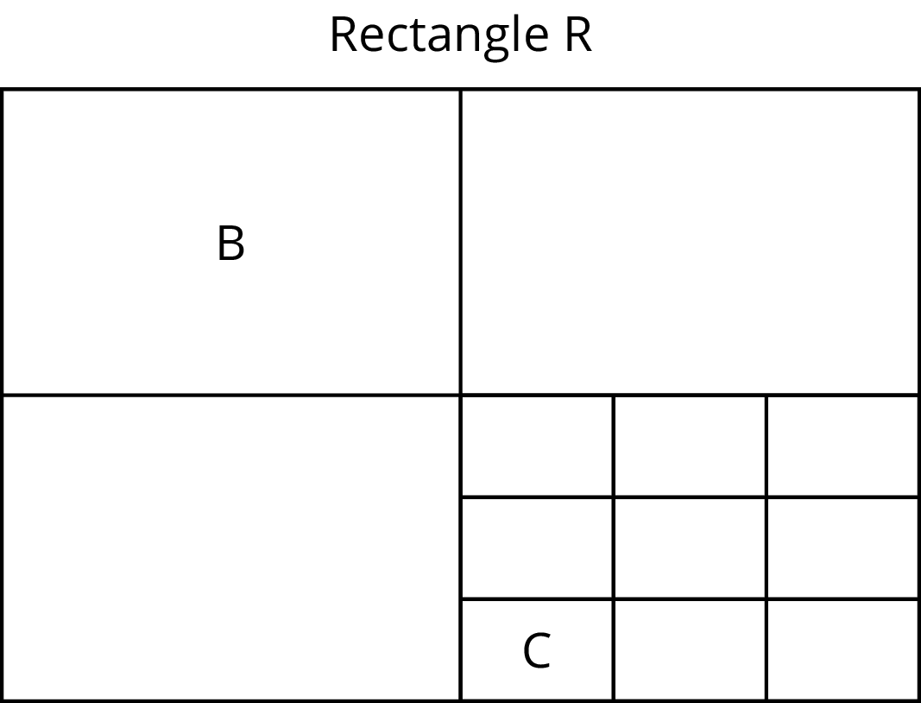

© CC BY Open Up Resources. Adaptations CC BY IM.

