Unit 3 Lesson 4: Describe, Compare, and Sort Shapes

WU Choral Count: Extend the Count Sequence (Warm up)

Student Task Statement

1 Classroom Shape Hunt

Student Task Statement
Shape A
Shape B

2 Shape Sort

Student Task Statement

3 Centers: Choice Time

Student Task Statement
Choose a center.
Which One
Picture Books
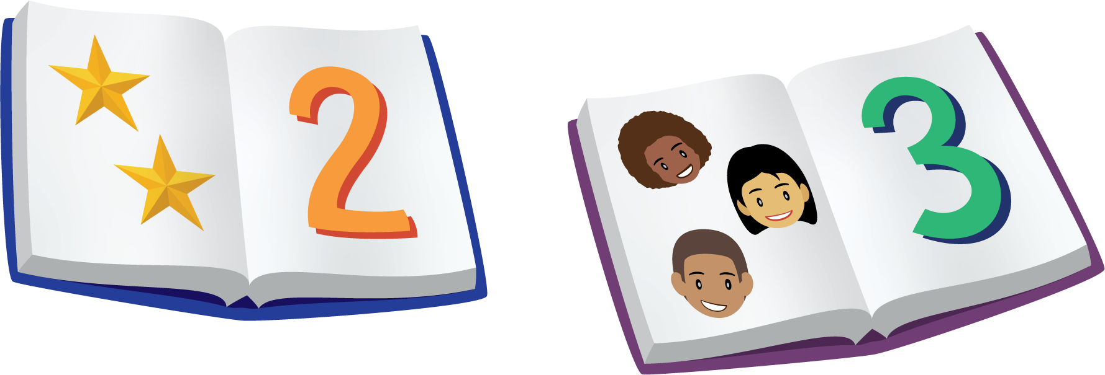
Bingo
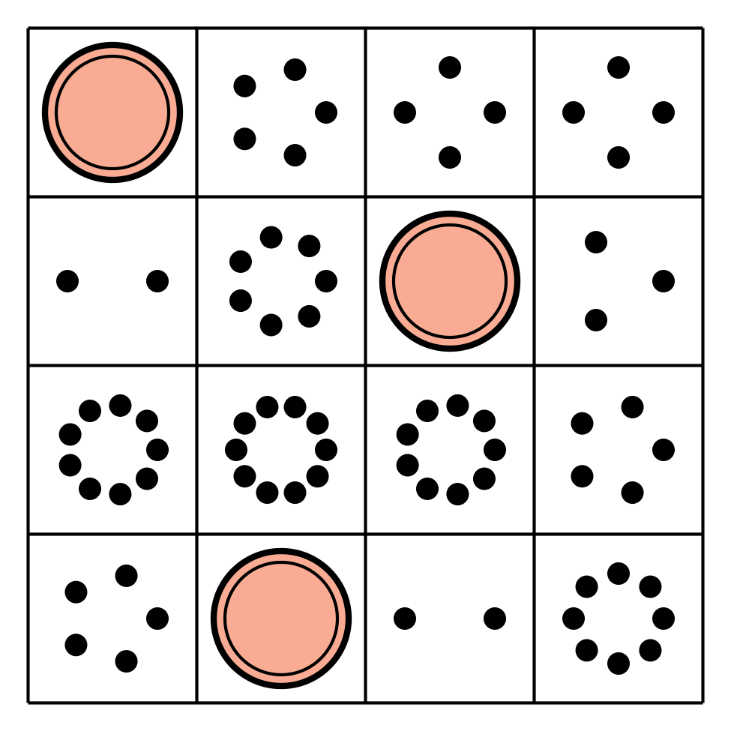
Shake and Spill
© CC BY 2021 Illustrative Mathematics®

