Unit 2 Lesson 25: Representing Systems of Inequalities

1 Which One Doesn’t Belong: Splash Zone! (Warm up)

Student Task Statement
Which one doesn't belong?
A: Clare’s family wants to
- spend at least 4 hours at the amusement park
- spend more time in the Splash Zone than riding rides
B: Jada’s family wants to
- be at the amusement park from 4 p.m. to 8 p.m.
- spend most of their time riding rides
C: Priya’s family wants to
- spend 2 hours at Splash Zone
- spend 2 hours riding rides
D: Diego’s family wants to
- spend no more than 6 hours at the amusement park
- spend at least twice as long riding rides as they spend at Splash Zone

2 Amusing Solutions

Student Task Statement
For each family, let $x$ be the amount of time each family spends riding rides, and $y$ be the amount of time each family spends at the Splash Zone.
List one or more ordered pairs $\left(x,y\right)$ that would fit the constraints. If you can only list one, explain why you can only list one.
- Clare’s family wants to spend at least 4 hours at the amusement park, and they want to spend more time in the Splash Zone than riding rides.
- Jada’s family wants to be at the amusement park from 4 p.m. to 8 p.m., and they want to spend most of their time riding rides.
- Priya’s family wants to spend 2 hours at Splash Zone and 2 hours riding rides.
- Diego’s family wants to spend no more than 6 hours at the amusement park, and they want to spend at least twice as long riding rides as they spend at Splash Zone.

3 Which Section?

Student Task Statement
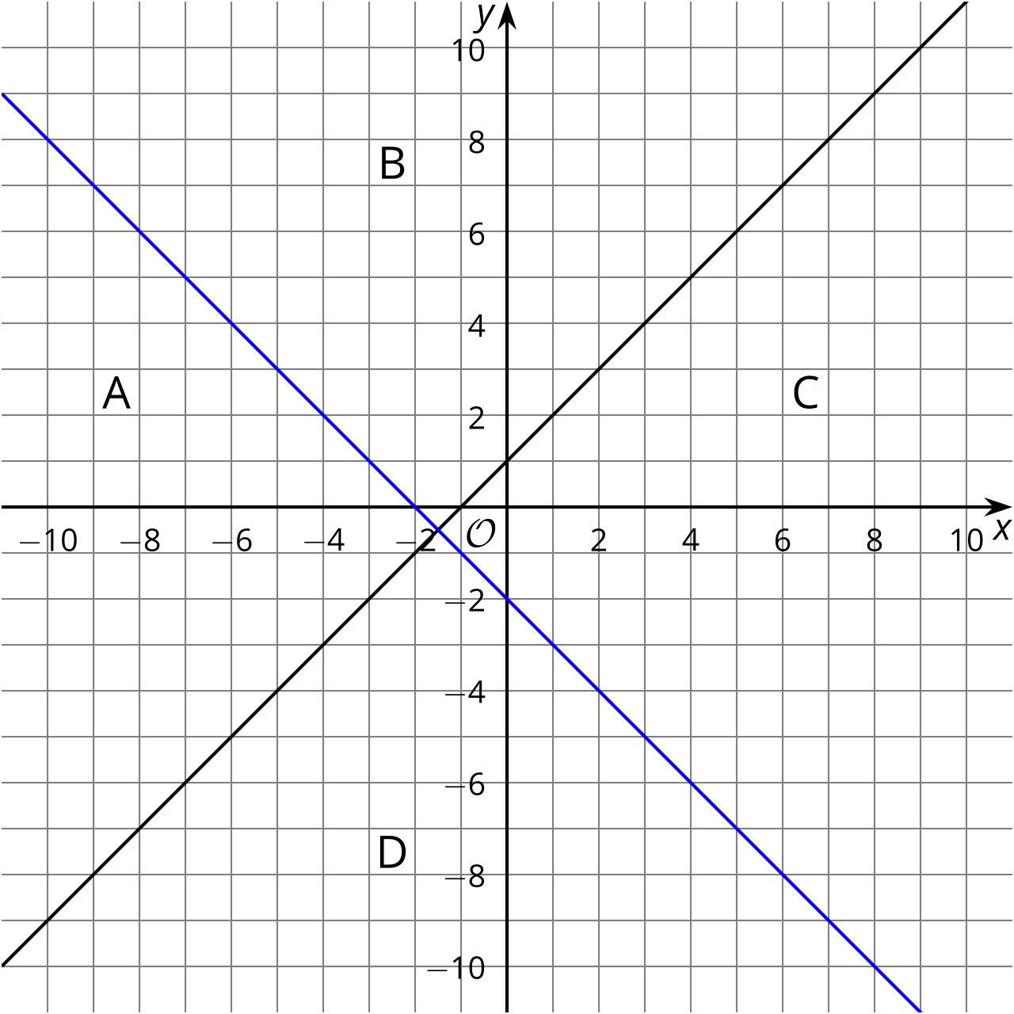
- The graph shows the lines $y=x+1$ and $y=\text{-}x−2$. Which line represents $y=x+1$?
- For each of the 4 regions, write a coordinate pair for a point in that region.
- Change the equations represented by the lines into inequalities so that the region labeled as A is shaded by both inequalities.
  - $y\underset{_}{​}x+1$
  - $y\underset{_}{​}\text{-}x−2$
- Use the coordinate pairs you chose for region A to check your inequalities.
© CC BY 2019 by Illustrative Mathematics®

