Lesson 12: Practice With Proportional Relationships
- Let’s find unknown values in proportional relationships.

12.1: Vegetable Garden
These are the plans for a vegetable garden that a school is designing.
Scale: 1 unit = 2.8 ft
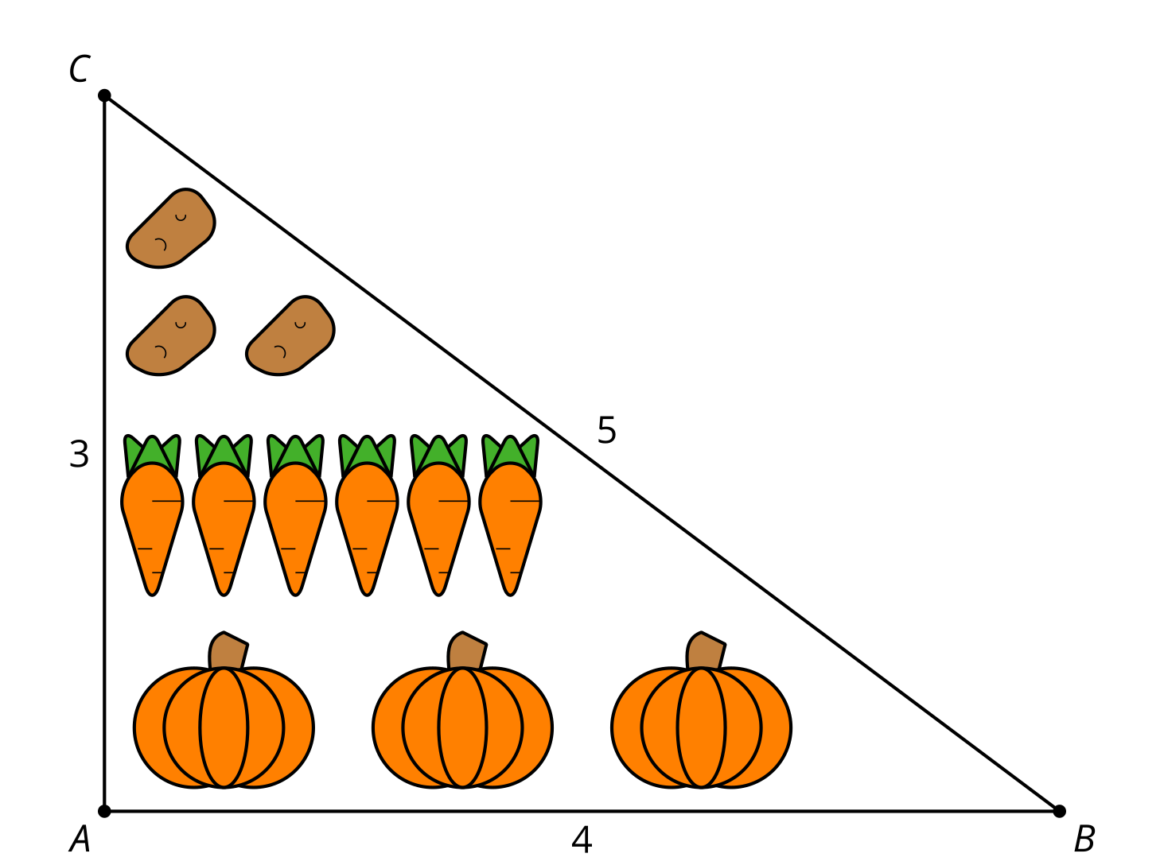
Write at least 3 equivalent ratios or equations using lengths from both the diagram and the full-size garden.

12.2: Card Sort: Corresponding Parts
Your teacher will give you a set of cards. Group them into pairs of similar figures. For each pair, determine:
- a similarity statement
- the scale factor between the similar figures
- the missing lengths

12.3: Quilting Questions
- Here is a quilt design made of right isosceles triangles. The smallest squares in the center have an area of 1 square unit. Find the dimensions of the triangles.
- 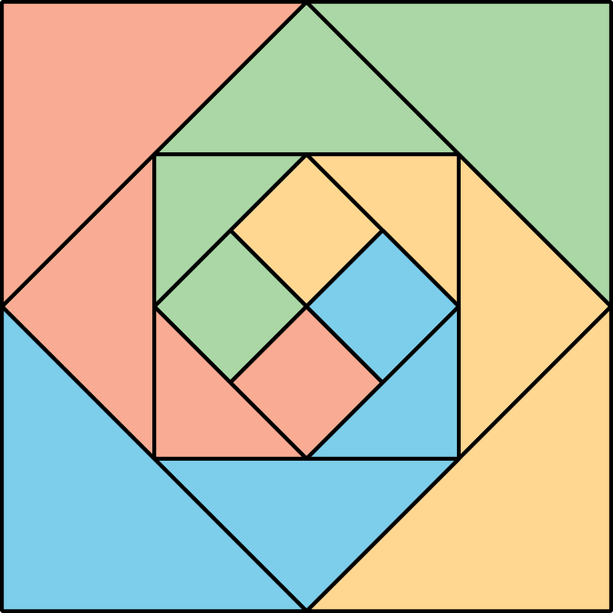
- Are the triangles similar? If so, what are the scale factors?
- This quilt is meant for a baby (1 unit = 6 inches). To make a quilt for a queen-size bed, it needs to be 90 inches wide. What dimensions should the center squares of the big quilt have to reach that width?

Are you ready for more?
- Here is a quilt design made of right triangles. Find as many different size triangles as you can.
- 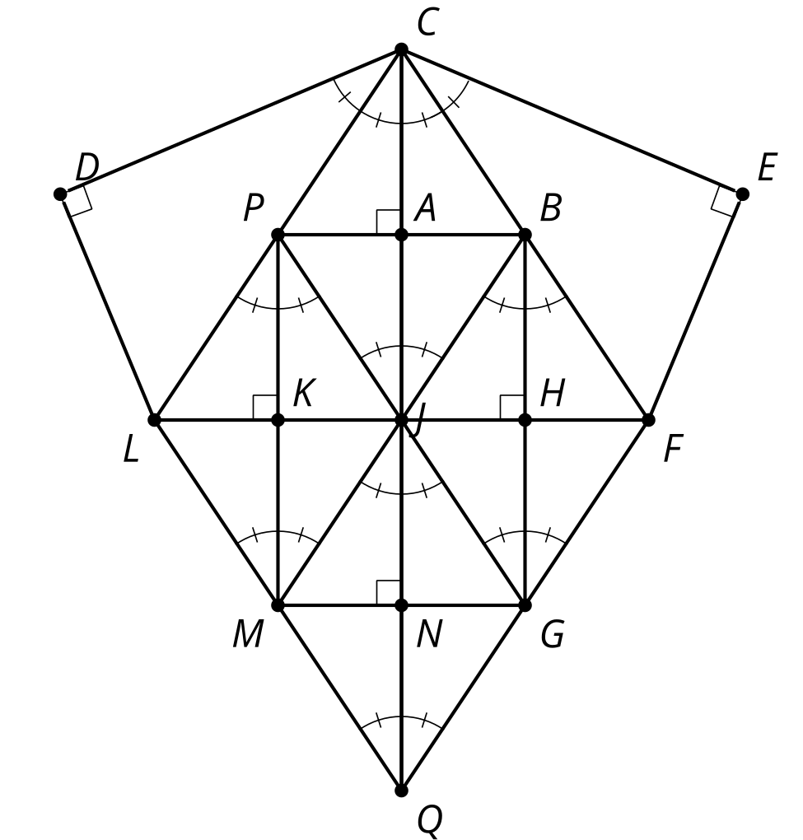
- Write similarity statements for 2 pairs of triangles.
- The smallest triangles have legs 2 units and 3 units long. Write some equivalent ratios or equations that will help you determine the dimensions of triangle $LCQ$. Use your equivalent ratios or equations to find the dimensions of triangle $LCQ$.

Lesson 12 Summary
When 2 figures are similar, there are lots of equivalent ratios between the triangles and within the triangles. We can use those relationships to find missing lengths. For example, if we know that triangle $ABC$ is similar to triangle $DEF$, we know that pairs of corresponding side lengths are in the same proportion. $\frac{AB}{DE}=\frac{BC}{EF}=\frac{AC}{DF}$
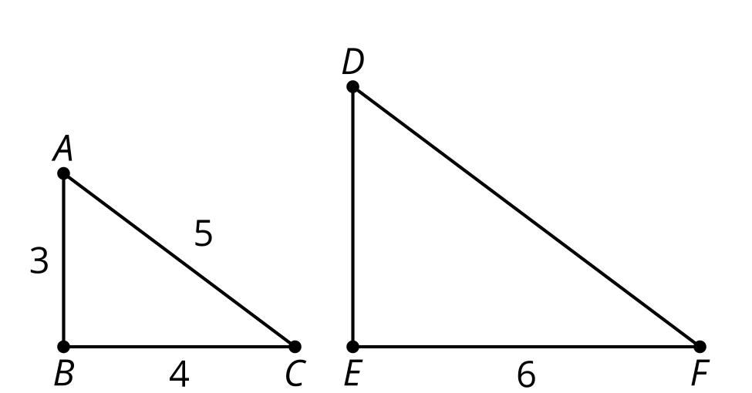
We also know that pairs of side lengths in one triangle are in the same proportion as pairs of side lengths in the other triangle.
$\frac{AB}{BC}=\frac{DE}{EF}$
$\frac{AB}{AC}=\frac{DE}{DF}$
$\frac{AC}{BC}=\frac{DF}{EF}$
We can use these equivalent ratios to find unknown side lengths. Which equivalent ratios would work to find $DE$ and $DF$?
We can use $\frac{AB}{BC}=\frac{DE}{EF}$ to find $DE$. Then $\frac{3}{4}=\frac{DE}{6}$, which gives $DE=4.5$.
Or we can use $\frac{AB}{DE}=\frac{BC}{EF}$ to find $DE$. In this case, we get $\frac{3}{DE}=\frac{4}{6}$, which also gives $DE=4.5$.
© CC BY 2019 by Illustrative Mathematics®

