Unit 8 Lesson 2: More Multiplication

WU Estimation Exploration: Large Product (Warm up)

Student Task Statement
$9,​999×896$
Record an estimate that is:
too low | about right | too high

1 Kiran’s Work

Student Task Statement
- Find the value of the product.
- 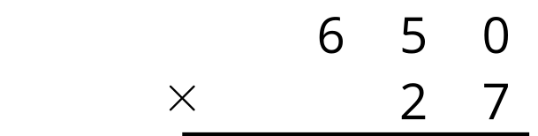
- Below is Kiran’s work finding the value of the product $650×27$. Is his answer reasonable? Explain your reasoning.
- 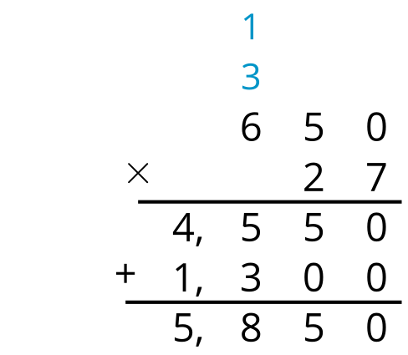
- What parts of the work do you agree with? Be prepared to explain your reasoning.
- What parts of the work do you disagree with? Be prepared to explain your reasoning.
- Look at your solution to problem 1. Is there anything you want to revise? Be prepared to explain.

2 Zero the Hero

Student Task Statement
Find the value of each product.
1.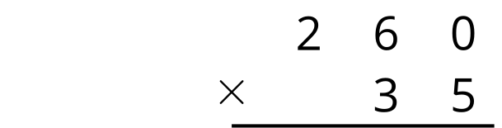
2.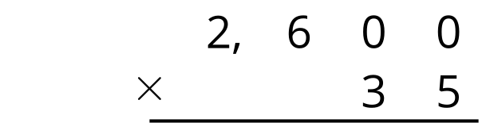
3.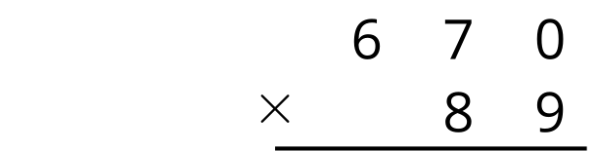
4.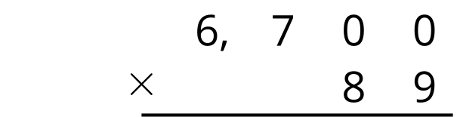

Activity Synthesis
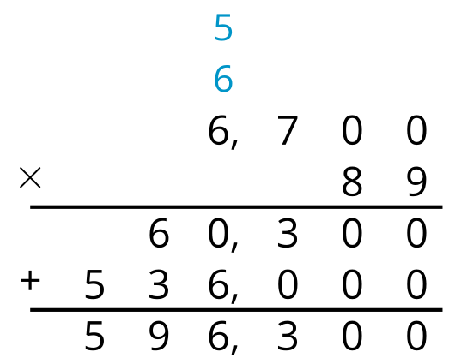

Images for Activity Synthesis
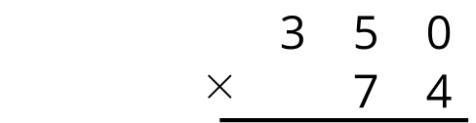
© CC BY 2021 Illustrative Mathematics®

