Unit 1 Lesson 6: Expressions for Volume

WU True or False: Parentheses or No Parentheses (Warm up)

Student Task Statement
Decide if each statement is true or false. Be prepared to explain your reasoning.
- $\left(4×2\right)×5=4×\left(2×5\right)$
- $\left(2×5\right)×4=2×20$
- $5×4×2=10×40$

1 Card Sort: Match the Expression

Student Task Statement
- Match each rectangular prism with the expression(s) that represents its volume in cubic units. Be prepared to explain your reasoning.
- For each prism write one additional expression, not in the card sort, that represents its volume in cubic units.
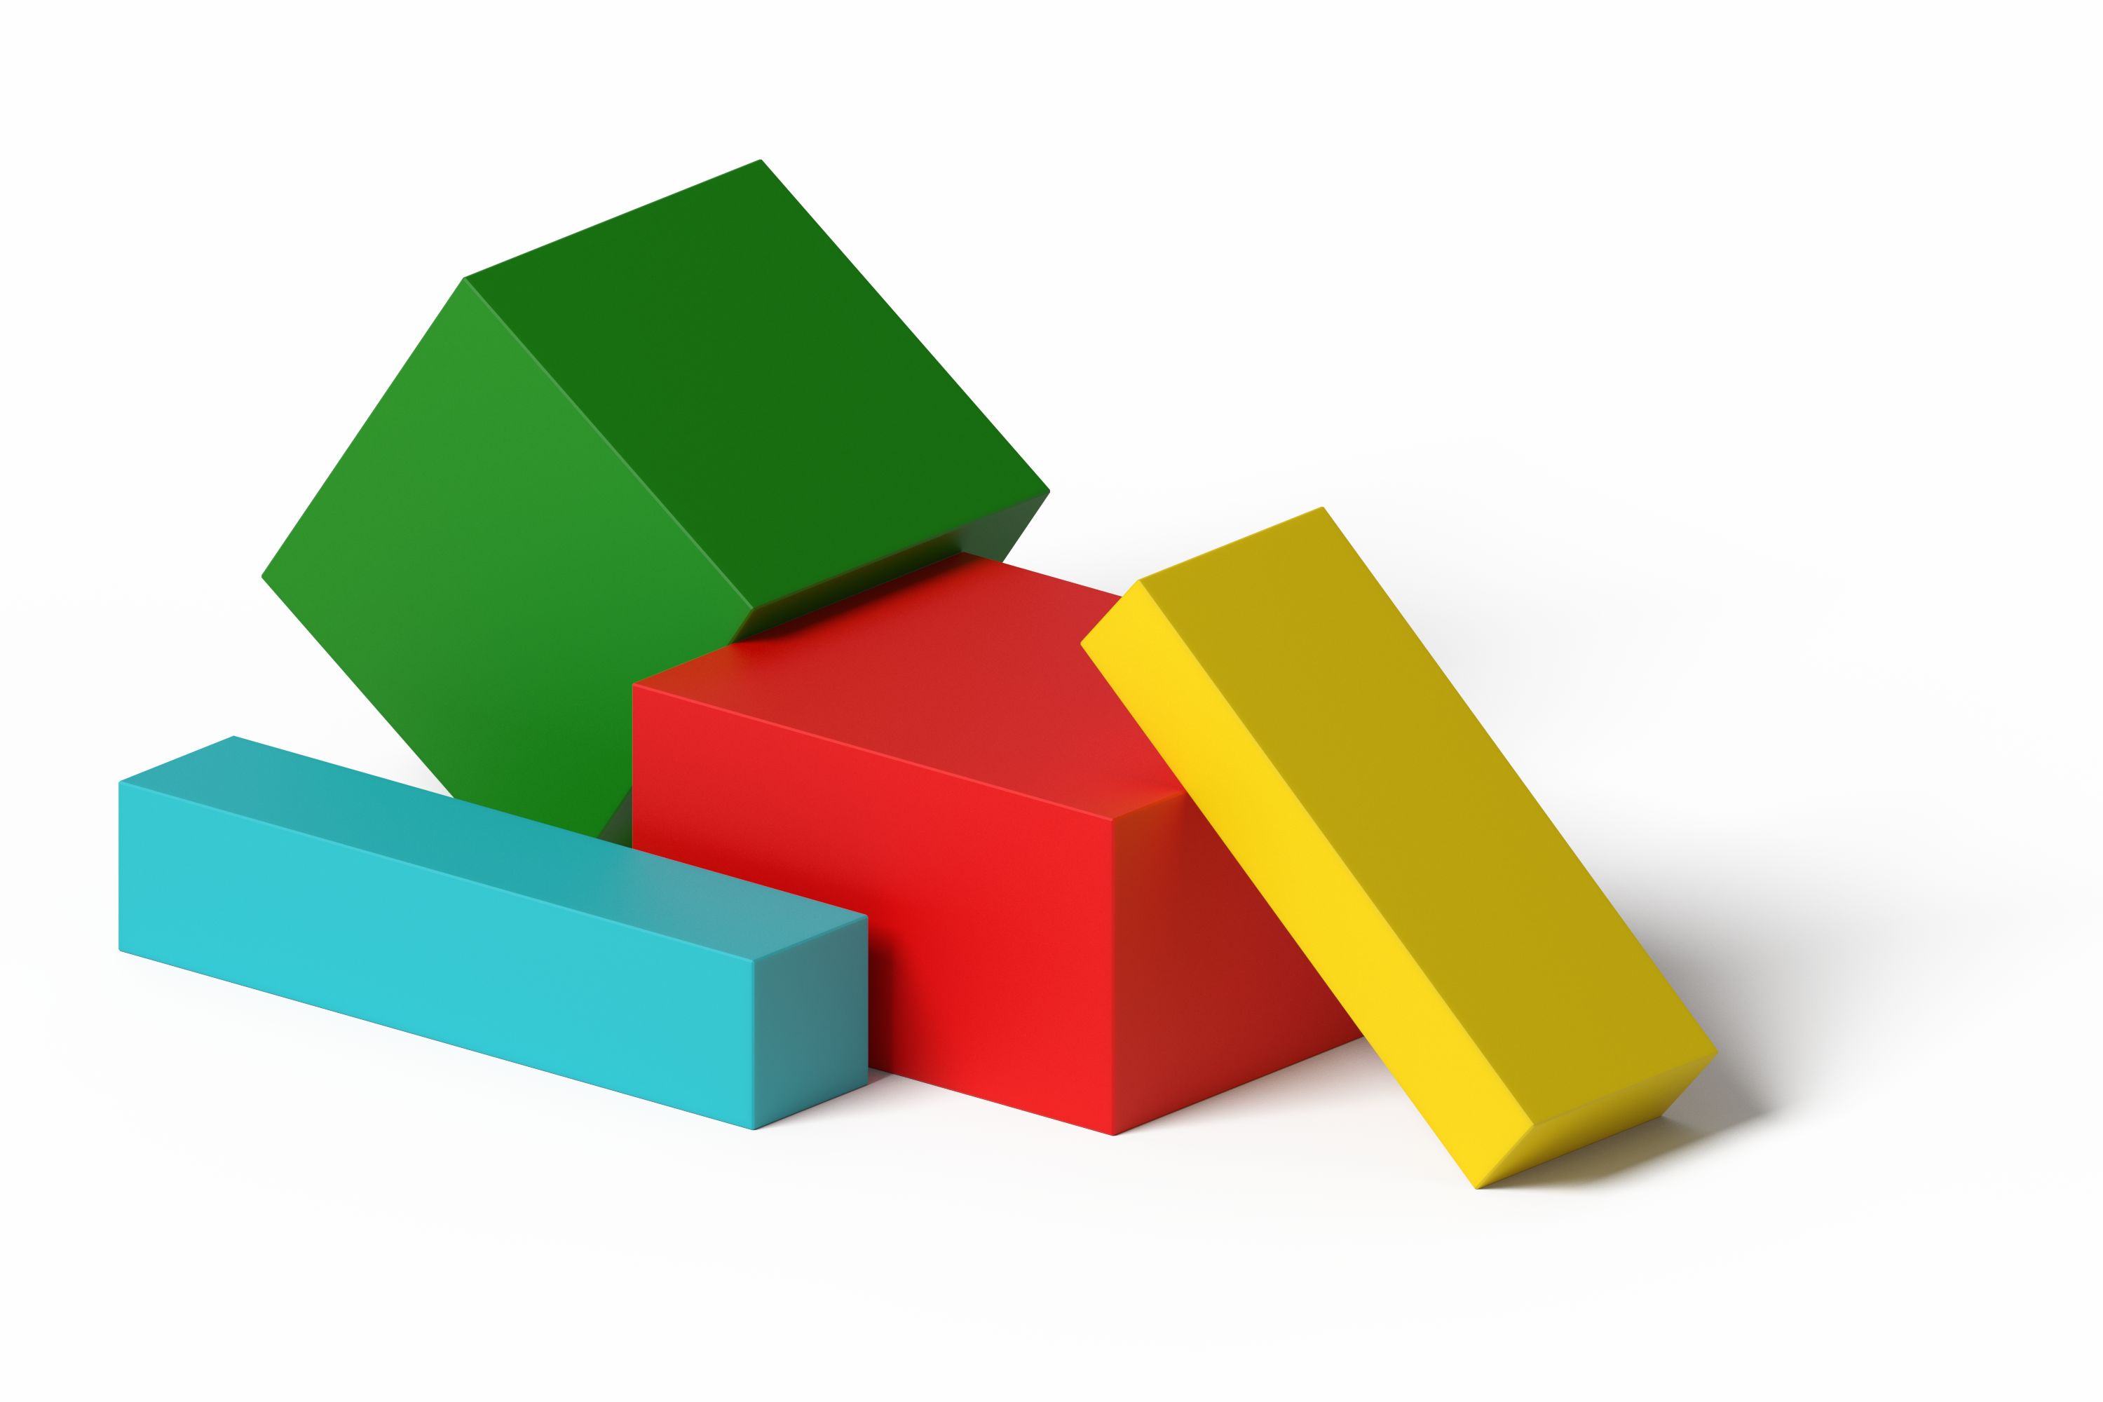

Activity Synthesis
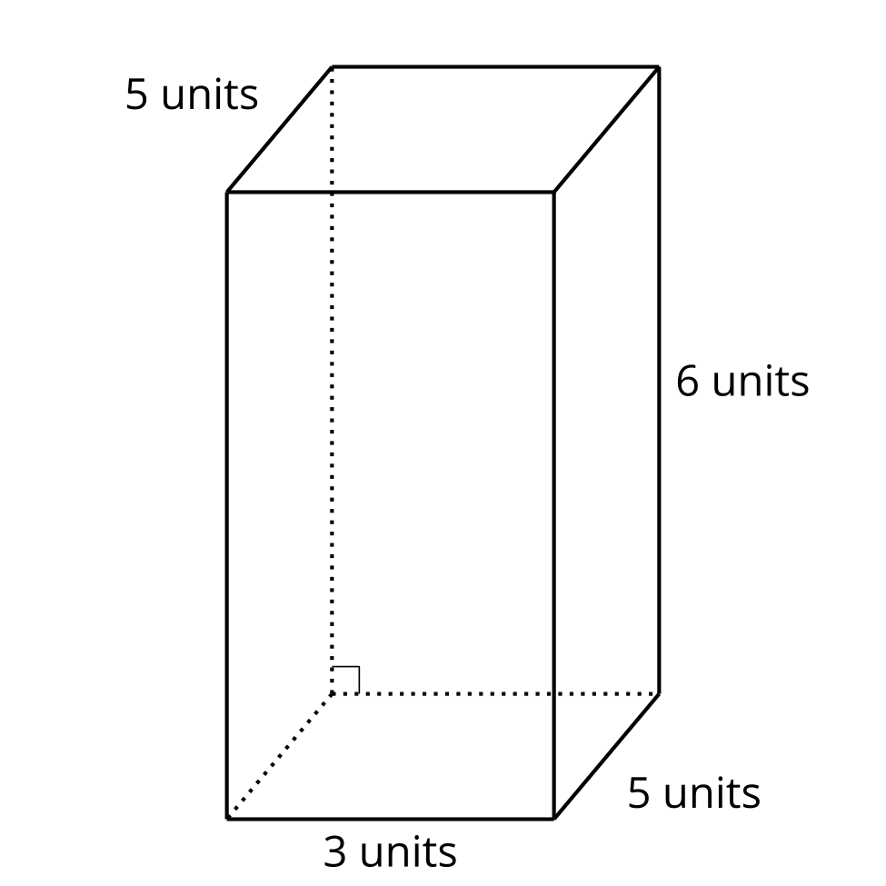

2 A Tale of Two Tables

Student Task Statement
- Work with your partner to complete the tables. One partner completes Table 1 and the other completes Table 2.
- Prism A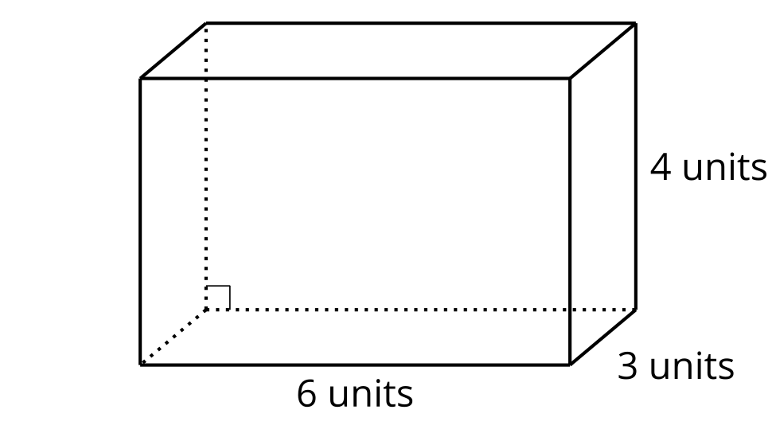
- Prism B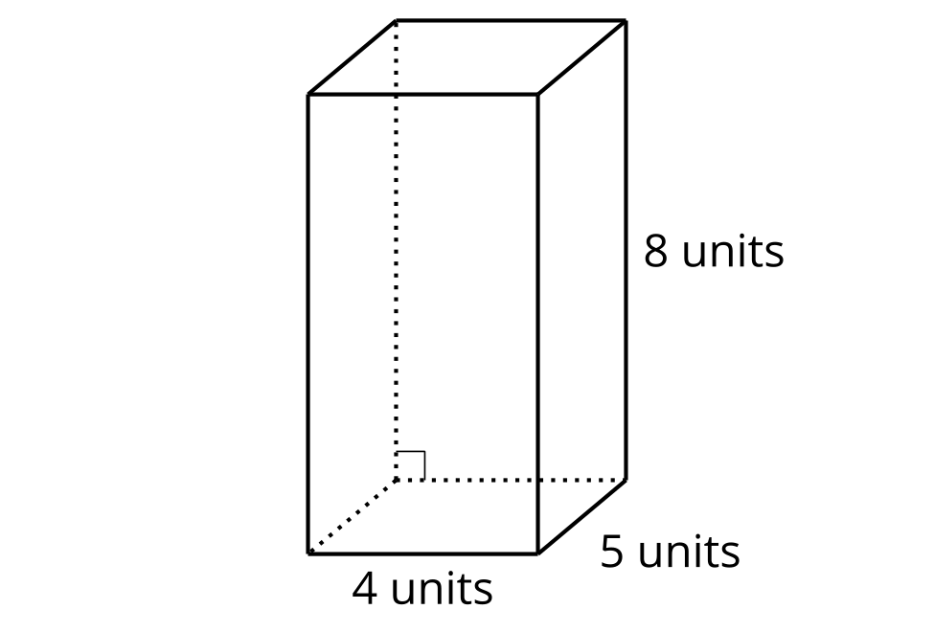
- Table 1
 | - length (units) | - width (units) | - height (units) | - volume (cubic units)
- Prism A
- Prism B
- Table 2
 | - area of the base (square units) | - height (units) | - volume (cubic units)
- Prism A
- Prism B
- Compare your tables and discuss:
  - What do the tables have in common?
  - What is different about the tables?

3 Two Truths and a Lie (Optional)

Student Task Statement
Your teacher will assign you and your partner two prisms.
A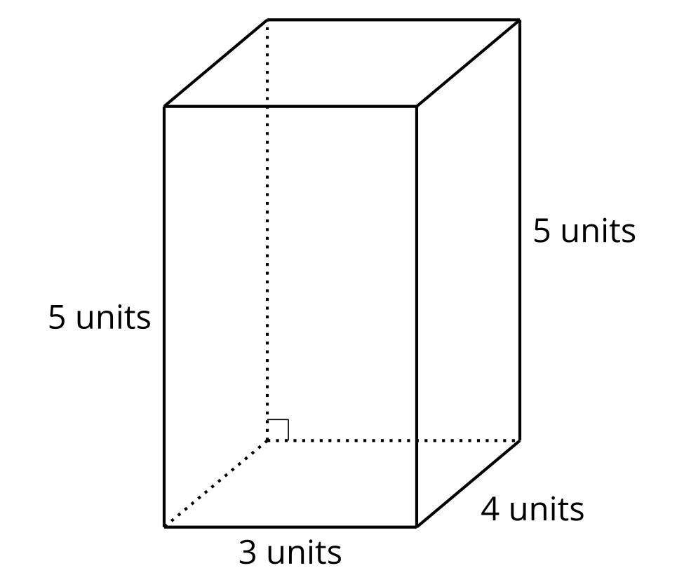
B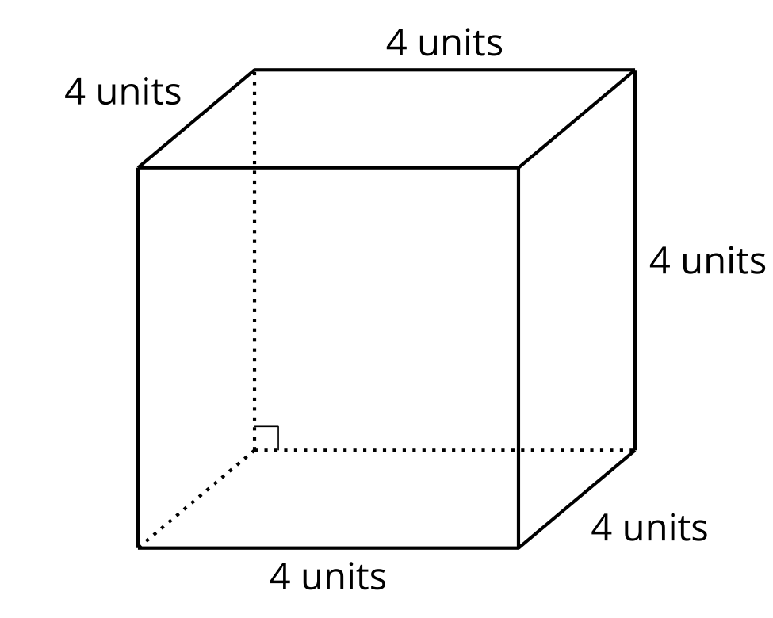
C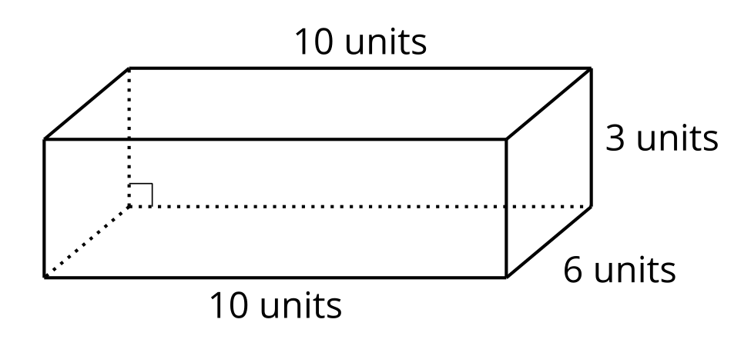
D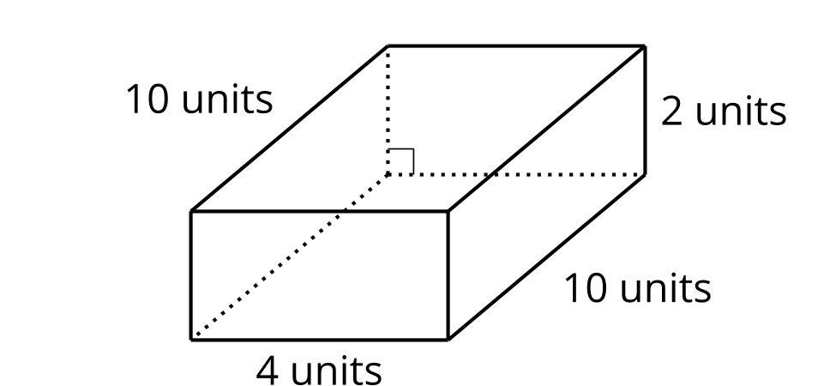
For each of your assigned prisms:
- Write 2 expressions to represent the volume in cubic units.
- Write 1 expression that does NOT represent the volume in cubic units.
Give your expressions to your partner:
- For each prism, which expression does not represent its volume in cubic units? How do you know?
- What other expressions represent the volume of this prism in cubic units?

Images for Activity Synthesis
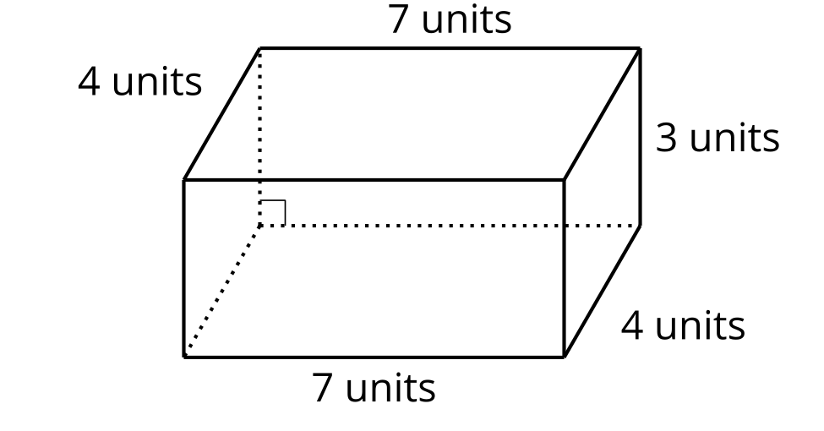
© CC BY 2021 Illustrative Mathematics®

