Unit 4 Lesson 11 Cumulative Practice Problems
- A child tosses a baseball up into the air. On its way down, it gets caught in a tree for several seconds before falling back down to the ground.
- 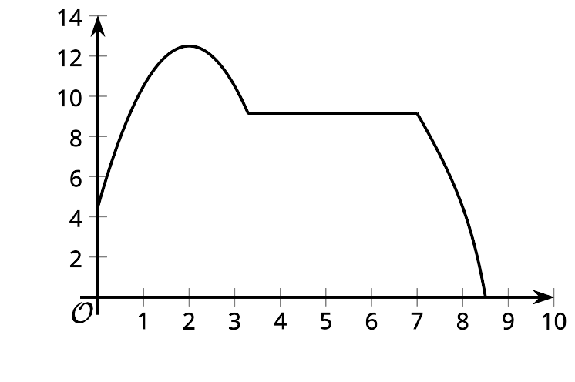
- Select the best description of the range of this function.
  - The range includes all numbers from 5 to 12.5.
  - The range includes all integers between 0 and 12.5.
  - The range includes all numbers from 0 to 8.5.
  - The range includes all numbers from 0 to 12.5.
- To raise funds for a trip, members of a high school math club are holding a game night in the gym. They sell tickets at $5 per person. The gym holds a maximum of 250 people. The amount of money raised is a function of the number of tickets sold.
- Which statement accurately describes the domain of the function?
  - all numbers less than 250
  - all integers
  - all positive integers
  - all positive integers less than or equal to 250
- $C$ gives the cost, in dollars, of a cafeteria meal plan as a function of the number of meals purchased, $n$. The function is represented by the equation $C(n)=4+3n$.
  - Find a value of $n$ such that $C(n)=31$ is true.
  - What does that value of $n$ tell you about the cafeteria meal plan?
- (From Unit 4, Lesson 5.)
- Lin completes a 5K using a combination of walking and running. Here are four graphs that represent four possible situations. Each graph shows the distance, in meters, as a function of time, in minutes.

- Graph 1
- 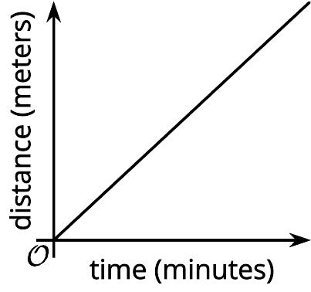

- Graph 2
- 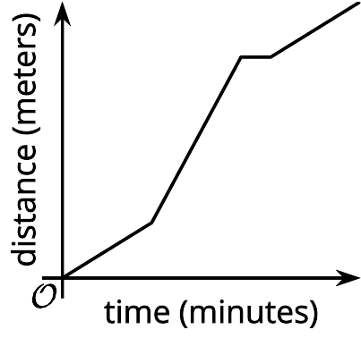

- Graph 3
- 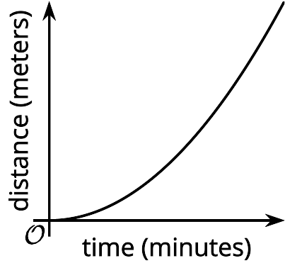

- Graph 4
- 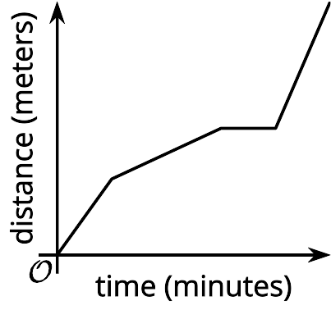
- Match each description with a graph that could represent it.
  - Lin starts out running, but then slows down to a jog. After 10 minutes, she stops for a water break. She then runs the rest of the way.
  - Lin starts the race walking, gradually getting faster and faster.
  - Lin jogs at a steady pace for the entire race.
  - Lin starts out walking, then moves to a steady run. After 15 minutes, she stops to stretch a cramped leg. Then, she walks the rest of the way.
  - Graph 1
  - Graph 2
  - Graph 3
  - Graph 4
- The graph $H$ shows the height, in meters, of a rocket $t$ seconds after it was launched.
  - Find $H(0)$. What does this value represent?
  - 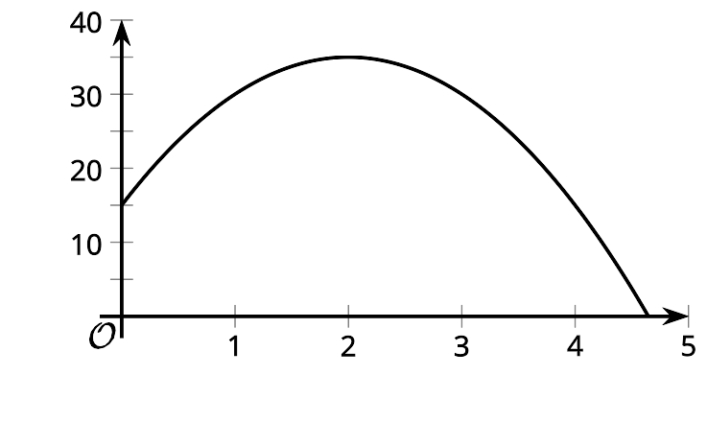
  - Describe the domain of this function.
  - Describe the range of this function.
  - Find $H(x)=0$. What does this value represent?
- Mai has to decide between two cafeteria meal plans. Under plan A, each meal costs $2.50. Under plan B, one month of meals costs $30.
  - Write an equation for function $A$, which gives the cost, in dollars, of buying $n$ meals under plan A.
  - Write an equation for function $B$, which gives the cost, in dollars, of buying $n$ meals under plan B.
  - Mai estimates that she’ll buy 15 meals per month. Which meal plan should she choose? Explain your reasoning.
- (From Unit 4, Lesson 5.)
- Kiran is playing a video game. He earns 3 stars for each easy level he completes and 5 stars for each difficult level he completes. He completes more than 20 levels total and earns 80 or more stars.
  - Create a system of inequalities that describes the constraints in this situation. Be sure to specify what each variable represents.
  - Graph the inequalities and show the solution region.
  - 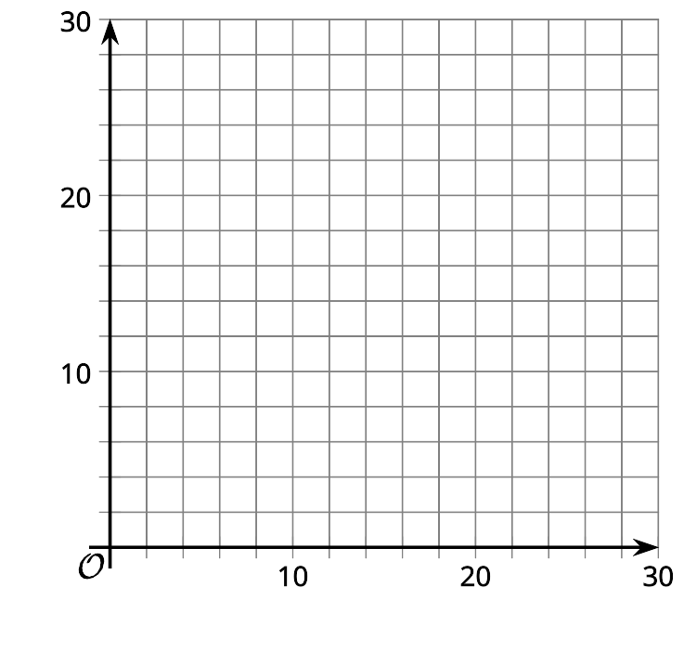
  - Then, identify a point that represents a combination of stars and levels that is a solution to the system.
  - Interpret the point $(5,6)$ in the context of this situation and determine how many stars Kiran earns based on this point.
- (From Unit 2, Lesson 25.)
© CC BY 2019 by Illustrative Mathematics

