Lesson 22: Subtract from Teen Numbers
- Let’s subtract from a teen number.

Warm-up: Number Talk: Subtract from a Teen Number
Find the value of each expression mentally.
- $14−4$
- $14−5$
- $17−7$
- $17−9$

22.1: Subtraction Methods
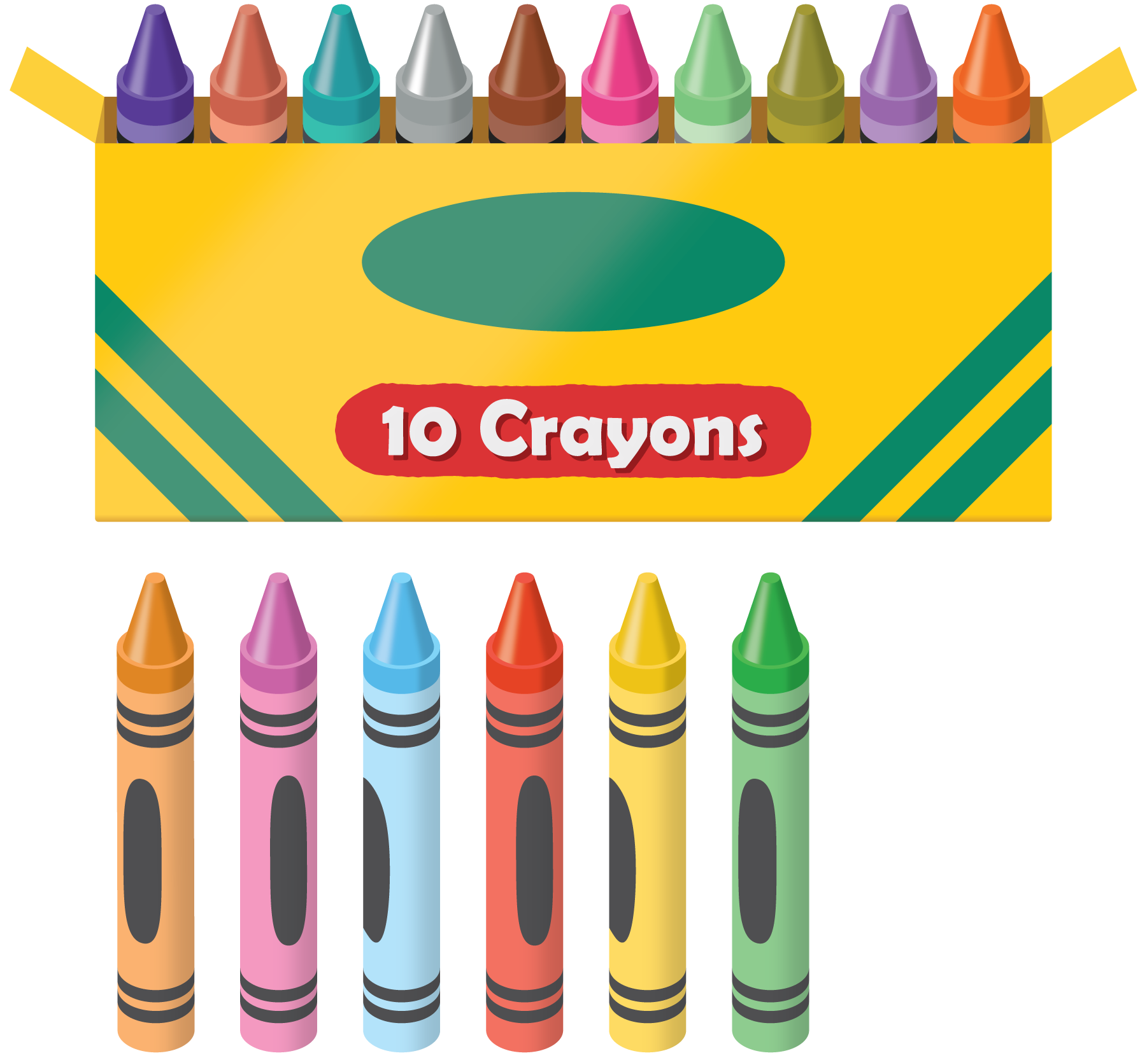
Elena has 16 crayons.
She gives 7 crayons to Diego.
How many crayons does she have left?
Show your thinking using drawings, numbers, or words.

22.2: Number Card Subtraction
- Choose a teen number card.
- Choose a number card to subtract.
- Find the difference.
- Write an equation.
My equations:
Pick your favorite equation.
Show how you found the value of the difference using drawings, numbers, or words.
© CC BY 2021 Illustrative Mathematics®

