Unit 6 Lesson 6: Measure with Paper Clips

WU Estimation Exploration: Length of the Desk (Warm up)

Student Task Statement
How long is the desk?
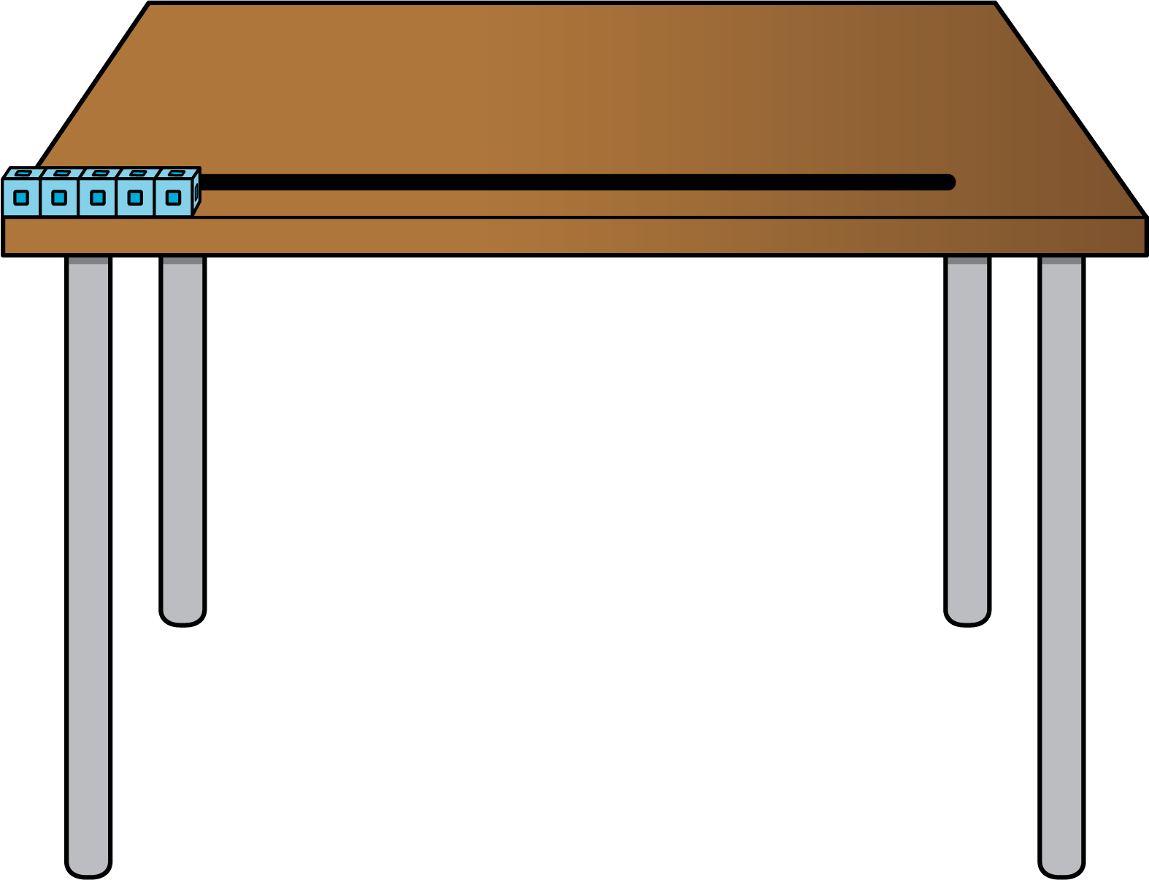
Record an estimate that is:
too low | about right | too high

1 Measure with Paper Clips

Student Task Statement

2 Measure Our Workbook

Student Task Statement
Circle whether you agree or disagree with each student.
Explain why you agree or disagree.
- 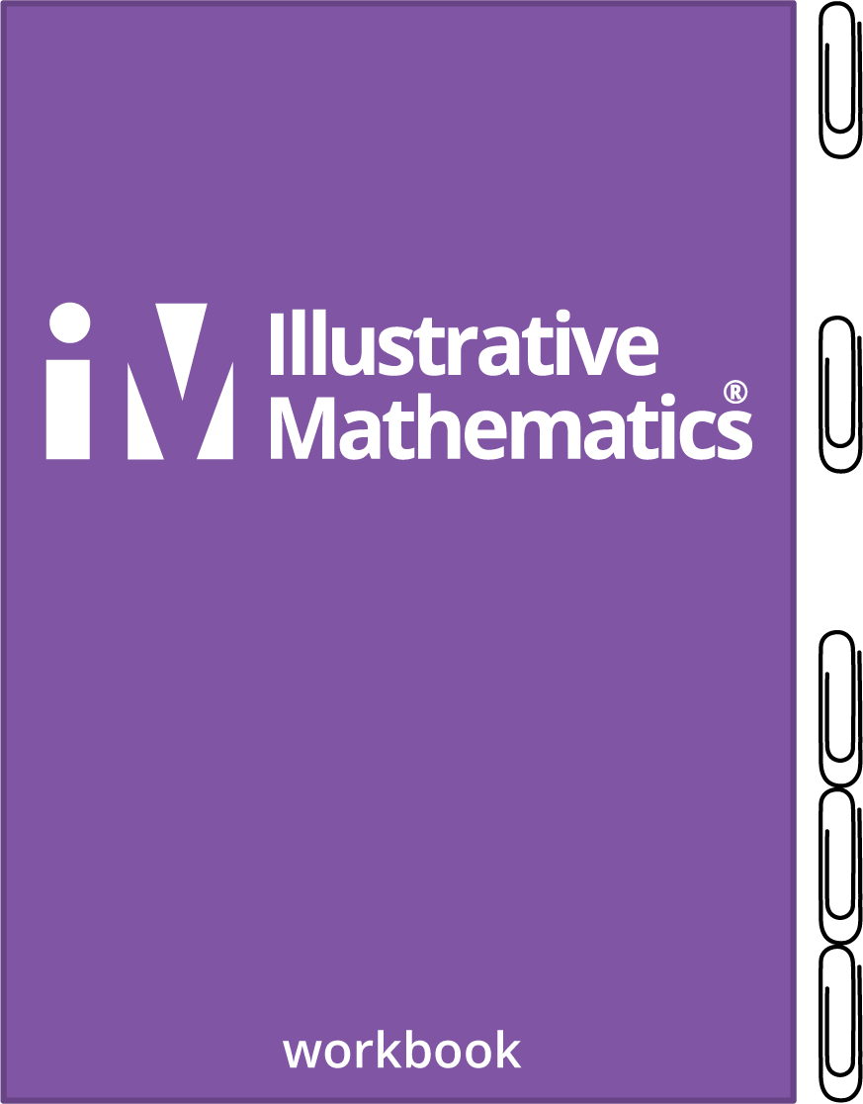
- Andre says that his student workbook is 5 paper clips long.
- Agree
- Disagree
- I _______________ because _________________________________
- 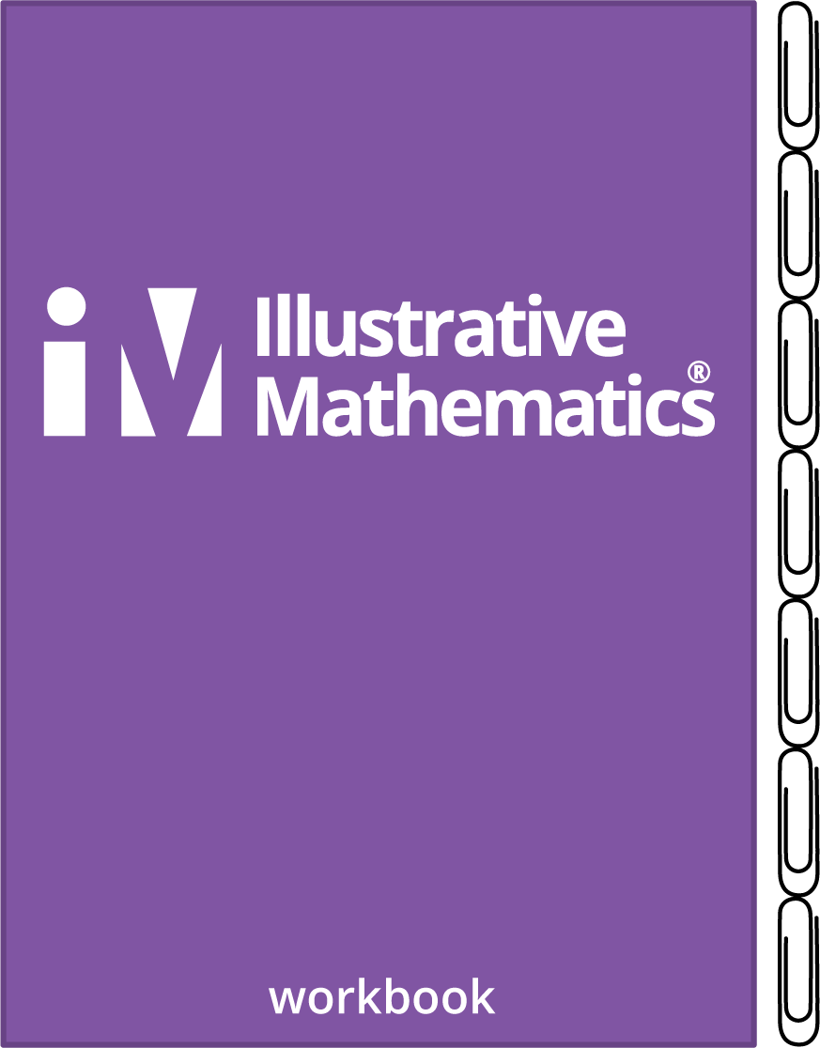
- Tyler says the workbook is 7 paper clips long.
- Agree
- Disagree
- I _______________ because _________________________________
- 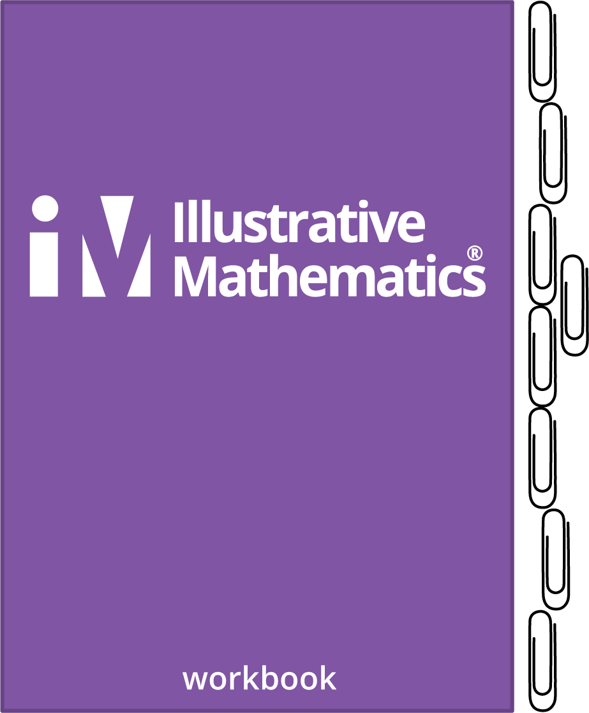
- Clare says the workbook is 8 paper clips long.
- Agree
- Disagree
- I _______________ because _________________________________

3 Measure Strips of Tape

Student Task Statement
Use paper clips to measure each strip of tape.
- The length of Tape A is _________ paper clips.
- The length of Tape B is _________ paper clips.
- The length of Tape C is _________ paper clips.
- The length of Tape D is _________ paper clips.
- The length of Tape E is _________ paper clips.
- The length of Tape F is _________ paper clips.
© CC BY 2021 Illustrative Mathematics®

