Unit 3 Lesson 4: Equal Groups of Non-Unit Fractions

WU Notice and Wonder: Thirds (Warm up)

Student Task Statement
What do you notice? What do you wonder?
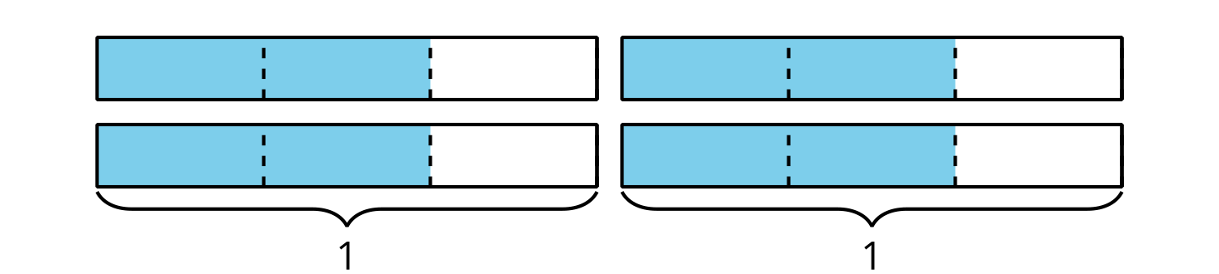

1 Jars of Jam

Student Task Statement
Elena fills 5 small jars with homemade jams to share with her friends. Each jar can fit $\frac{3}{4}$ cup of jam. How many cups of jam are in the jars? Explain or show your reasoning.
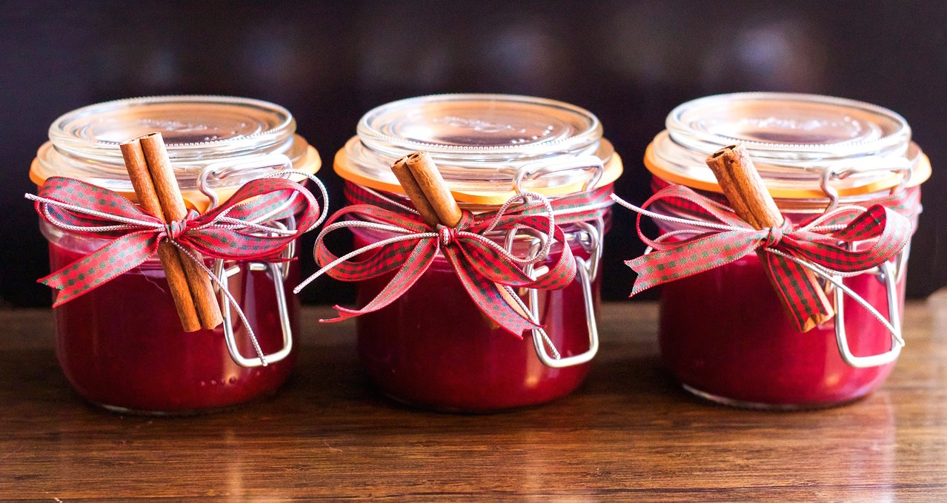
If you have time: Elena still has some jam left. She takes 2 large jars and puts $\frac{5}{4}$ cups of jam in each jar. How many cups of jam are in the jars?

2 How Do We Multiply?

Student Task Statement
- This diagram represents $\frac{2}{5}$.
  - Show how you would use or adjust the diagram to represent $4×\frac{2}{5}$.
  - What is the value of the shaded parts in your diagram?
- This diagram represents $\frac{5}{8}$.
  - Show how you would use or adjust the diagram to represent $3×\frac{5}{8}$.
  - What is the value of the shaded parts in your diagram?
- Find the value of each expression. Draw a diagram if you find it helpful. Be prepared to explain your reasoning.
  - $2×\frac{1}{6}$
  - $2×\frac{4}{6}$
  - $2×\frac{5}{6}$
  - $4×\frac{5}{6}$
- Mai said that to multiply any fraction by a whole number, she would multiply the whole number and the numerator of the fraction and keep the same denominator. Do you agree with Mai? Explain your reasoning.

Images for Activity Synthesis
© CC BY 2021 Illustrative Mathematics®

