Unit 5 Lesson 7: Using Diagrams to Represent Multiplication

1 Estimate the Product (Warm up)

Student Task Statement
For each of the following products, choose the best estimate of its value. Be prepared to explain your reasoning.
- $(6.8)⋅(2.3)$
  - 1.40
  - 14
  - 140
- $74⋅(8.1)$
  - 5.6
  - 56
  - 560
- $166⋅(0.09)$
  - 1.66
  - 16.6
  - 166
- $(3.4)⋅(1.9)$
  - 6.5
  - 65
  - 650

2 Connecting Area Diagrams to Calculations with Whole Numbers (Optional)

Student Task Statement
- Here are three ways of finding the area of a rectangle that is 24 units by 13 units.
- 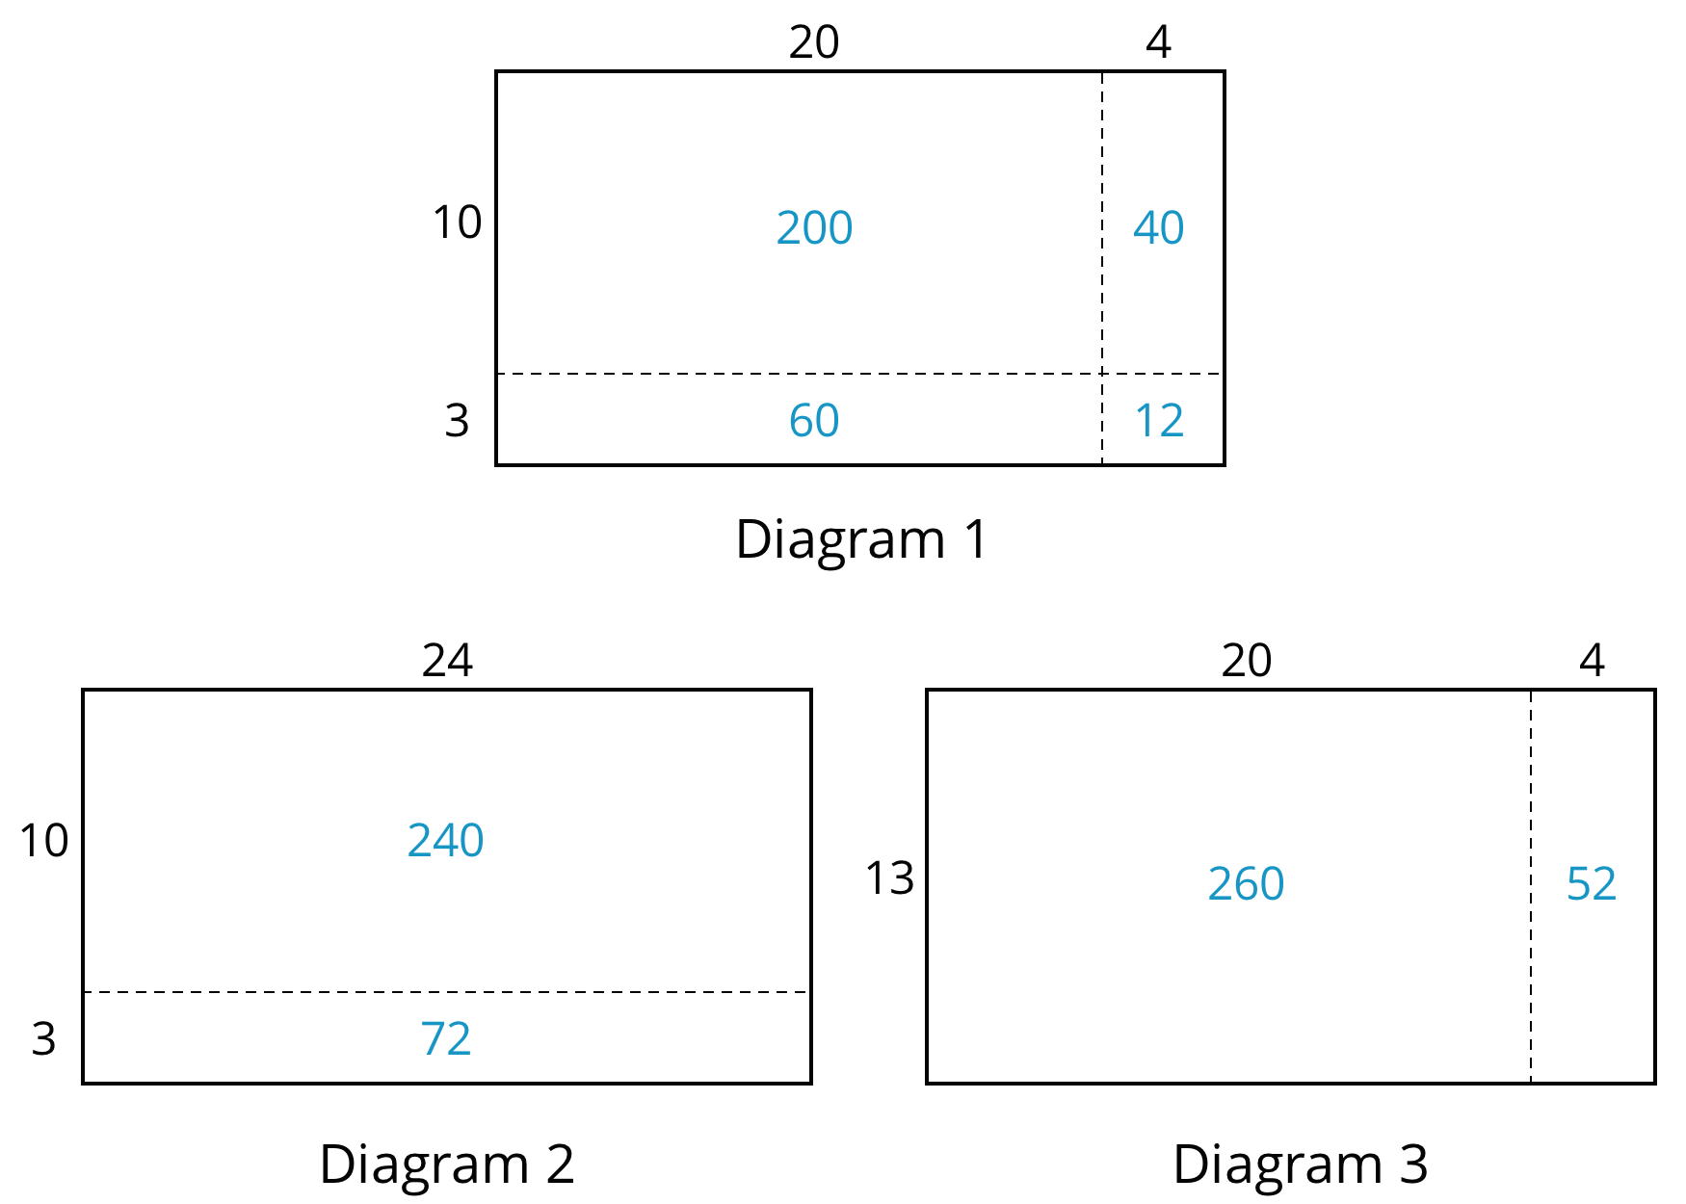
  - What do the diagrams have in common? How are they the same?
  - How are the diagrams different?
  - If you were to find the area of a rectangle that is 37 units by 19 units, which of the three ways of decomposing the rectangle would you use? Why?
- You may be familiar with different ways to write multiplication calculations. Here are two ways to calculate 24 times 13.
- 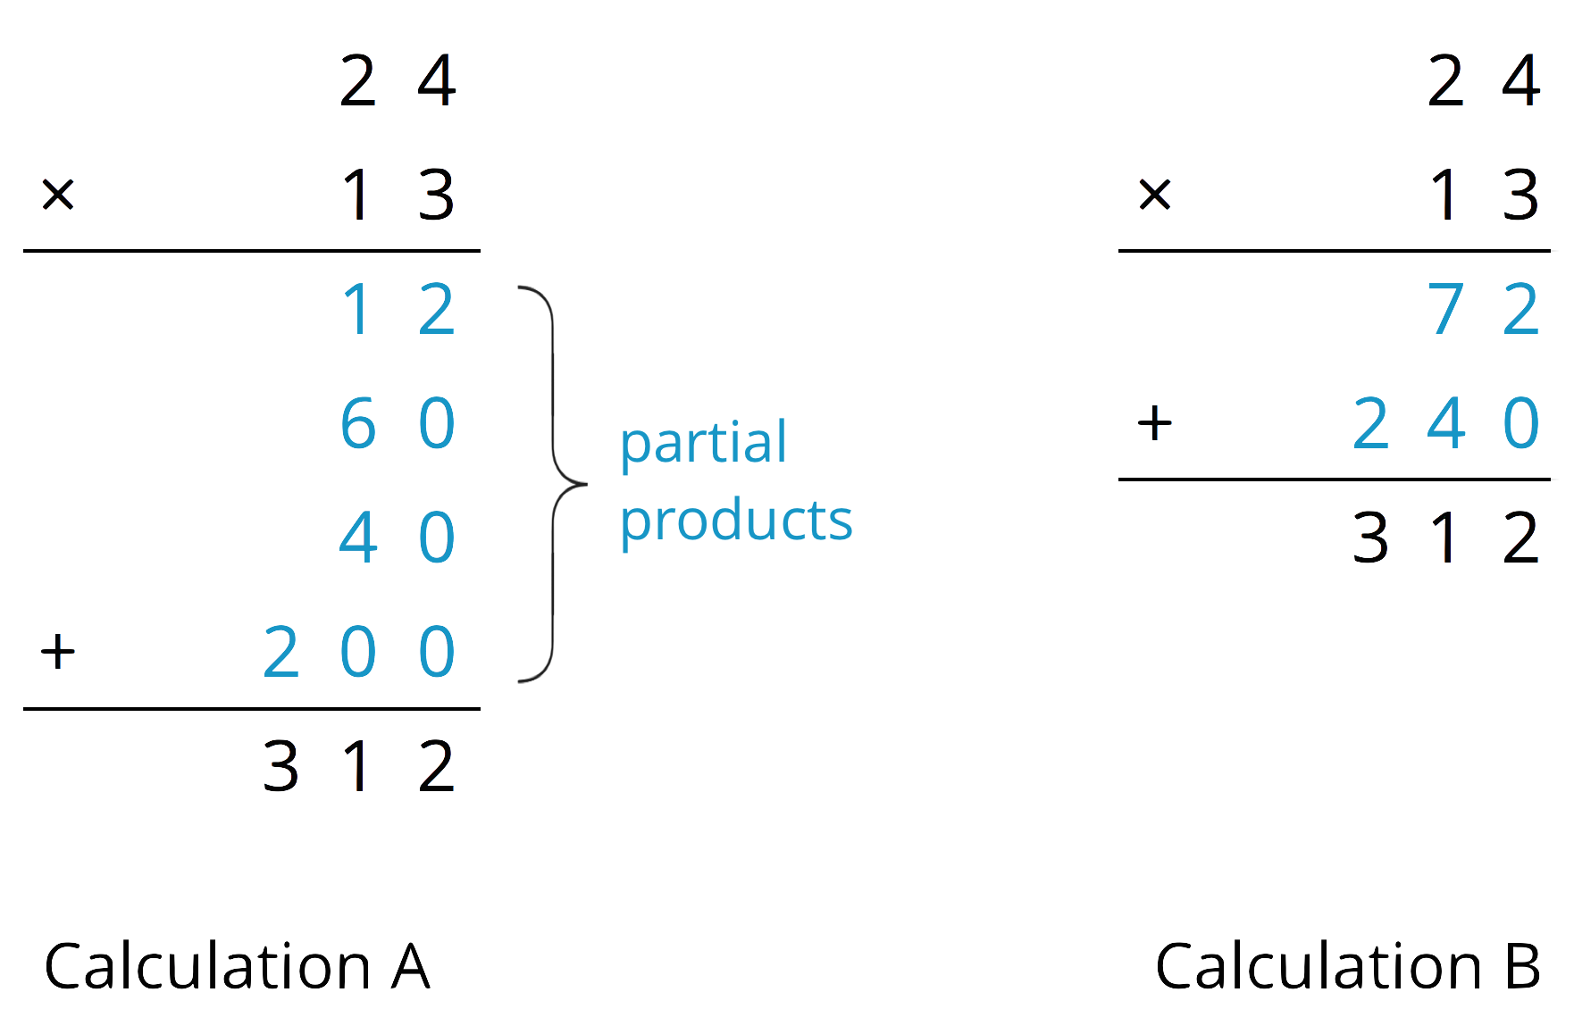
  - In Calculation A, how are each of the partial products obtained? For instance, where does the 12 come from?
  - In Calculation B, how are the 72 and 240 obtained?
  - Look at the diagrams in the first question. Which diagram corresponds to Calculation A? Which one corresponds to Calculation B?
  - How are the partial products in Calculation A and the 72 and 240 in Calculation B related to the numbers in the diagrams?
- Use the two following methods to find the product of 18 and 14.
  - Calculate numerically.
  - 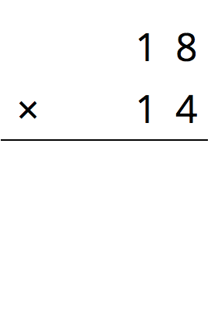
  - Here is a rectangle that is 18 units by 14 units. Find its area, in square units, by decomposing it. Show your reasoning.
- Compare the values of $18⋅14$ that you obtained using the two methods. If they are not the same, check your work.

Activity Synthesis
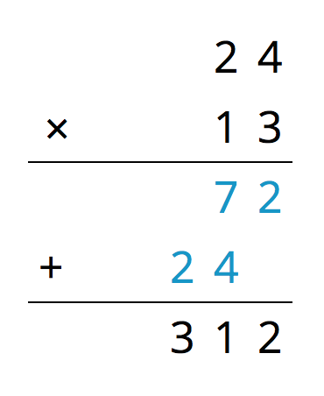

3 Connecting Area Diagrams to Calculations with Decimals

Student Task Statement
- You can use area diagrams to represent products of decimals. Here is an area diagram that represents $(2.4)⋅(1.3)$.
- 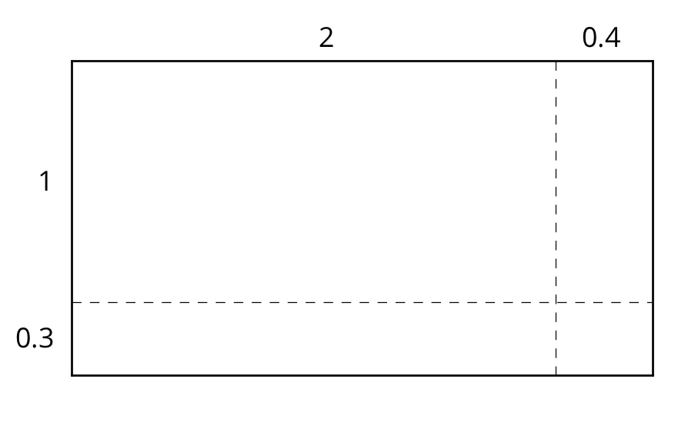
  - Find the region that represents $(0.4)⋅(0.3)$. Label it with its area of 0.12.
  - Label the other regions with their areas.
  - Find the value of $(2.4)⋅(1.3)$. Show your reasoning.
- Here are two ways of calculating $(2.4)⋅(1.3)$.
- 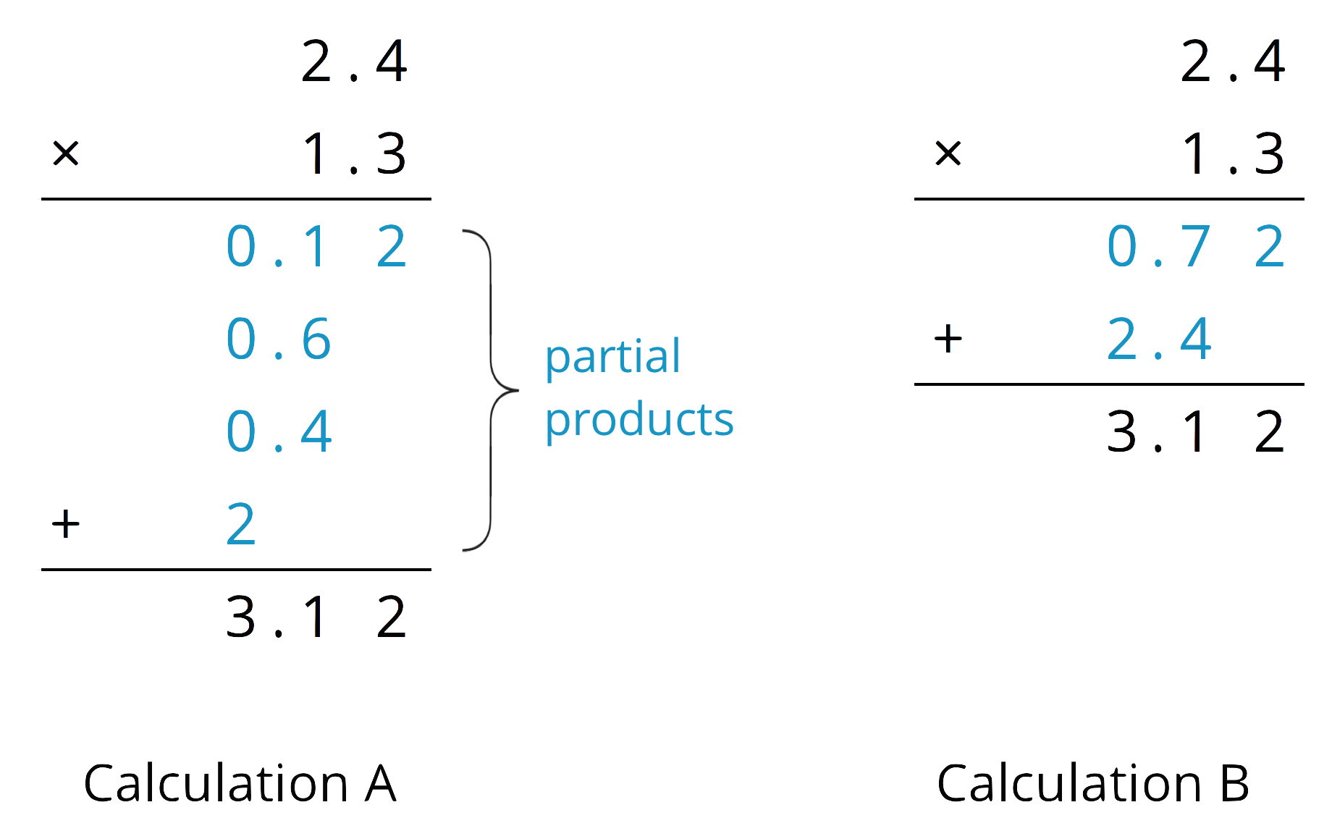
- Analyze the calculations and discuss these questions with a partner:
  - In Calculation A, where does the 0.12 and other partial products come from?
  - In Calculation B, where do the 0.72 and 2.4 come from?
  - In each calculation, why are the numbers below the horizontal line aligned vertically the way they are?
- Find the product of $(3.1)⋅(1.5)$ by drawing and labeling an area diagram. Show your reasoning.
- Show how to calculate $(3.1)⋅(1.5)$ using numbers without a diagram. Be prepared to explain your reasoning. If you are stuck, use the examples in a previous question to help you.

Activity Synthesis
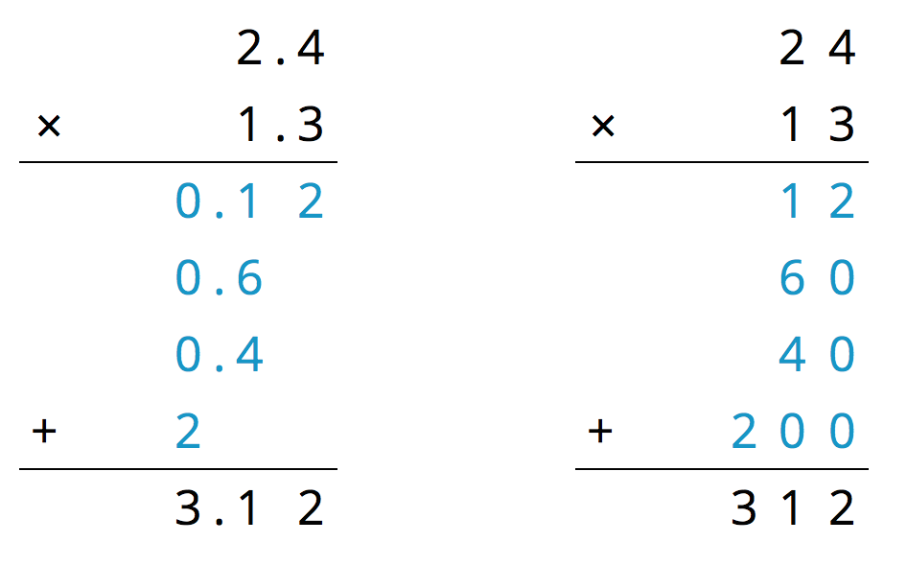

4 Using the Partial Products Method (Optional)

Student Task Statement
- Label the area diagram to represent $(2.5)⋅(1.2)$ and to find that product.
- 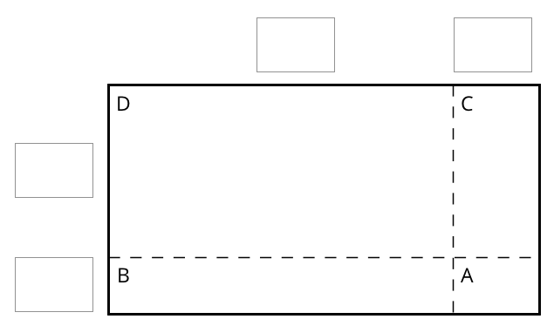
  - Decompose each number into its base-ten units (ones, tenths, etc.) and write them in the boxes on each side of the rectangle.
  - Label Regions A, B, C, and D with their areas. Show your reasoning.
  - Find the product that the area diagram represents. Show your reasoning.
- Here are two ways to calculate $(2.5)⋅(1.2)$. Each number with a box gives the area of one or more regions in the area diagram.
- 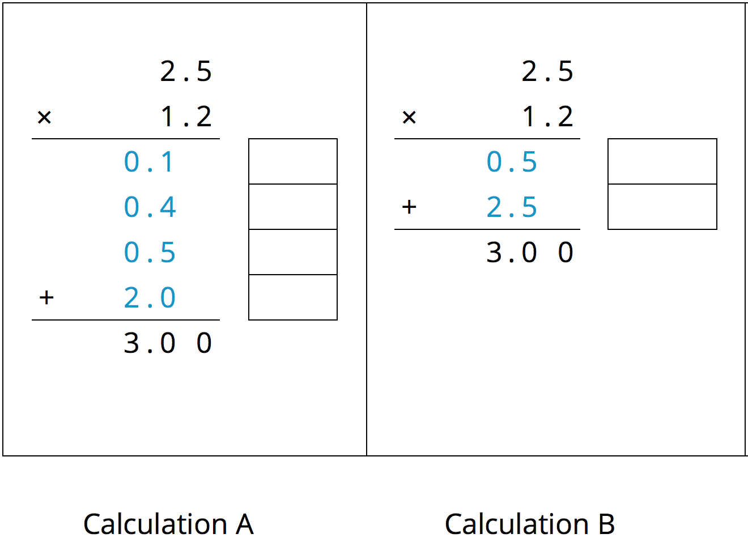
  - In the boxes next to each number, write the letter(s) of the corresponding region(s).
  - In Calculation B, which two numbers are being multiplied to obtain 0.5?
Which numbers are being multiplied to obtain 2.5?

Activity Synthesis
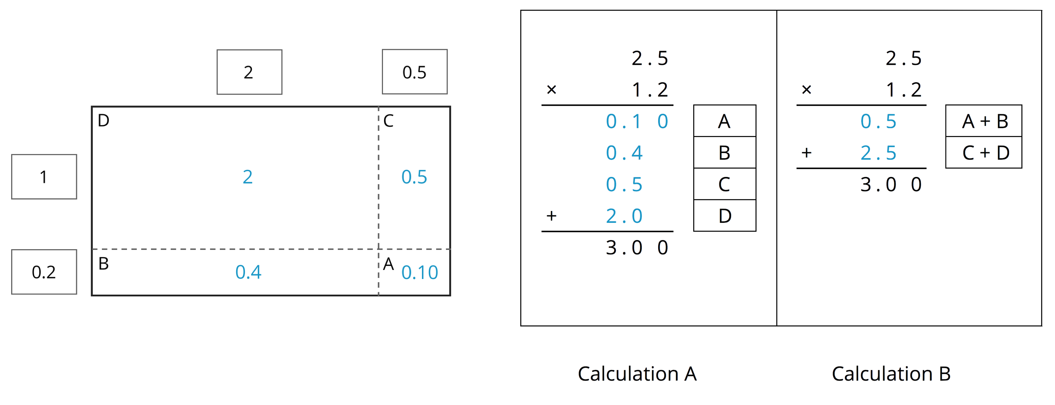
© CC BY Open Up Resources. Adaptations CC BY IM.

