## Unit 3 Lesson 8: Draw Shapes

### WU What Do You Know About Rectangles? (Warm up)

#### Student Task Statement

What do you know about rectangles?

### 1 Connect the Dots

#### Student Task Statement

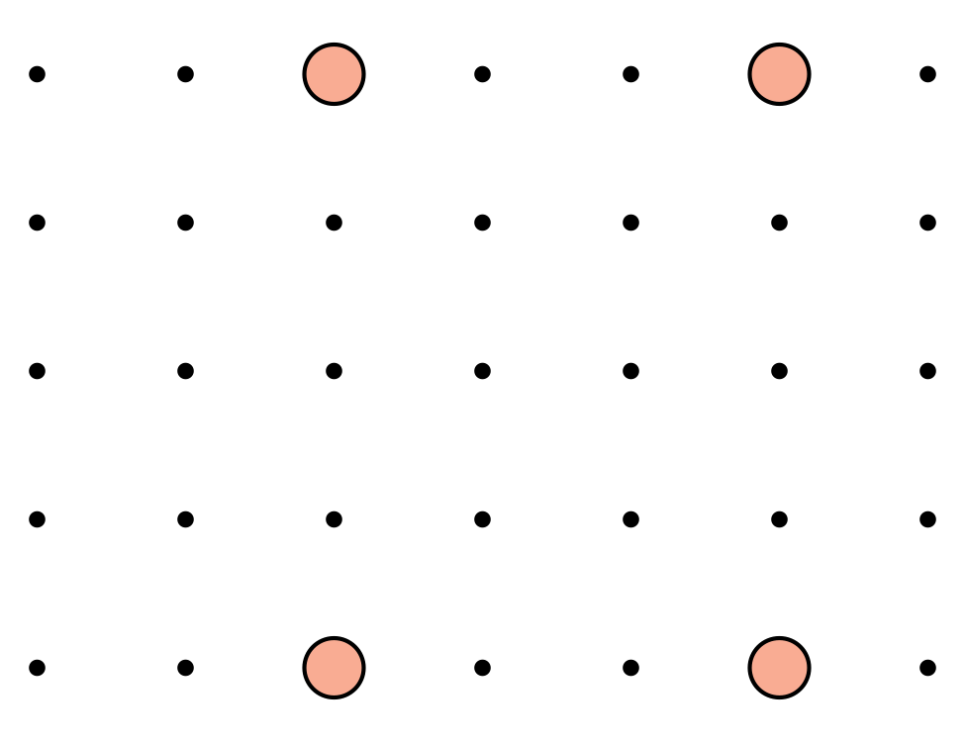



* 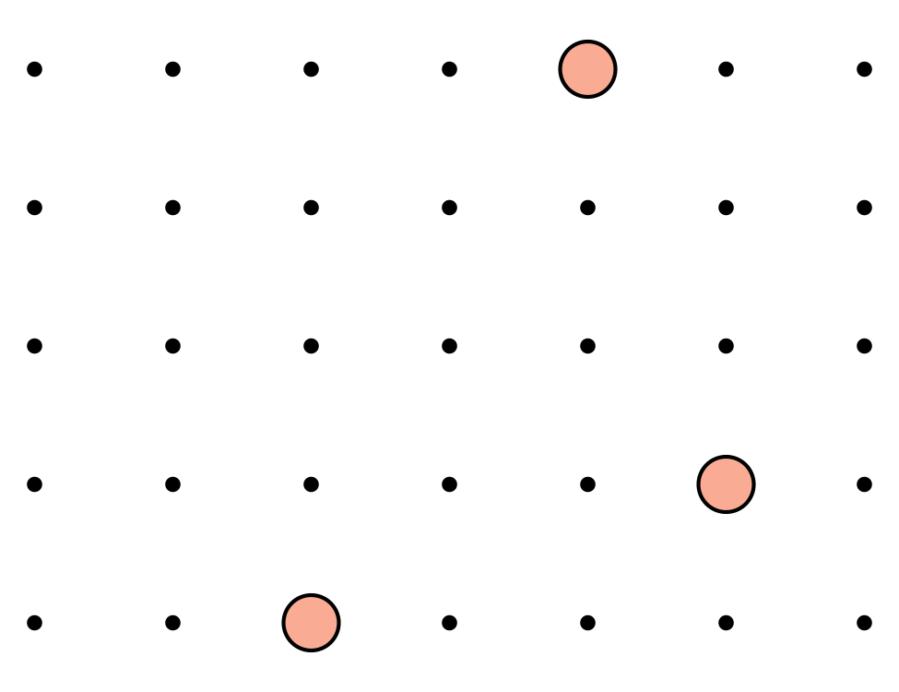



* 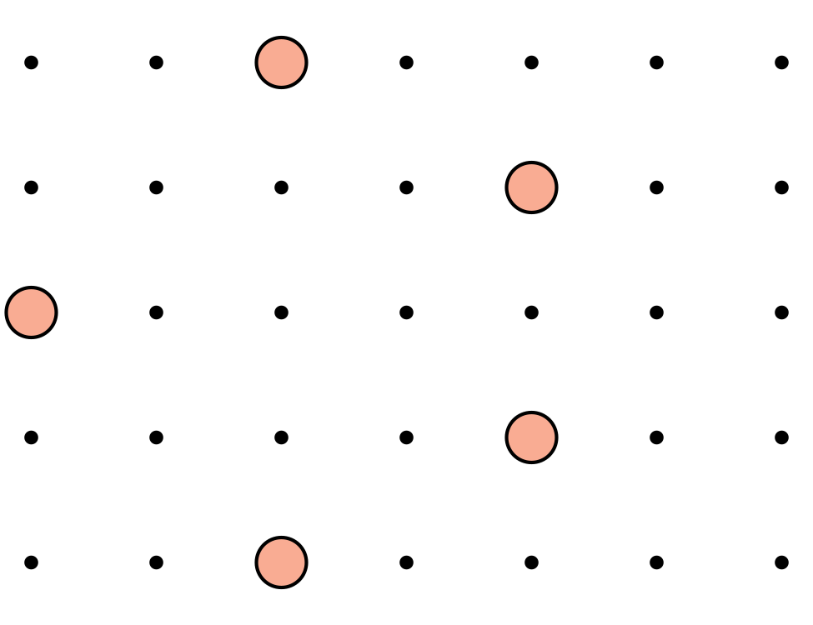



* 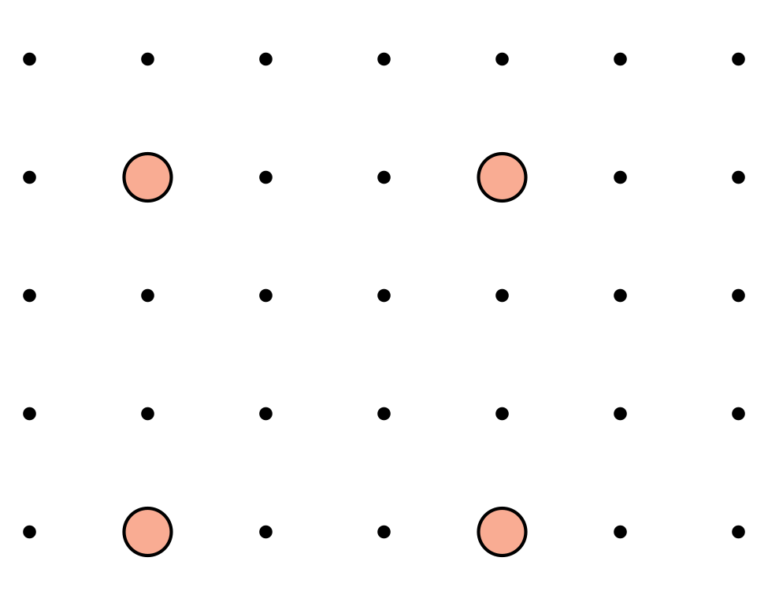



* 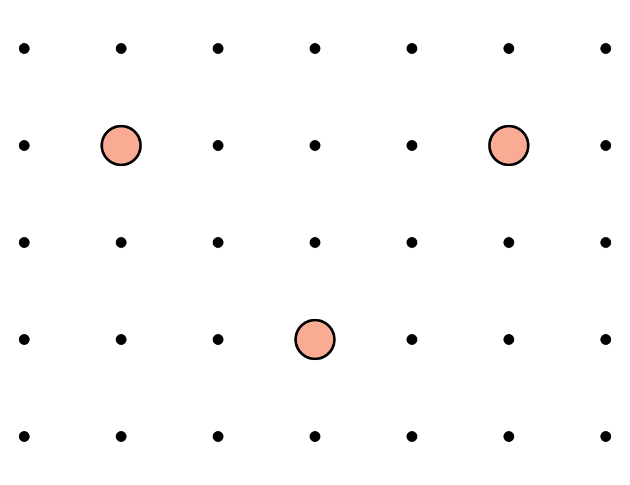



* 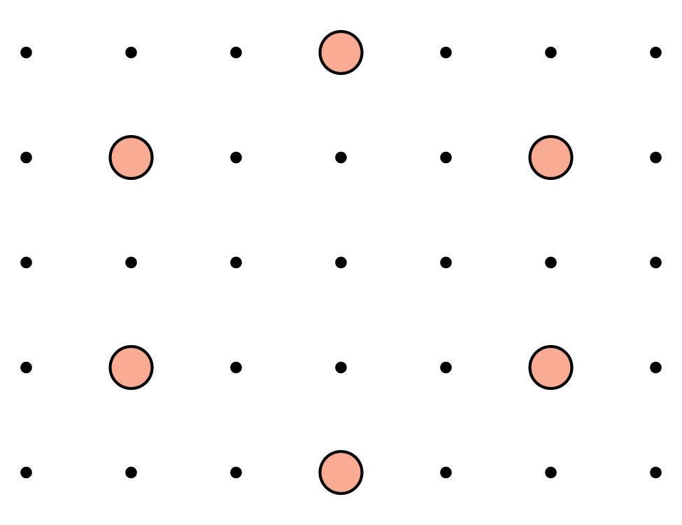

Synthesis:

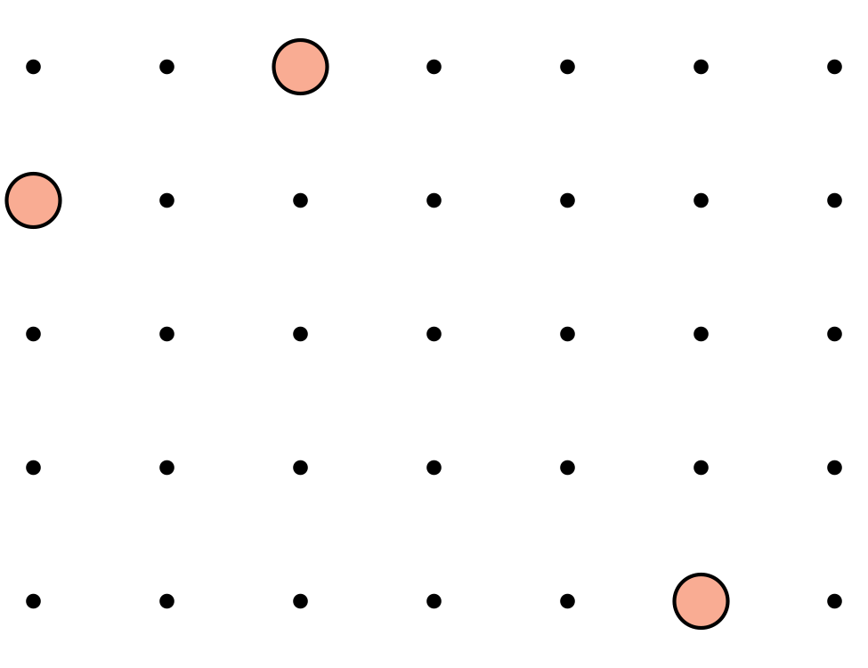

### 2 Describe and Draw Shapes

#### Images for Launch

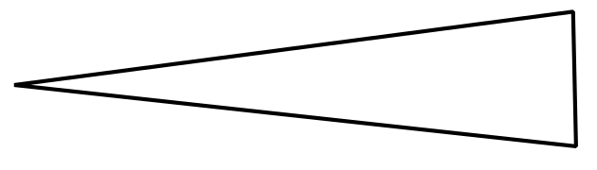

#### Student Task Statement

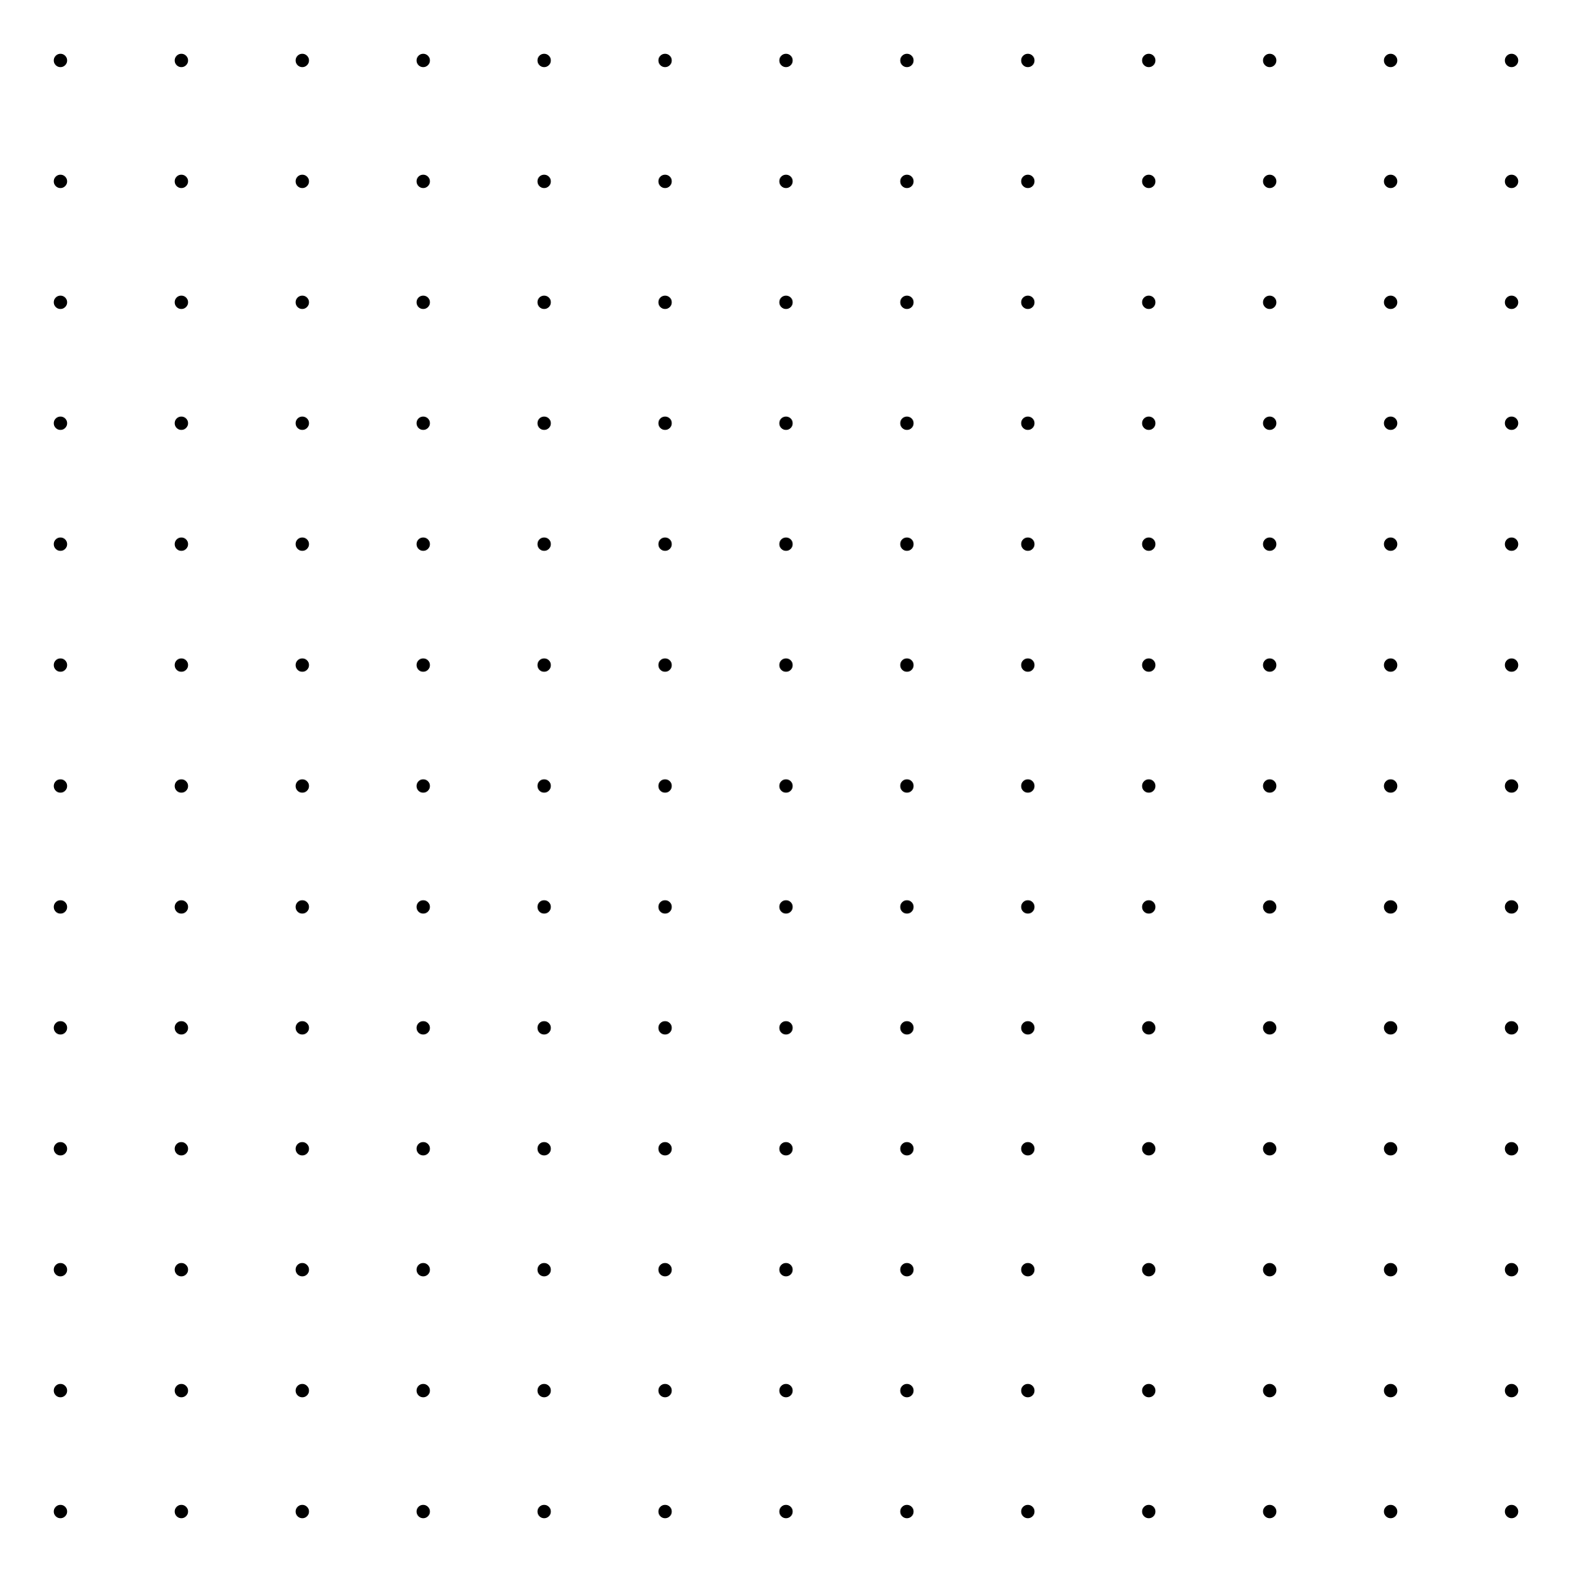

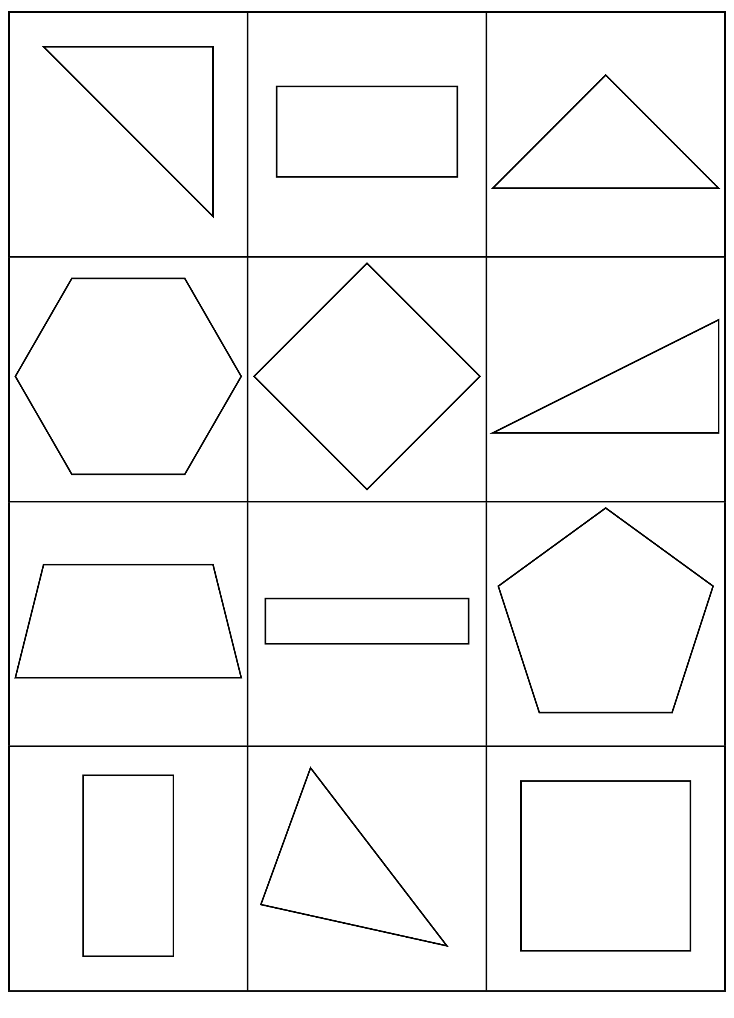







### 3 Introduce Build Shapes, Describe the Flat Shape

#### Student Task Statement



Choose a center.

Build Shapes

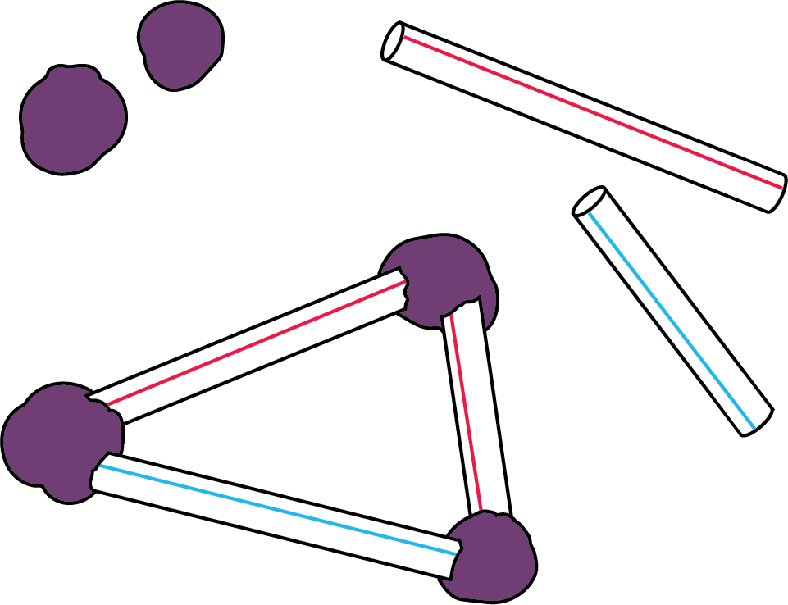

Counting Collections

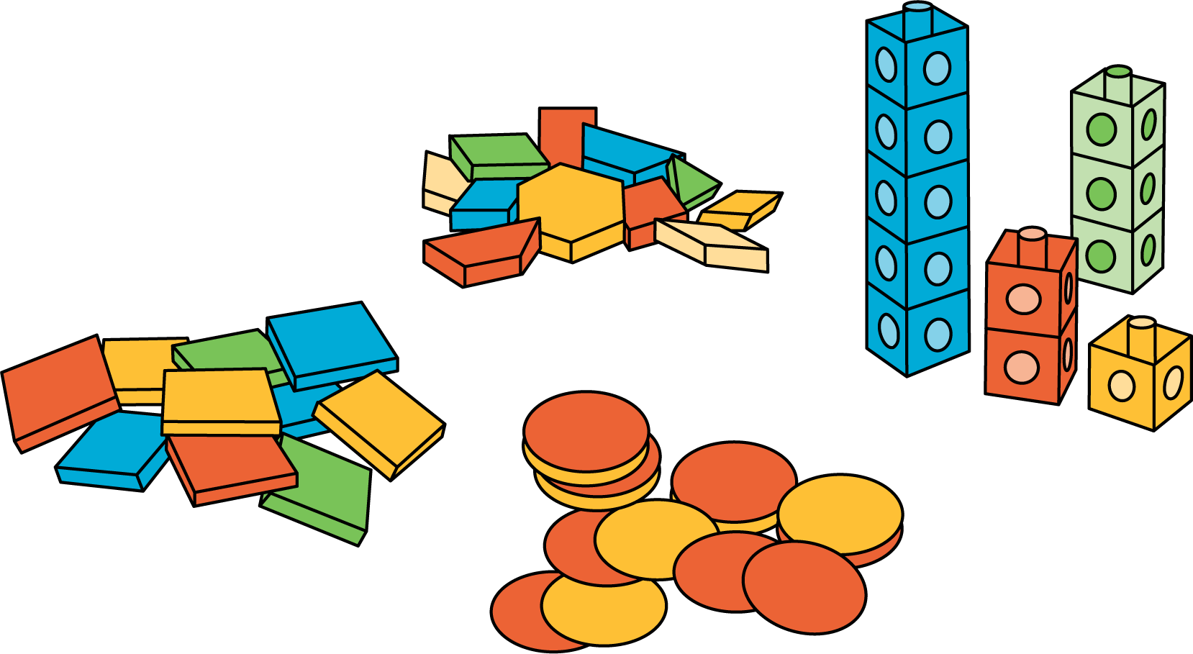

Which One

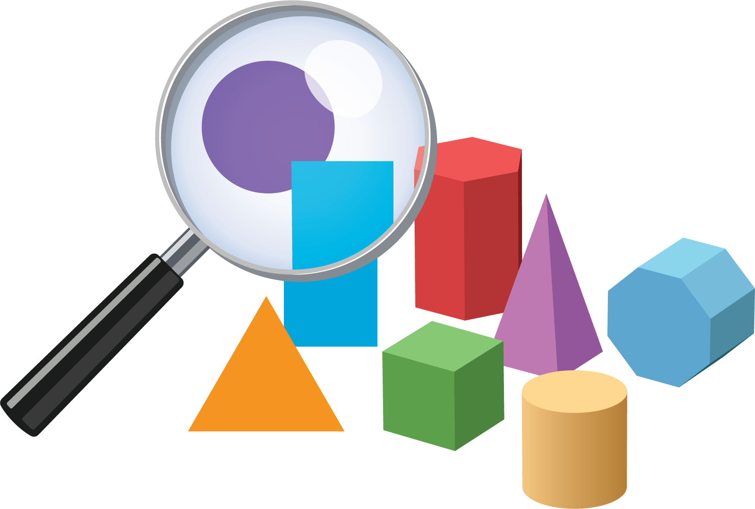

Picture Books

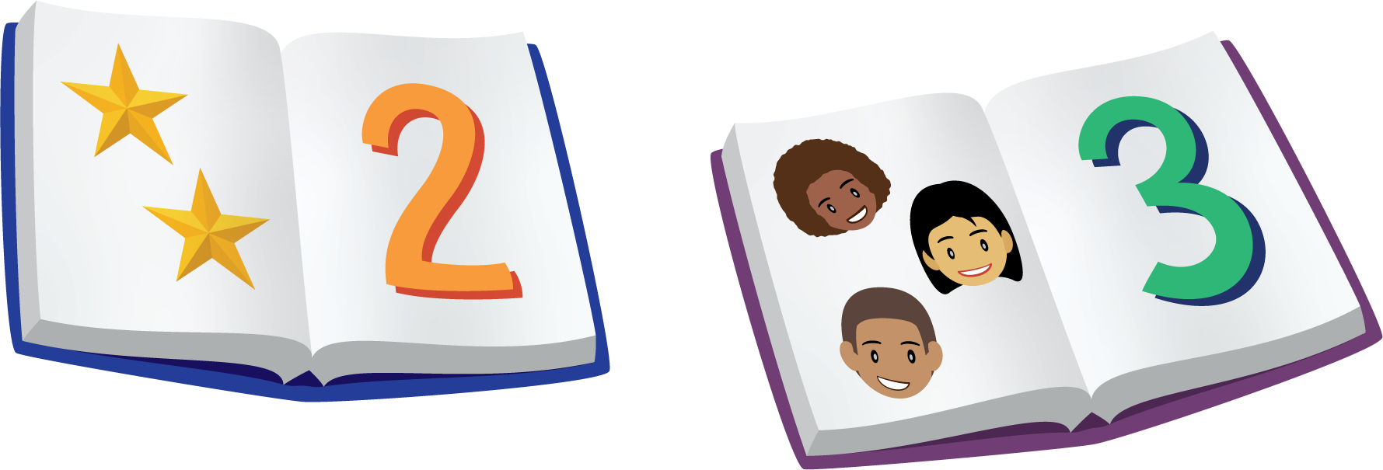

Bingo

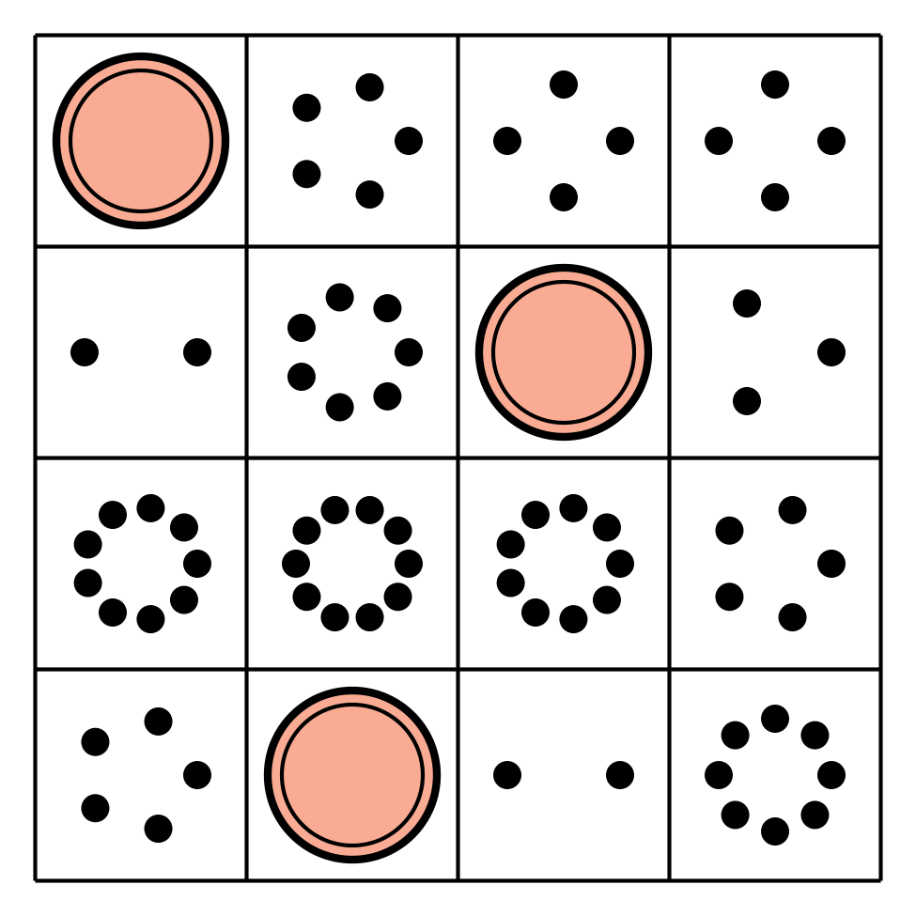

Shake and Spill

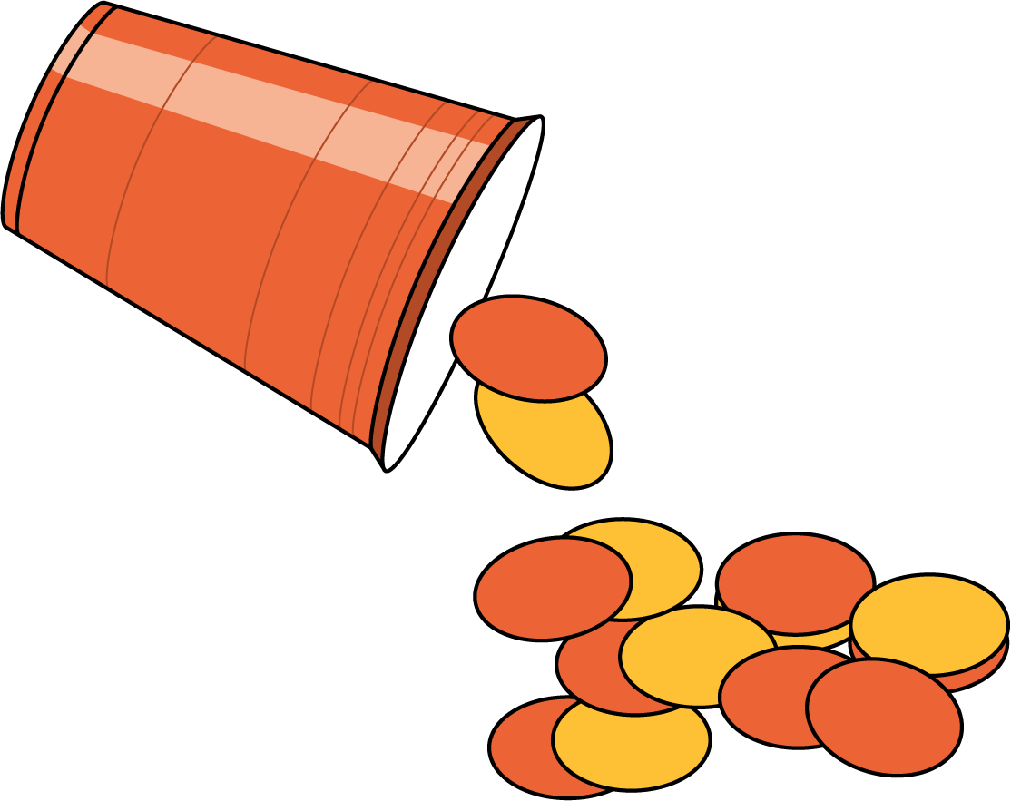

#### Images for Activity Synthesis

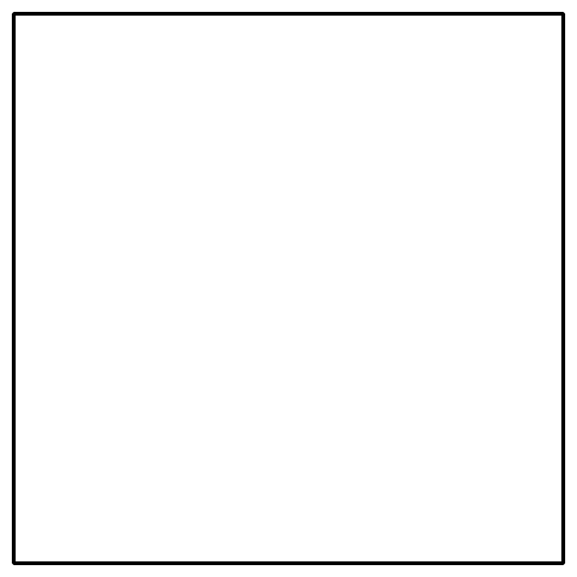

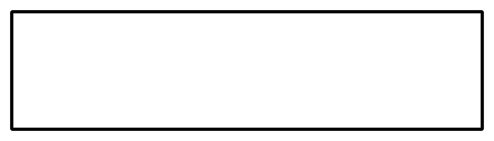



© CC BY 2021 Illustrative Mathematics®